|  |  |  |
| --- | --- | --- |
| **شعار جامعة بنها الجديد**f |  |  |
| **Benha University** |  | **Faculty of Computers & Artificial Intelligence** |

**Rover**

**(ALTaif)**

A senior project submitted in partial fulfillment of the requirements for the degree of Bachelor of Computers and Artificial Intelligence.

**Artificial intillegence Departement,**

***Project Team***

1. Mohamed Khaled Ahmed Abd Allatif
2. Mohamed Hassan Mohamed Hassan
3. Mohamed Saeed Hassan Hassan
4. Farah Mohamed Kamel Ali
5. Dina Mohamed El-Sayed Ahmed
6. Razan Bassel Sayed Imam

***Under Supervision of***

**Dr. Mahmoud Abd-Elaal**

Benha, February 2023

DEDICATION

In Allah satisfaction … In serve Humanity …

For Egypt…

For our mothers …., our fathers…, And our family…

To everyone he wished for university education and sought for it, but he was not lucky, and Fates did not help him

To everyone we love…

First of all we thank God for the most mercy for enabling us to present this project in the best form that we wanted to be, we would like to thank our supervisor of this project, Dr. (Mahmoud Abd Alaal) for his valuable help and advice to come out with this project. We thank our faculty and doctors that provided us with all the knowledge. Most of all we are all thankful for our families for their endless love, assistance, support and encouragement. And for our friends for their understanding and support for us to complete this project.

Acknowledgment

First of all we thank God for the most mercy for enabling us to present this project in the best form that we wanted to be, we would like to thank our supervisor of this project, Dr. (Mahmoud Abd Al aal) for his valuable help and advice to come out with this project. We thank our faculty and doctors that provided us with all the knowledge. Most of all we are all thankful for our families for their endless love, assistance, support and encouragement. And for our friends, for their understanding, and support for us to complete this project.

DECLARATION

We hereby certify that this material, which we now submit for assessment on the program of study leading to the award of Bachelor of Computers and Artificial Intelligence in *(bachelor)* is entirely our own work, that we have exercised reasonable care to ensure that the work is original, and does not to the best of our knowledge breach any law of copyright, and has not been taken from the work of others save and to the extent that such work has been cited and acknowledged within the text of our work.

**Signed:** _____________________________

**Date:** Tuesday, 14 February 2023.

ABSTRACT

Rovers are considered from the most powerful devices that can act as human being and can explore places in many different situations.

In our project we thought of something that can be small, fast, and act as human in performing for difficult situations, so we got the idea of making the Rover.

We designed the car kit with motors and wheels and connect to it the Arduino uno to control its movement then we used the raspberry pi to help Rover in the object detection.

Our rover includes a camera with object detection model to told us what around the rover in the environment which it is in, includes DHT11 sensor that measures humidity and temperature, after ending the mission the rover will provide us with a map to the paths that it moved in, and provides us with dashboard includes the analysis of the gained data through its mission.

All these outputs will be monitored and observed through a flutter application which is connected to a firebase, and firebase is connected to the raspberry pi.

We can start the mission of the rover and end it from start button and end button in the application.

Our application contains authentication, can reach the live video with the object detection model, contains temperature and humidity measures, reach the map of the mission and contains all last maps, and can reach although the dashboard of the analysis.

Table of Contents

List of figures iii

1. Chapter One: Introduction and background 1

1.1 Introduction 1

1.2 problem definition 1

1.2.1 What is the importance of this problem? 2

1.2.2 What are the current solutions? 2

1.2.3 How will your solution solve the problem? What is new? 2

1.3 Scope 3

1.4 Why Flutter ? 4

1.5 embedded system 6

1.5.1 Embedded system history 7

1.6 Computer vision 9

1.6.1 Object detection 9

1.6.2 Object detection Algorithms 10

2 Chapter Two: Analysis and design 11

2.1 introduction 11

2.2 User and system requirements 11

2.2.1 Functional requirements 12

2.2.2 Non-functional requirements 12

2.3 Stakeholders 13

2.4 System design 14

2.4.1 Block diagram 15

2.4.2 Use cases 15

2.4.3 Class diagram 16

2.4.4 Sequence diagrams 18

2.4.5 Database design 19

2.5 Used technologies and tools 19

2.5.1 YOLO version 5 21

2.5.2 Flutter 21

2.5.3 Pytorch 22

2.5.4 Open-CV 22

2.5.5 Raspberry pi OS 22

2.5.6 Arduino IDE 23

2.5.7 Firebase 23

2.5.8 Raspberry pi 4 model B 8 GB ram 23

2.5.9 Arduino Uno 24

2.5.10 DC motors 25

2.5.11 Wheals and car kit 25

2.5.12 Ultrasonic Sensor Module HC-SR04 27

2.5.13 Temperature and humidity sensors (DHT11) 28

2.5.14 Gyroscope MPU6050 29

2.5.15 Arduino motor driver (L293) 31

2.5.16 Raspberry pi camera 31

3 Chapter Three: Deliverable and evaluation 32

3.1 Introduction 32

3.2 User manual 32

3.3 procedures 51

3.3.1 Connection to form rover 51

3.3.2 Arduino rule for self-driving car 53

3.3.3 Setup raspberry pi 55

3.3.4 YOLO (You Only Look Once) 58

3.3.4.1 Why we used YOLO 58

3.3.4.2 How the YOLO algorithms work? 59

3.3.5 Raspberry pi and Arduino connection 65

3.3.6 DH11 sensor connection 66

3.3.7 Live video creation 67

3.3.8 Map generation 69

3.3.9 Report by power pi 71

3.3.9.1 Power pi overview 71

3.3.9.2 Power pi Desktop 71

3.3.9.3 Sample data 72

3.3.9.4 Phases in Development 72

3.3.9.5 Connection to data source 73

3.3.9.6 Reporting on the Data – Creating Visualizations 74

3.3.9.7 Building Basic Visualizations 74

3.3.9.8 Visualization Interactivity 75

3.3.9.9 Date Dimension – Time Intelligence 75

3.3.9.10 Adding a Time Intelligence Quick Measure 75

3.3.10 Firebase connection 77

3.3.11 Application to control rover 79

3.4 implementation 81

3.4.1 Implementation of flutter code 81

3.4.2 Implementation of python code using raspberry pi 84

3.4.3 Implementation of Arduino code 88

3.5 Testing 92

3.6 Evaluation 92

3.7 Summary 93

4 Chapter four: Discussion and conclusion 93

4.1 Main findings 93

4.2 Why is this project important? 94

4.3 Limitations 95

4.4 Future recommendations 95

Summary 95

References 96

List of figures

Figure ‎1‑1: Project stackholders. 10

Figure ‎1‑2: Block diagram. 12

Figure ‎1‑3: Use case (mission control). 13

Figure ‎1‑4:Use case (Rover system) 14

Figure ‎1‑5:Class diagram 15

Figure ‎1‑6:Sequence diagram(mission control) 16

Figure ‎1‑7: Sequence diagram(Rover system) 17

Figure ‎1‑8: ERD diagram 18

Figure ‎1‑9: Connections 23

Figure ‎1‑10: Arduino flowchart 24

Figure ‎1‑11: Arduino tasks 25

1. Chapter One: Introduction and background

## Introduction

Rover definition could be a mobile itinerant robot that the main purpose needed from it is helping us in detecting objects, paths, exploring a specific area and gathering data about it such as temperature, humidity, Soil Moisture, …etc. by using specific sensors and it also can draw a map for this area. These data that we had gathered we can use it in different types of scientific +research such as helping researchers in finding the reason of climate changing that is a big challenge that we are facing today, in agriculture, mining, exploring new planets to know information about it and helping in the progress of science.

So, it’s obviously that rover is very useful for geologists, Archaeologists, palaeontologists, Agricultural engineers, petroleum engineers, Discover forensic evidence and of course space agencies.

There are a lot of challenges that today we are facing such as climate change, and natural disasters. We need scientists to study and analyze these disasters to figure out the reasons for what happening and find solutions. To see the danger of what I say for example Sea levels are rising, and oceans are becoming warmer. Longer, more intense droughts threaten crops, wildlife, and freshwater supplies. From polar bears in the Arctic to marine turtles off the coast of Africa, our planet’s diversity of life is at risk from the changing climate, and The Catastrophic wildfires that eucalyptus forests in southern and eastern Australia in the summer of 2019-2020 were unprecedented in their scale and intensity. Started in October 2019 and burning through January 2020, they scorched millions of hectares and killed or displaced an estimated 3 billion animals. The scientific researchers need every way that could help in making that fast and hear our project can help.

## problem definition

We face some challenges in climate changing some of its reasons come from forest burning, changes that occur in the north and south poles and others. It’s difficult for scientists to be the whole time in the environment that is cruel, dark, cold, and dangerous and the main goal that wanted from scientists is just analyzing the data to figure out the reasons and the same thing in exploring planets, Agricultural engineering, petroleum engineering and other fields.

There is also main problem that we face which is detecting if there are any people still alive in the destroyed large buildings



### What is the importance of this problem?

Think of the climate changing challenge if we left it without solving the problem of forest burning, it could lead us to disasters such as Floods, lack of oxygen, extinction of species and many disasters and more of that could happens. all of this and I didn’t mention the other fields that the fast progress is necessary today to meet human needs from food, gas, power. Of course, after you read these words, you now appreciate the importance of this problem and how we need modern and fast technologies to help in the action world now takes.

### What are the current solutions?

The current solution here is that the researchers were doing the hard work by themselves and go to dangerous places that could have wild animals, remote lands where they could mislead the way, and cold places such as the North and South poles this puts researchers at risk and the solution of the problem that has found is we have to make the financers pay more and more money to secure them, using expensive transport methods all of that makes the progress too slow. So, we need new technologies that are reliable and faster solutions before the disaster evolves and gets worse.

### How will your solution solve the problem? What is new?

Modern technologies help us in solving the previous problems, one of these modern technologies is robotics we use programming skills, mechanics, electronics, and artificial intelligence that we will use all of them to build our project "Altaif". "Altaif" could be very useful as I said there is no need now to endanger the lives of researchers. Every kind of data now we can get it using sensors and with help of Artificial intelligence. Building Autonomous vehicles become so easy and more reliable. so, we can easily send the rover to the place to gather the data that we need and then it will back to us with the desired data and map for the place that would help researchers if they wanted to go and explore some areas by themselves.

## Scope

**Description and final deliveries:**

Our project is about a mobile robot called Rover, it can help in detecting objects and paths by drawing maps with directions, and in exploring different areas and collect data about it such as temperature, humidity, Soil Moisture by using specific sensors.

**Project objective and value creation:**

The value of the project is to use the data we had collected in different field such as helping researchers in finding the reason of climate changing that is a big challenge that we are facing today, in agriculture, exploring new planets to know information about it and helping in the progress of science. So, it’s obviously that rover is very useful for geologists, Archaeologists, paleontologists, Agricultural engineers, petroleum engineers, Discover forensic evidence and of course space agencies.

**Constraints and exclusions:**

One of the factors limiting the project is the large budget that is not currently available and the project period.

**Project milestones and timeline:**

The milestone of our project is simply a timeline that uses milestones to divide a project schedule into major phases.

Due to its simplicity, it’s used when project managers or sponsors need to share an overview of the project schedule with stakeholders or team members without going over every detail.

**The timeline:**

1. First term:

Making the hardware of the rover and connect Arduino with it to control the movement of the rover and add the ultrasonic sensor to it to avoid obstacles and control its movement and make the object detection model on the raspberry pi.

1. Second term:

Connect the rover with the raspberry pi and add the sensors to Arduino to measure temperature, humidity and balance the rover

## Why Flutter?

What is Flutter? Back in the days of Objective C/Swift and Java/Kotlin as the primary languages for mobile development, building apps was expensive. You had to build two separate apps, which meant doing the work twice. To solve this problem, several frameworks have been constructed for the creation of hybrid (or cross-platform) apps in HTML5 and JavaScript. Among the cross-platform toolkits, including Phonegap, Xamarin, React Native, and more, the Flutter framework has quickly become increasingly popular among developers, enterprises, entrepreneurs, and users. Flutter is a portable UI toolkit for building native-like apps across mobile, web, and desktop, from a single codebase. It uses the programming language Dart and incorporates Material Design and Cupertino widgets. Flutter developers can create a spectacular UI that looks and feels native. It behaves naturally on any platform, even though you‘re using one codebase. Flutter is the only framework with a mobile SDK that provides a responsive style without using a Javascript bridge, thereby reaching a level of performance that rivals its cousin and direct competitor, React Native. It easily integrates with different platforms such as Android, IOS, Linux, MAC, Windows, and Google Fuchsia applications. Flutter is one of the best solutions to develop apps for Android and iOS without having to write a different codebase for each platform. The smartphone versions of these apps function as true native apps on Apple and Android devices and are compiled for the respective platform before publication. The Flutter SDK is based on the Dart programming language, also developed by Google. It intends to supplant classic JavaScript.

Advantage and disadvantage of Flutter app development: Every programming language has its advantages and disadvantages. But, in most cases, we can say that the advantages of Flutter, compared to similar technologies, clearly outweigh its disadvantages. Advantage of Flutter app development Flutter has numerous advantages over its competitors. These advantages are inherent in the programming language and in the set of development tools that allow Flutter to solve issues that other languages cannot cope with. 1. One codebase for all platforms Gone are the days of having to write code for Android and another codebase for iOS devices. Flutter‘s code reusability allows you to write just one codebase and use it not only for mobile Android and iOS but even for web, desktop, and more. This cuts development time in half significantly reduces the costs and enables you to launch your app that much faster. 2. ―It is all Widgets‖ principle offers countless possibilities Flutter ‘s custom widgets are an absolute delight when it comes to creating great visuals for your app. At the same time, you don‘t have to worry about the UI on different devices. 3. Rich libraries Flutter uses the Skia Graphics Library, which is a fast and mature open-source graphics library. It redraws the UI every time a view changes. The result? quick load and smooth app experience. 4. Fast testing with hot reload the app's development is much quicker with the hot reload feature. With Flutter, there is no need to reload the app to see every single change you make in the code. You can easily make changes to your app in real time, so you have more opportunities to experiment with the code and fix bugs on the go. Disadvantage of Flutter app development There are no flawless technology solutions, and Flutter is no exception. Flutter‘s cons aren‘t exactly deal-breakers, but here are a few reasons why it might not be the ideal toolkit for a specific app. 1. Large file size because of the widgets Flutter apps are quite large and ―heavy‖ to start with. They occupy a lot of space and take longer to download or update. 2. Complex updating programming requirements in operating systems requires updating Flutter modules. Since the modules are integrated as fixed elements in the program, the latter must also be recompiled and reinstalled on the devices. 3. Limited set of tools and libraries Flutter is a quite new development framework, so in some cases you may not be able to get the desired functions in the current library. Flutter will take some time to create certain tools, expand functionality and develop the community. So we created a flutter Application to make it easy for the user to control our Rover with the app.



## embedded system

An embedded system is a dedicated functional computer system within a larger mechanical or electrical system. Since the embedded system is dedicated to specific tasks, it can be designed by design engineers to minimize product size and expense and improve reliability and performance. Some embedded systems are mass-produced, taking advantage of economies of scale. Embedded systems are commonly found in consumer electronics, industrial, automotive, medical, commercial, and military applications. An embedded application is a software application that resides

permanently in an industrial or consumer device, providing some type of control function and/or user interface. The software is typically stored in non-volatile memory such as read-only memory (ROM) or flash memory, in contrast with a general-purpose computer that can be used to run all kinds of applications. An embedded system is a computer system—a combination of a computer processor, computer memory, and input-output peripheral devices that have a dedicated function within a larger mechanical or electrical system. It is embedded as part of a complete device, often including electrical or electronic hardware and mechanical parts. Because an embedded system typically controls the physical operations of the machine that it is embedded within, it often has real-time computing constraints. Embedded systems control many devices in common use today. In embedded systems, 98% of all microprocessors manufactured are used.

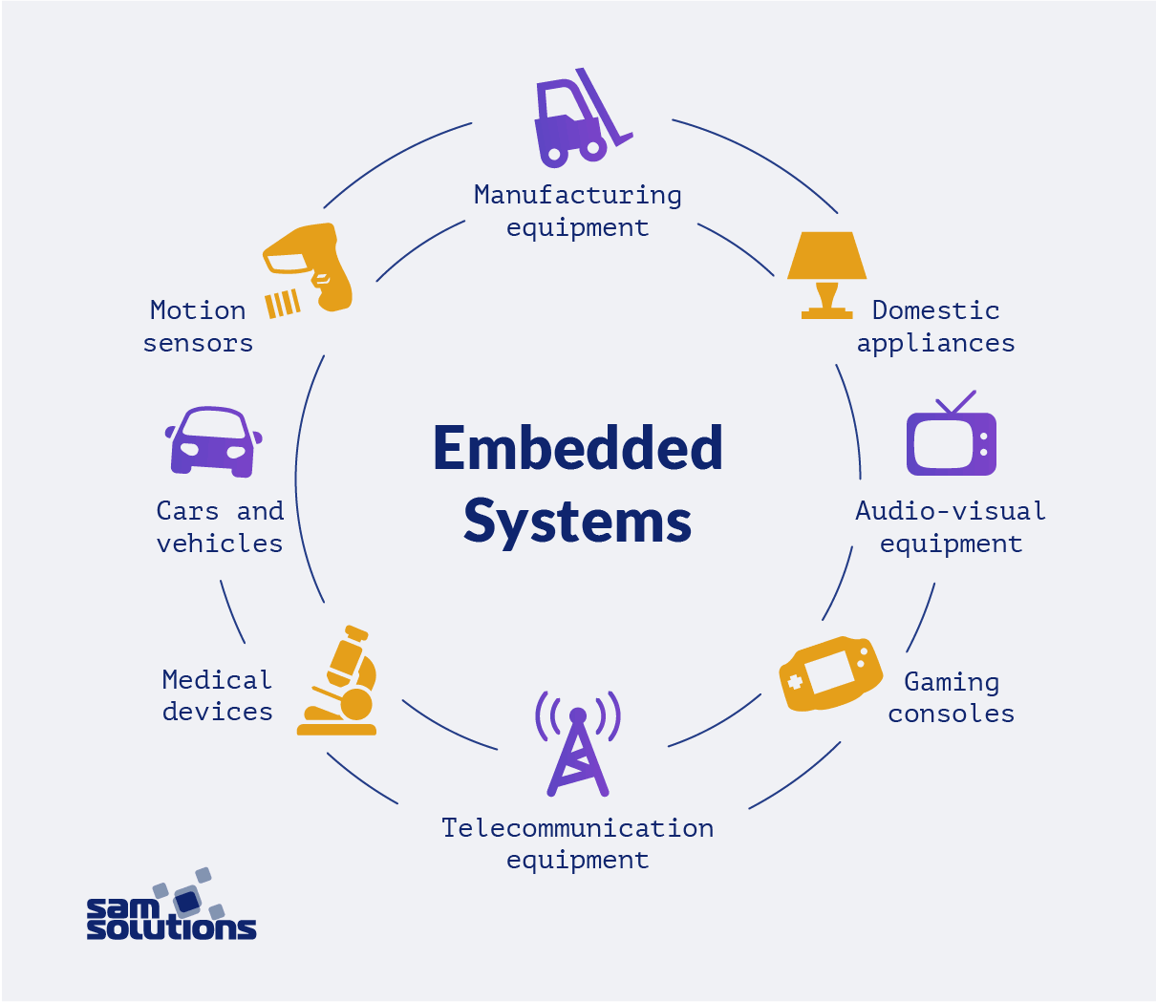

### Embedded system history

An embedded system is a combination of computer hardware and software designed for a specific function. Embedded systems may also function within a larger system. The systems can be programmable or have fixed functionality. Industrial machines, consumer electronics, agricultural and processing industry devices, automobiles, medical equipment, cameras, digital watches, household appliances, airplanes, vending machines, and toys, as well as mobile devices, are possible locations for an embedded system. Embedded systems date back to the 1960s. Charles Stark Draper developed an integrated circuit in 1961 to reduce the size and weight of the Apollo Guidance Computer, the digital system installed on the Apollo Command Module and Lunar Module. The first computer to use ICs, it helped astronauts collect real-time flight data. By the late 1960s and early 1970s, the price of integrated circuits dropped and usage surged. The first microcontroller was developed by Texas Instruments in 1971. The TMS1000 series, which became commercially available in 1974, contained a 4-bit processor, read-only memory (ROM), and random-access memory (RAM), and cost around $2 apiece in bulk orders. Also in 1971, Intel released what is widely recognized as the first commercially available processor, the 4004. The 4-bit microprocessor was designed for use in calculators and small electronics, though it required eternal memory and support chips. The 8-bit Intel 8008, released in 1972, had 16 KB of memory; the Intel 8080 followed in 1974 with 64 KB of memory. The 8080's successor, the x86 series, was released in 1978 and is still largely in use today in 1987, the first embedded operating system, the real-time VxWorks, was released by Wind River, followed by Microsoft's Windows Embedded CE in 1996. By the late 1990s, the first embedded Linux products began to appear. Today, Linux is used in almost all embedded devices. While some embedded systems can be relatively simple, they are becoming more complex, and more and more of them are now able to either supplant human decisionmaking or offer capabilities beyond what a human could provide. For instance, some aviation systems, including those used in drones, can integrate sensor data and act upon that information faster than a human could, permitting new kinds of operating features. The embedded system is expected to continue growing rapidly, driven in large part by the internet of things. Expanding IoT applications, such as wearables, drones, smart homes, smart buildings, video surveillance, 3D printers, and smart transportation, are expected to fuel embedded system growth. Embedded systems vary in complexity but, generally, consist of three main elements: • Hardware. The hardware of embedded systems is based around microprocessors and microcontrollers. Microprocessors are very similar to microcontrollers and, typically, refer to a CPU (central processing unit) that is integrated with other basic computing components such as memory chips and digital signal processors (DSPs). Microcontrollers have those components built into one chip. • Software and firmware. Software for embedded systems can vary in complexity. However, industrial-grade microcontrollers and embedded IoT systems usually run very simple software that requires little memory. • Real-time operating system. These are not always included in embedded systems, especially smaller-scale systems. RTOSes define how the system works by supervising the software and setting rules during program execution.

In terms of hardware, a basic embedded system would consist of the following elements: • Sensors convert physical sense data into an electrical signal. • Analog-to-digital (A-D) converters change an analog electrical signal into a digital one. • Processors process digital signals and store them in memory. • Digital-to-analog (D-A) converters change the digital data from the processor into analog data. • Actuators compare actual output to memory-stored output and choose the correct one. The sensor reads external inputs, the converters make that input readable to the processor, and the processor turns that information into useful output for the embedded system.

## Computer vision

Computer vision is a field of artificial intelligence (AI) that enables computers and systems to derive meaningful information from digital images, videos, and other visual inputs and take actions or make recommendations based on that information. If AI enables computers to think, computer vision enables them to see, observe, and understand. Computer vision works much the same as human vision, except humans have a head start. Human sight has the advantage of lifetimes of context to train how to tell objects apart, how far away they are, whether they are moving, and whether there is something wrong in an image.

Computer vision trains machines to perform these functions, but it has to do it in much less time with cameras, data, and algorithms rather than retinas, optic nerves, and the visual cortex. Because a system trained to inspect products or watch a production asset can analyse thousands of products or processes a minute, noticing imperceptible defects or issues, it can quickly surpass human capabilities. Computer vision is used in industries ranging from energy and utilities to manufacturing and automotive – and the market is continuing to grow. It is expected to continue the continuous growth of the field in the future.

### Object detection

Object detection is a computer technology related to computer vision and image processing that deals with detecting instances of semantic objects of a certain class (such as humans, buildings, or cars) in digital images and videos. Well-researched domains of object detection include face detection and pedestrian detection. Object detection has applications in many areas of computer vision, including image retrieval and video surveillance.

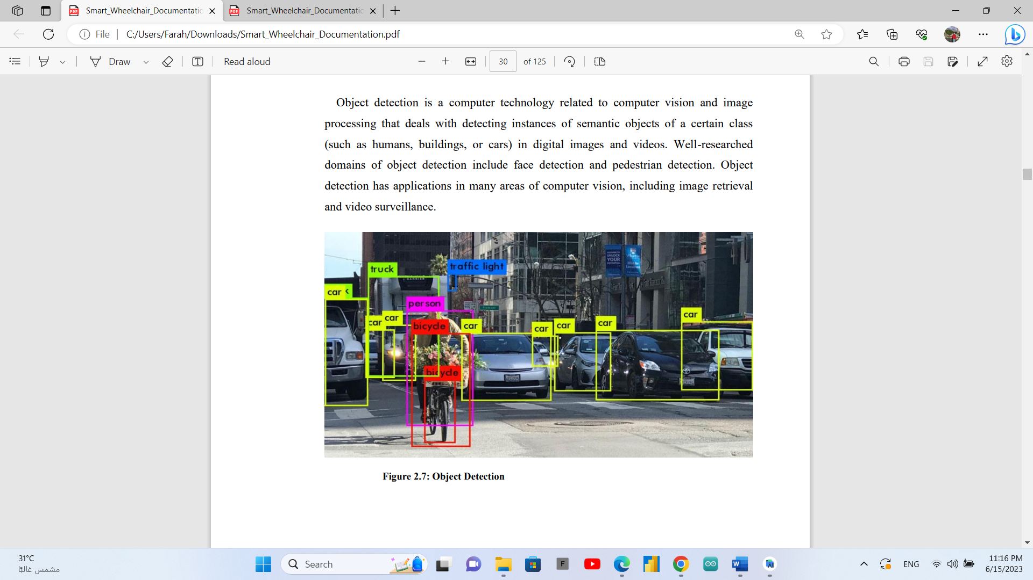

### Object detection Algorithms

1. YOLO (You Only Look Once)
2. Fast R-CNN
3. Faster R-CNN
4. Region-based Convolutional Neural Networks (R-CNN)
5. Region-based Fully Convolutional Network (R-FCN)
6. Single Shot Detector (SSD)
7. Spatial Pyramid Pooling (SPP-net)
8. Histogram of Oriented Gradients (HOG)

# Chapter Two: Analysis and design

## introduction

System analysis and design is a process that we use in our project to evaluate particular business situations and develop ways to improve them through more optimal methods. We may use this process to reshape our organization. System analysis and design also typically emphasize how systems act, their relationships to other subsystems and the ability of both to meet a specific goal. This often involves analysing a system's performance and the quality of its output.

System analysis refers to the process of gathering data, interpreting information, identifying issues and using the results to recommend or develop possible system improvements. During this stage, we may also evaluate future business needs and how improvements may answer them. System design involves the process in which an organization, in an appropriate situation, develops a newer system or strategy to complement or replace an existing one. This design and development cycle includes planning, analysis, design, implementation and maintenance.

## User and system requirements

The project will provide data about the places that rover will explore. User requirements are all possible objects that can be detected by the rover

Data and measurement about the place environment such as: Temperature, Humility, Ground level. Collect this data by DHT11 and GY-521 sensors. Then send all data to raspberry pi to save it in the data base then print a report for all this data

The rover can auto driving, where it can be in dangerous places, the project provide auto driving by using object detection and ultrasonic

### Functional requirements

1. Object detection
2. Auto driving
3. Measuring
4. Temperature
5. Humidity
6. Distance
7. Balancing
8. Walk through maze
9. Collection measurements in database

### Non-functional requirements

1. Security :
   1. By using wired connection
2. Usefulness
   1. Can use in different fields and make real help
3. Useable
   1. Easy to use by GUI
4. Reliability

## Stakeholders

Project Stakeholders include any individual, group, or organization who may affect, be affected by, or perceive itself to be affected by a decision, activity, or outcome of a project. The diagram below shows examples of individuals or groups that can be project stakeholders.

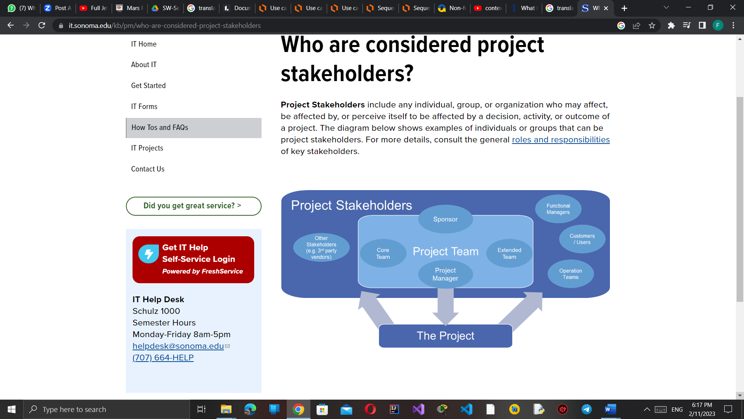

**Figure 2.3‑1: Project stakeholders**

Our project stakeholders are:

1. We considered the core team of the project
2. Project manager (the team leader)
3. Companies that will fund us (sponsor)
4. Operational teams
5. The users of our project who are the geologists, Archaeologists, palaeontologists, Agricultural engineers, petroleum engineers, space agencies, users that need the rover in their building to detect objects and measure the temperature in it, and many other users.

## System design

Systems design is the process of defining elements of a system like modules, architecture, components and their interfaces and data for a system based on the specified requirements. It is the process of defining, developing, and designing systems which satisfies the specific needs and requirements of a business or organization.

A designer uses the modelling languages to express the information and knowledge in a structure of system that is defined by a consistent set of rules and definitions. The designs can be defined in graphical or textual modelling languages.

We used the Unified Modelling Language (UML) To describe software both structurally and behaviourally with graphical notation.

### Block diagram

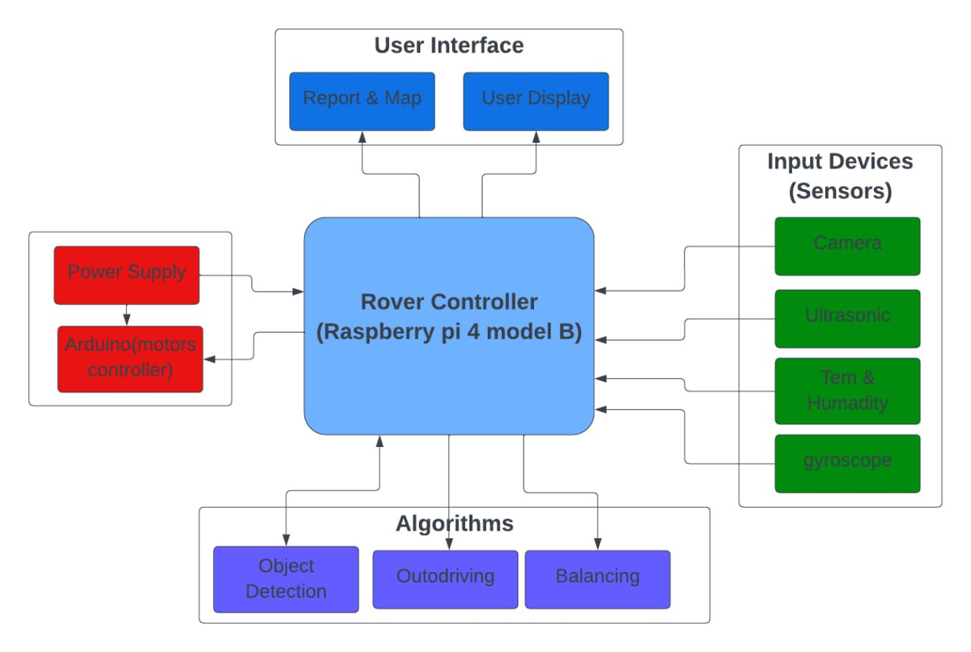

**Figure 2.4.1‑1: Block diagram**

### Use cases

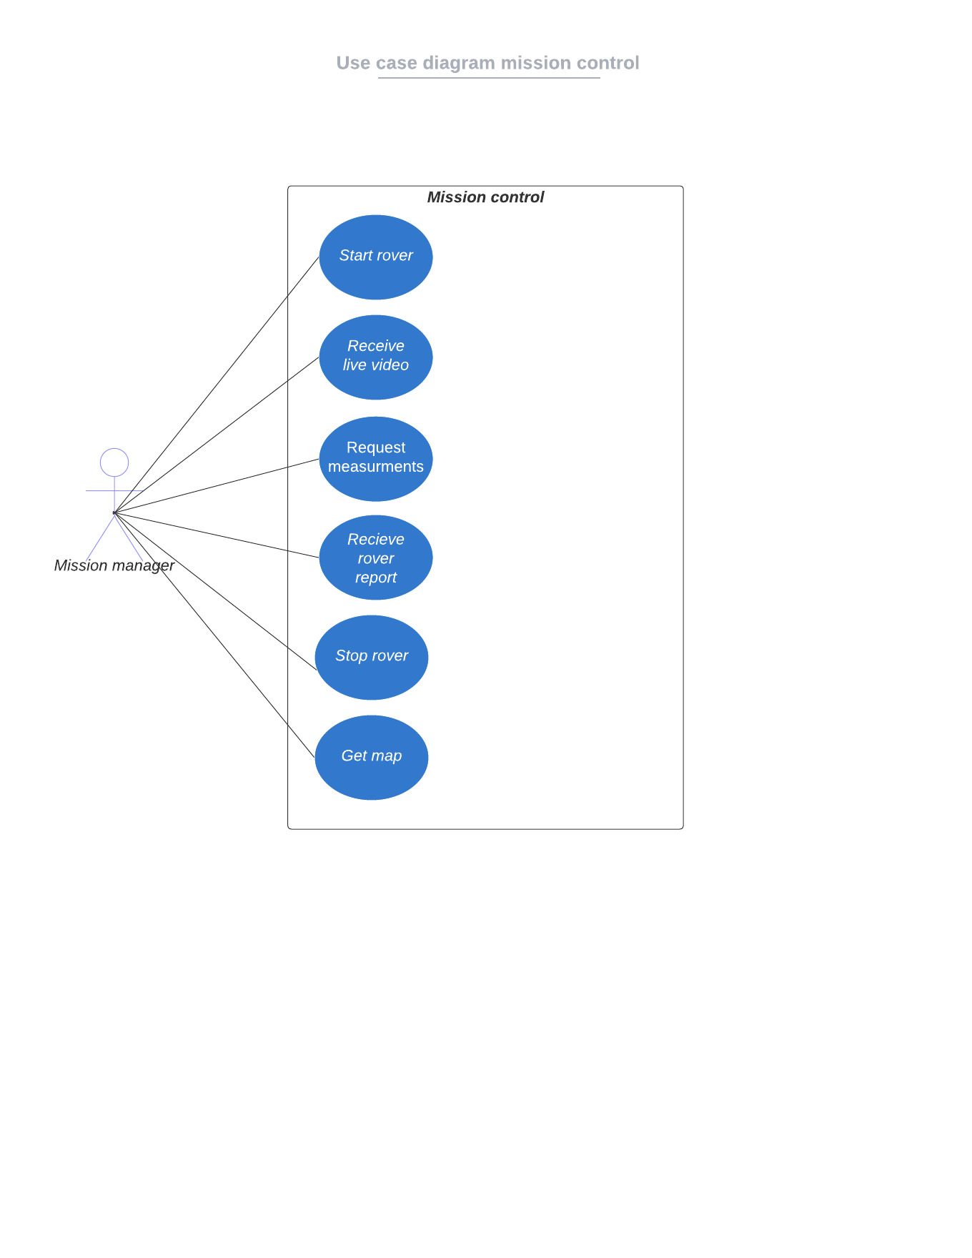

**Figure 2.4.2‑1: Use case (mission control)**

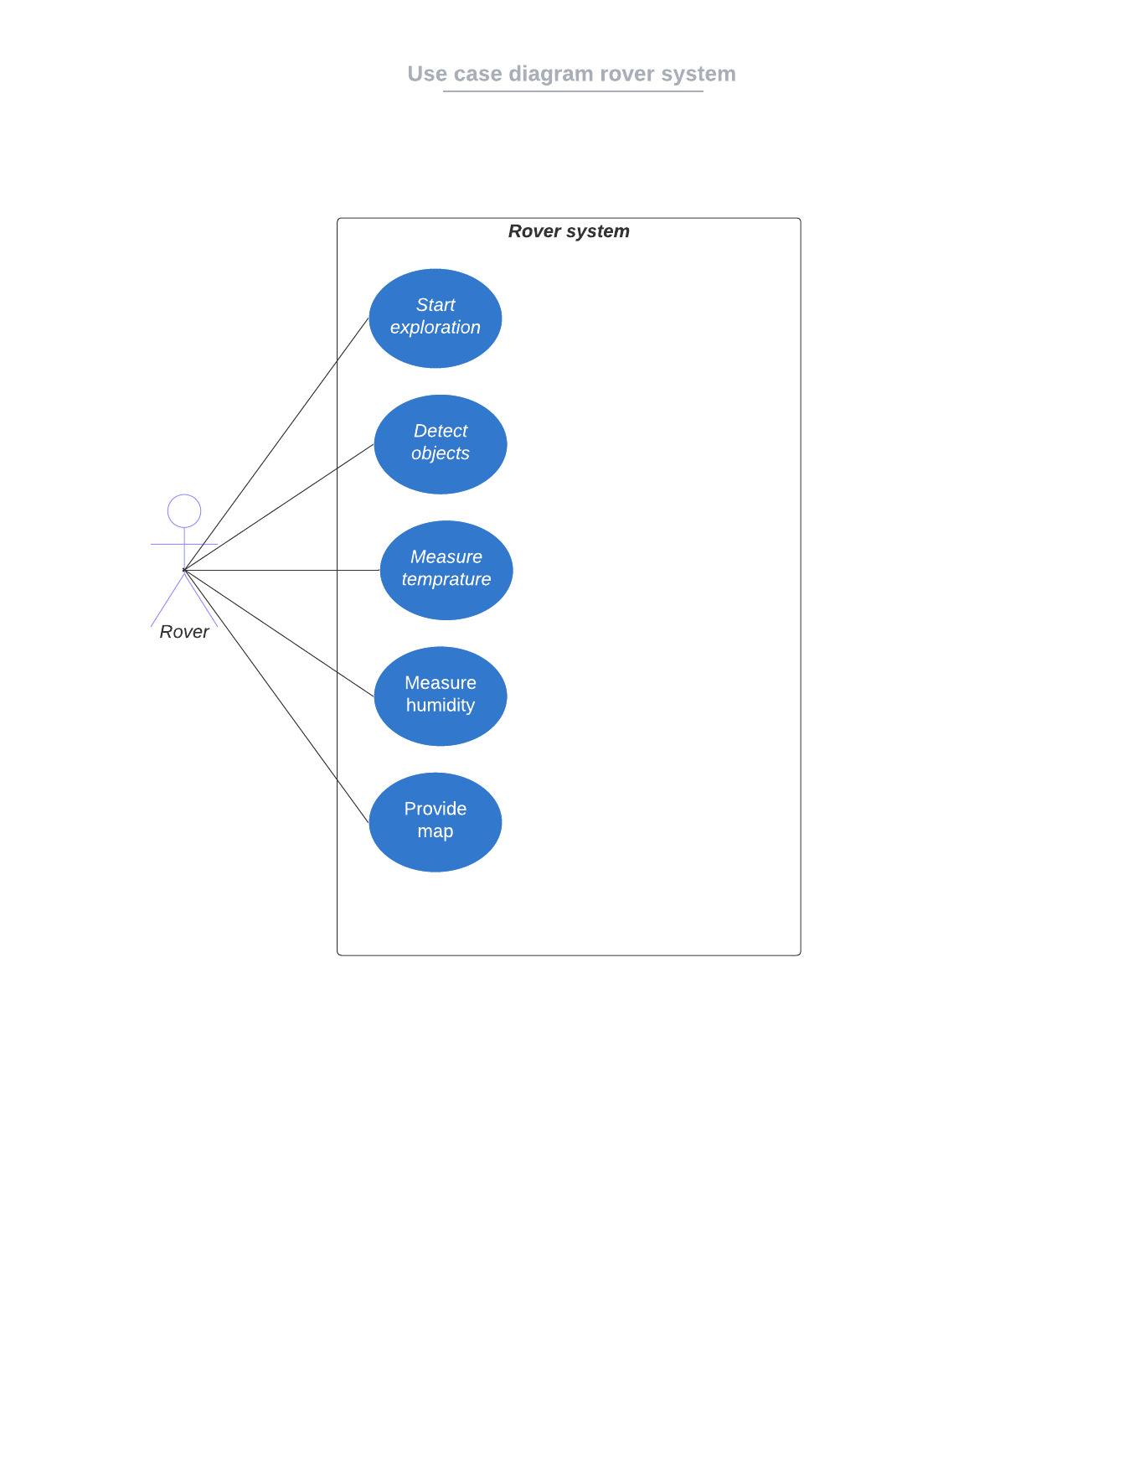

**Figure 2.4.2‑2: Use case (Rover system)**

### Class diagram

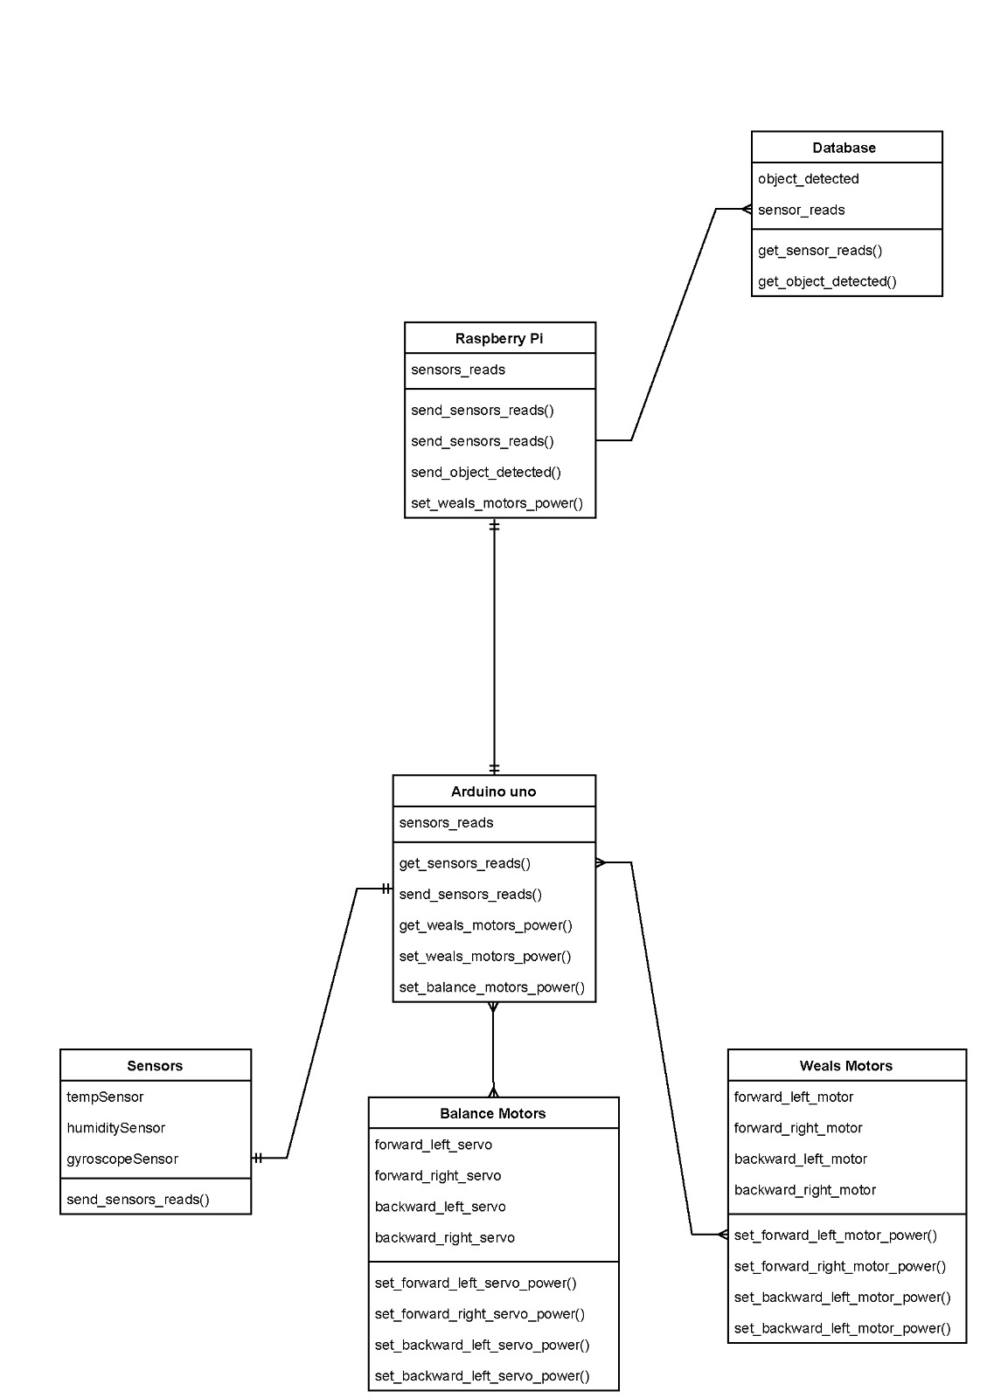**Figure 2.4.3‑1: Class diagram**

### Sequence diagrams

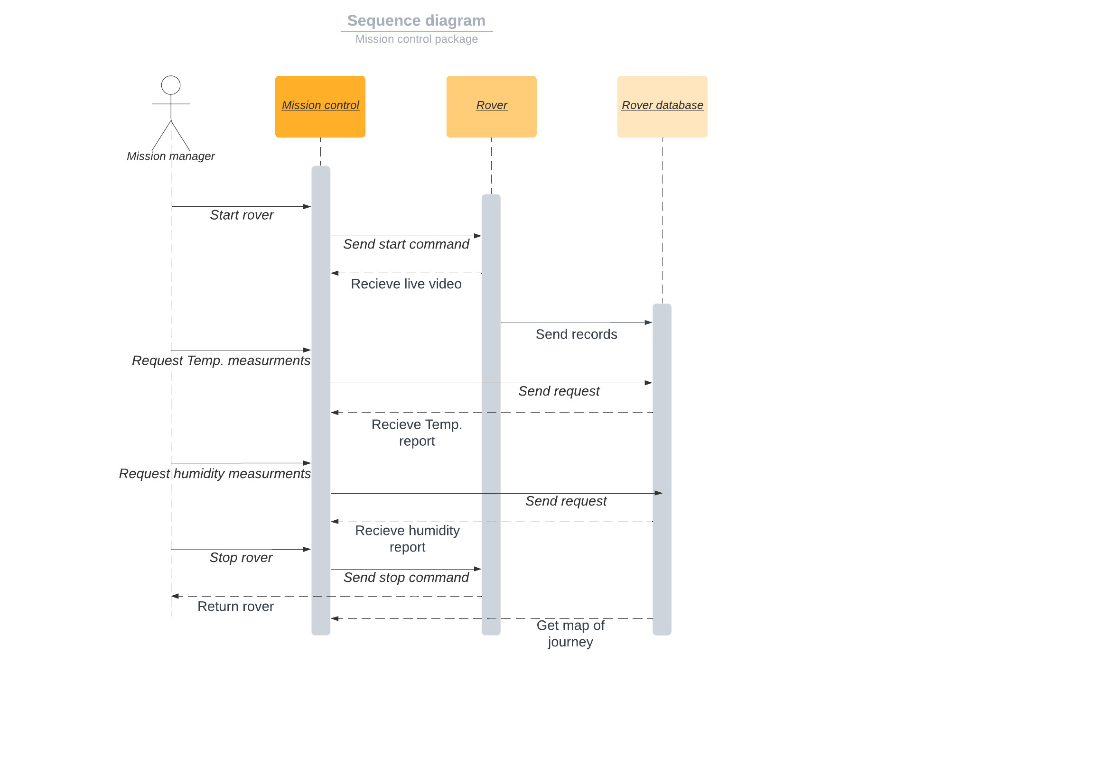

**Figure 2.4.4‑1: Sequence diagram (mission control)**

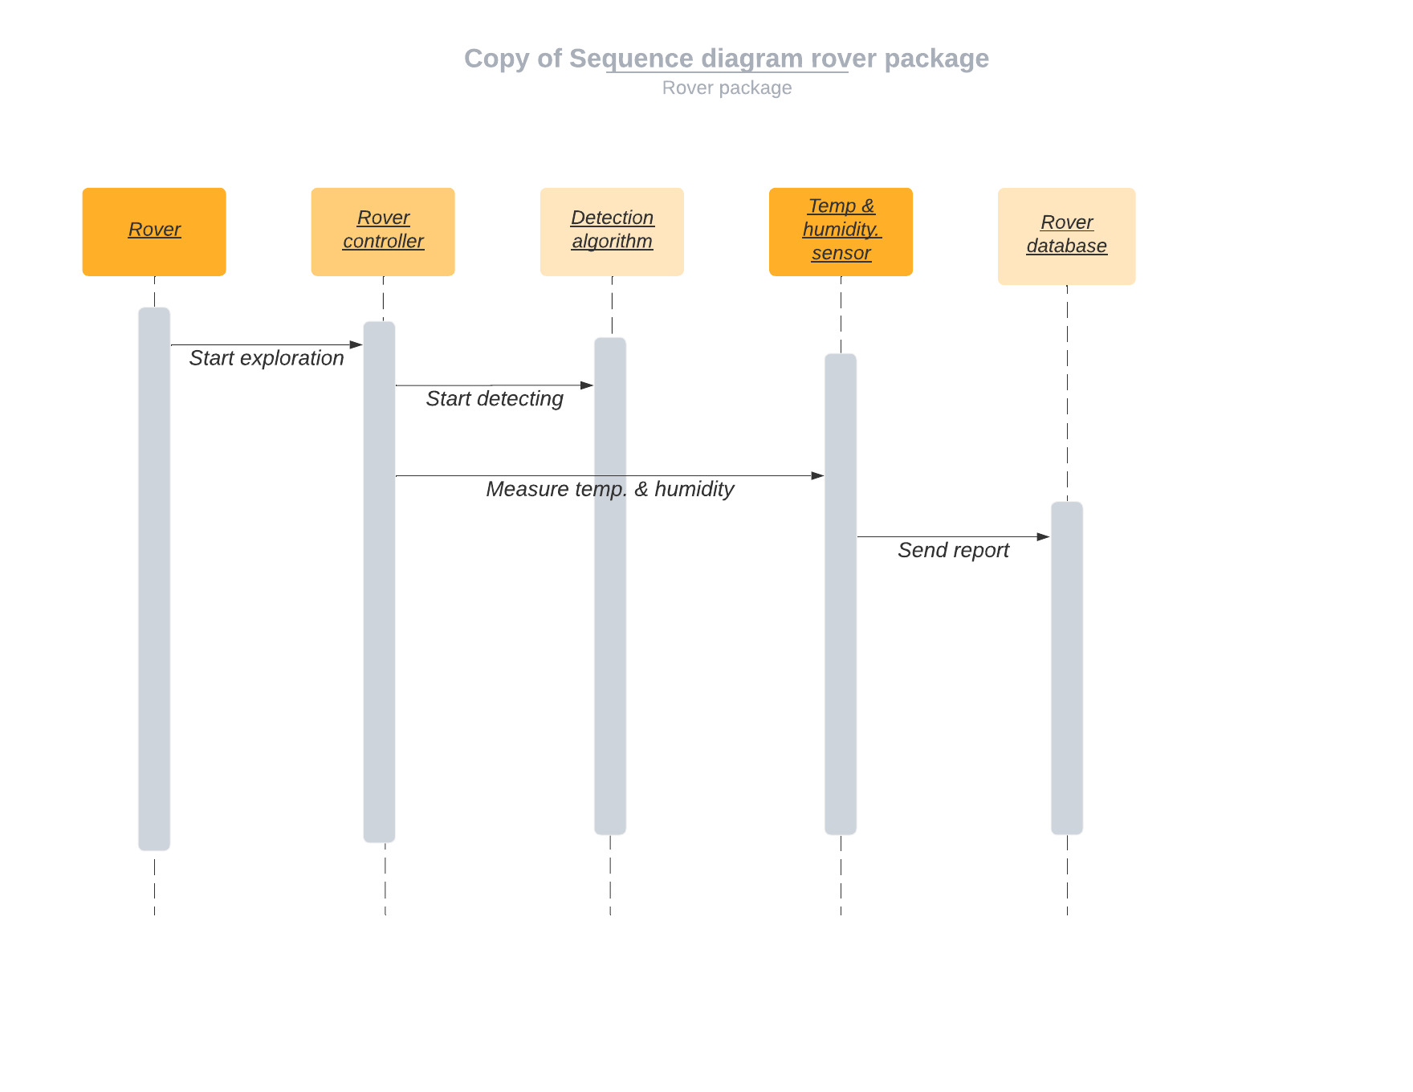**Figure 2.4.4‑2: Sequence diagram (Rover system)**

### Database design

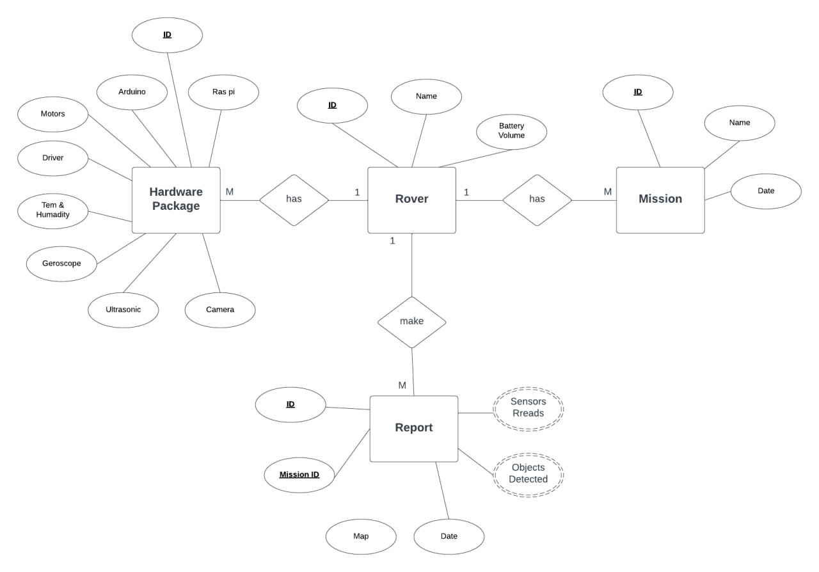

**Figure 2.4.5‑1: ER Diagram**

## Used technologies and tools

**Used technologies:**

1. Yolo version 5
2. Flutter
3. PyTorch
4. Open-CV
5. Raspberry pi OS
6. Arduino IDE
7. Firebase

**Used tools:**

1. Raspberry pi 4 model B 8 GB ram
2. Arduino uno
3. DC motors
4. Wheals and car kit
5. Ultrasonic sensors Module HC-SR04
6. Temperature and humidity sensors (DHT11)
7. Gyroscope MPU6050
8. Arduino motor driver (L293)
9. Raspberry pi camera

### YOLO version 5

YOLOv5 was released by Glenn Jocher on June9, 2020. It follows the recent releases of YOLOv4 (April 23, 2020). YOLOv5 is smaller and generally easier to use in production. Given it is natively implemented in PyTorch (rather than Darknet), modifying the architecture and exporting to many deploy environments is straightforward. YOLOv5s is about 88% smaller than big-YOLOv4 (27MBvs244 MB)

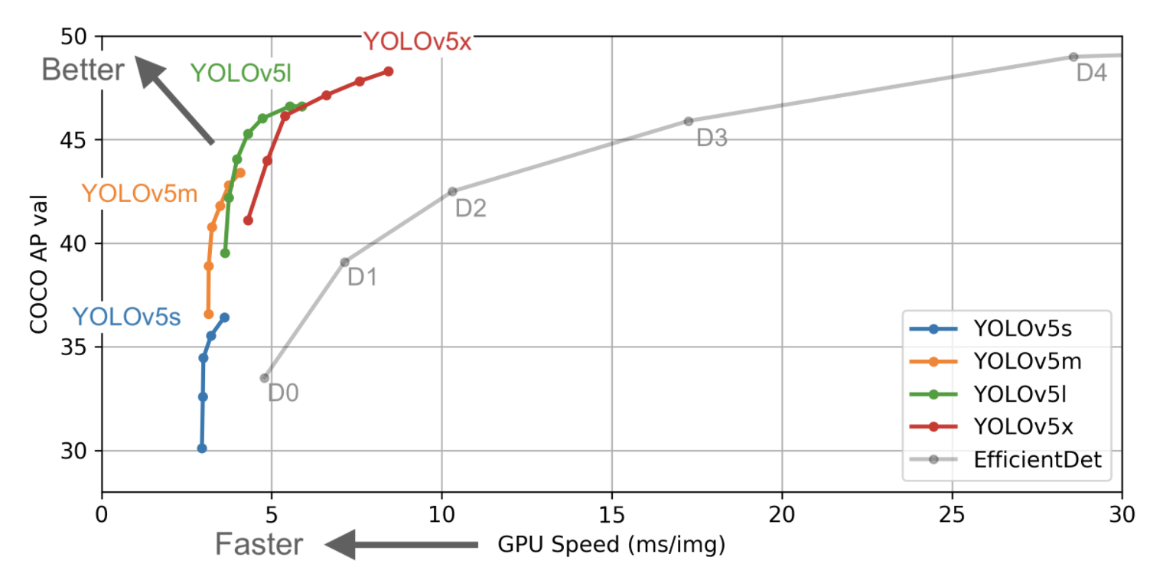

### Flutter

Flutter is one of the best solutions to develop apps for Android and iOS without having to write a different codebase for each platform. The smartphone versions of these apps function as true native apps on Apple and Android devices and are compiled for the respective platform before publication. The Flutter SDK is based on the Dart programming language, also developed by Google. It intends to supplant classic JavaScript.



### Pytorch

PyTorch is a [machine learning](https://en.wikipedia.org/wiki/Machine_learning) [framework](https://en.wikipedia.org/wiki/Software_framework) based on the [Torch](https://en.wikipedia.org/wiki/Torch_(machine_learning)) library, used for applications such as [computer vision](https://en.wikipedia.org/wiki/Computer_vision) and [natural language processing](https://en.wikipedia.org/wiki/Natural_language_processing), originally developed by [Meta AI](https://en.wikipedia.org/wiki/Meta_AI) and now part of the [Linux Foundation](https://en.wikipedia.org/wiki/Linux_Foundation) umbrella. It is [free and open-source software](https://en.wikipedia.org/wiki/Free_and_open-source_software) released under the [modified BSD license](https://en.wikipedia.org/wiki/Modified_BSD_license). Although the [Python](https://en.wikipedia.org/wiki/Python_(programming_language)) interface is more polished and the primary focus of development, PyTorch also has a [C++](https://en.wikipedia.org/wiki/C%2B%2B) interface.

A number of pieces of [deep learning](https://en.wikipedia.org/wiki/Deep_learning) software are built on top of PyTorch,

including [Tesla Autopilot](https://en.wikipedia.org/wiki/Tesla_Autopilot), [Uber](https://en.wikipedia.org/wiki/Uber)'s Pyro, Hugging Face's Transformers, [PyTorch Lightning](https://en.wikipedia.org/wiki/PyTorch_Lightning" \o "PyTorch Lightning), and Catalyst.

PyTorch provides two high-level features:

* Tensor computing (like [NumPy](https://en.wikipedia.org/wiki/NumPy)) with strong acceleration via [graphics processing units](https://en.wikipedia.org/wiki/Graphics_processing_unit) (GPU).
* [Deep neural networks](https://en.wikipedia.org/wiki/Deep_neural_networks) built on a tape-based [automatic differentiation](https://en.wikipedia.org/wiki/Automatic_differentiation) system.

### Open-CV

OpenCV (Open Source Computer Vision Library) is an open source computer vision and machine learning software library. OpenCV was built to provide a common infrastructure for computer vision applications and to accelerate the use of machine perception in the commercial products.

### Raspberry pi OS

Raspberry Pi OS (formerly Raspbian) is a free operating system based on Debian GNU/Linux and optimised for the Raspberry Pi hardware (the armhf processor architecture). Raspberry Pi OS comes with over 35,000 packages, or pre-compiled software bundled in a nice format for easy installation on a Raspberry Pi. The initial build was completed in June of 2012, but the distribution continues to be active developed with an emphasis on improving the stability and performance of as many Debian packages as possible. Although Debian produces a distribution for the arm architecture, it is compatible only with versions later than the one used on the Raspberry Pi (ARMv7-A CPUs and higher vs the Raspberry Pi's ARMv6 CPU).

### Arduino IDE

Arduino IDE is an open-source software, designed by Arduino.cc and mainly used for writing, compiling & uploading code to almost all Arduino Modules.

It is an official Arduino software, making code compilation too easy that even a common person with no prior technical knowledge can get their feet wet with the learning process.

### Firebase

Firebase is a Backend-as-a-Service (BaaS) app development platform that provides hosted backend services such as a realtime database, cloud storage, authentication, crash reporting, machine learning, remote configuration, and hosting for your static files.

### Raspberry pi 4 model B 8 GB ram

The Raspberry Pi 4 Model B was released in June 2019 with a 1.5 GHz 64-bit quad core [ARM Cortex-A72](https://en.wikipedia.org/wiki/ARM_Cortex-A72) processor, on-board 802.11ac [Wi-Fi](https://en.wikipedia.org/wiki/Wi-Fi), [Bluetooth 5](https://en.wikipedia.org/wiki/Bluetooth_5), full [gigabit Ethernet](https://en.wikipedia.org/wiki/Gigabit_Ethernet) (throughput not limited), two [USB 2.0](https://en.wikipedia.org/wiki/USB_2.0) ports, two [USB 3.0](https://en.wikipedia.org/wiki/USB_3.0) ports, 1–8 GB of RAM, and dual-monitor support via a pair of micro HDMI ([HDMI Type D](https://en.wikipedia.org/wiki/Mini-HDMI)) ports for up to [4K resolution](https://en.wikipedia.org/wiki/4K_resolution). The version with 1 GB RAM has been abandoned and the prices of the 2 GB version have been reduced. The 8 GB version has a revised circuit board. The Pi 4 is also powered via a [USB-C](https://en.wikipedia.org/wiki/USB-C) port, enabling additional power to be provided to downstream peripherals, when used with an appropriate PSU. But the Pi can only be operated with 5 volts and not 9 or 12 volts like other mini computers of this class. The initial Raspberry Pi 4 board has a design flaw where third-party [e-marked](https://en.wikipedia.org/wiki/USB-C#Cables) USB cables, such as those used on Apple MacBooks, incorrectly identify it and refuse to provide power. [Tom's Hardware](https://en.wikipedia.org/wiki/Tom%27s_Hardware) tested 14 different cables and found that 11 of them turned on and powered the Pi without issue. The design flaw was fixed in revision 1.2 of the board, released in late 2019. In mid-2021, Pi 4 B models appeared with the improved Broadcom BCM2711C0.

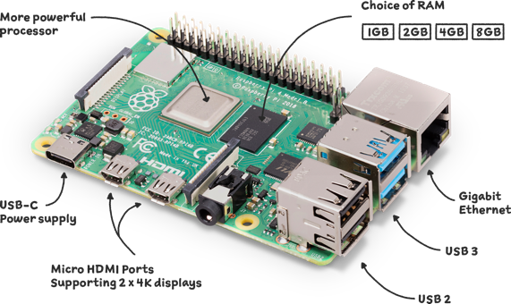

### Arduino Uno

The Arduino Uno is an open-source microcontroller board based on the Microchip ATmega328P microcontroller (MCU) and developed by Arduino.cc and initially released in 2010.The board is equipped with sets of digital and analog input/output (I/O) pins that may be interfaced to various expansion boards (shields) and other circuits. The board has 14 digital I/O pins (six capable of PWM output), 6 analog I/O pins, and is programmable with the Arduino IDE (Integrated Development Environment), via a type B USB cable. It can be powered by a USB cable or a barrel connector that accepts voltages between 7 and 20 volts, such as a rectangular 9-volt battery. It has the same microcontroller as the Arduino Nano board, and the same headers as the Leonardo board. The hardware reference design is distributed under a Creative Commons Attribution Share-Alike 2.5 license and is available on the Arduino website. Layout and production files for some versions of the hardware are also available.

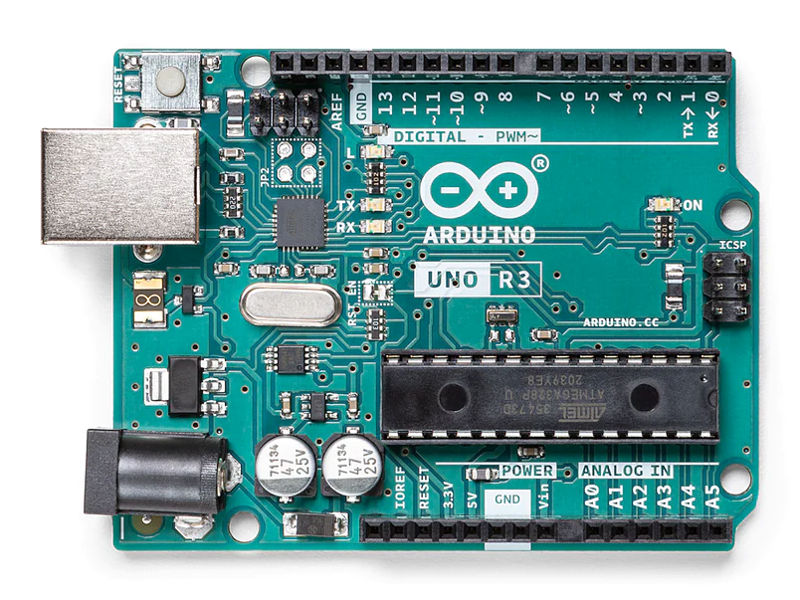

### DC motors

A DC motor is an electrical machine that converts electrical energy into mechanical energy. A direct current, or DC, motor is the most common type of motor. DC motors normally have just two leads, one positive and one negative. To control the direction of the spin of DC motor, without changing the way that the leads are connected, you can use a circuit called an H-Bridge. An H bridge is an electronic circuit that can drive the motor in both directions. H-bridges are used in many different applications, one of the most common being to control motors in robots. And that‘s what we used electric motors are broadly classified into two categories AC Motors and DC Motors. We used the simple DC motors because we didn't need more power to move the car as it's just a module and to save cost.

### Wheals and car kit

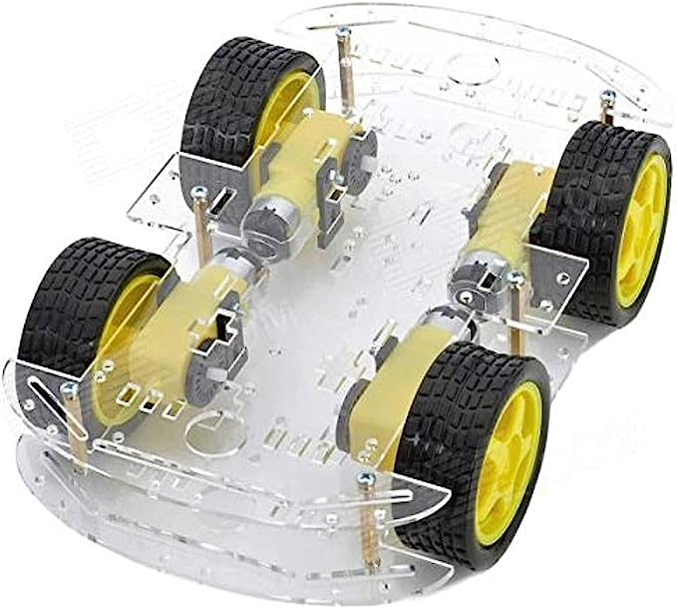

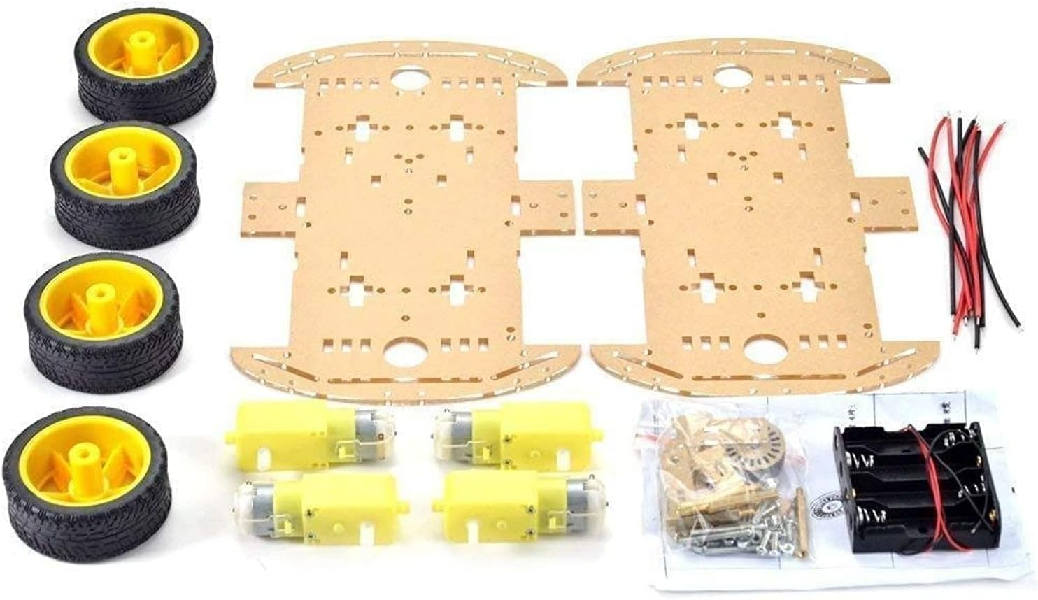

### Ultrasonic Sensor Module HC-SR04

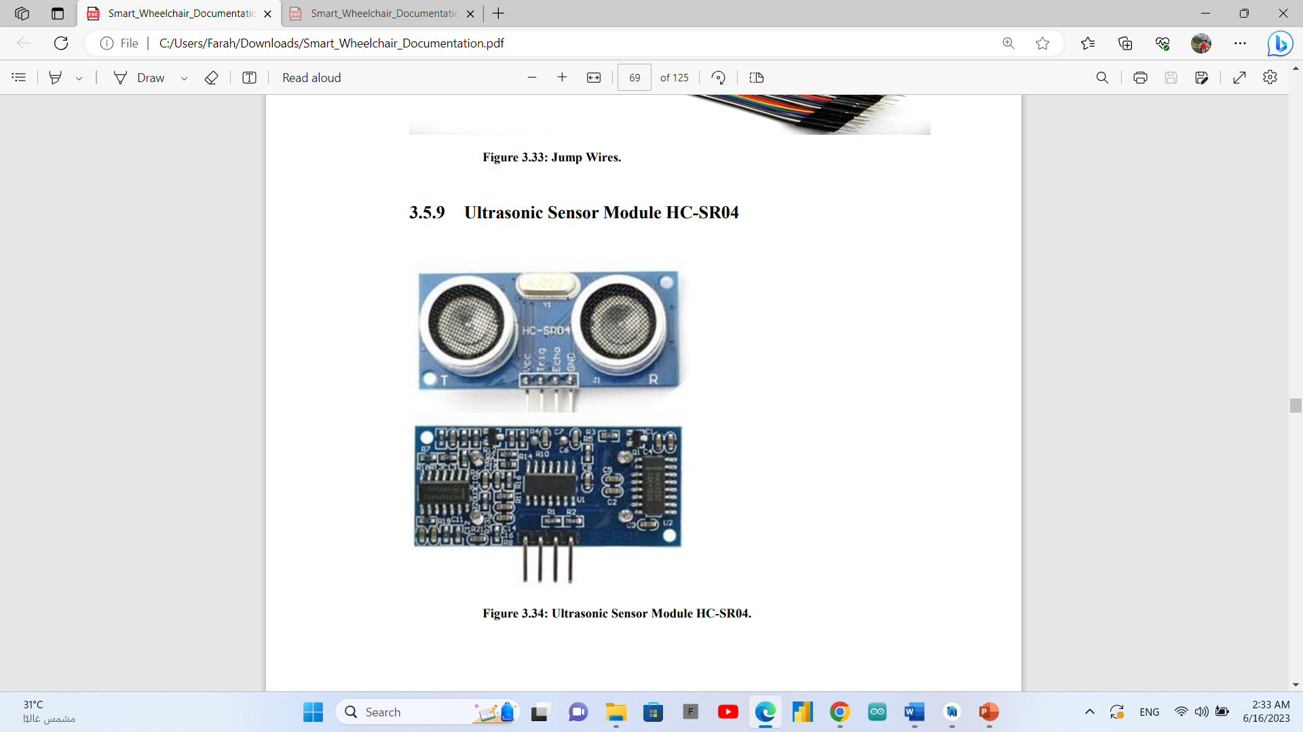

An ultrasonic sensor is an electronic device that measures the distance of a target object by emitting ultrasonic sound waves, and converts the reflected sound into an electrical signal. Ultrasonic waves travel faster than the speed of audible sound. Ultrasonic sensors have two main components: the transmitter (which emits the sound using piezoelectric crystals) and the receiver (which encounters the sound after it has travelled to and from the target). Use a single transducer to send a pulse and to receive the echo. The sensor determines the distance to a target by measuring time lapses between the sending and receiving of the ultrasonic pulse

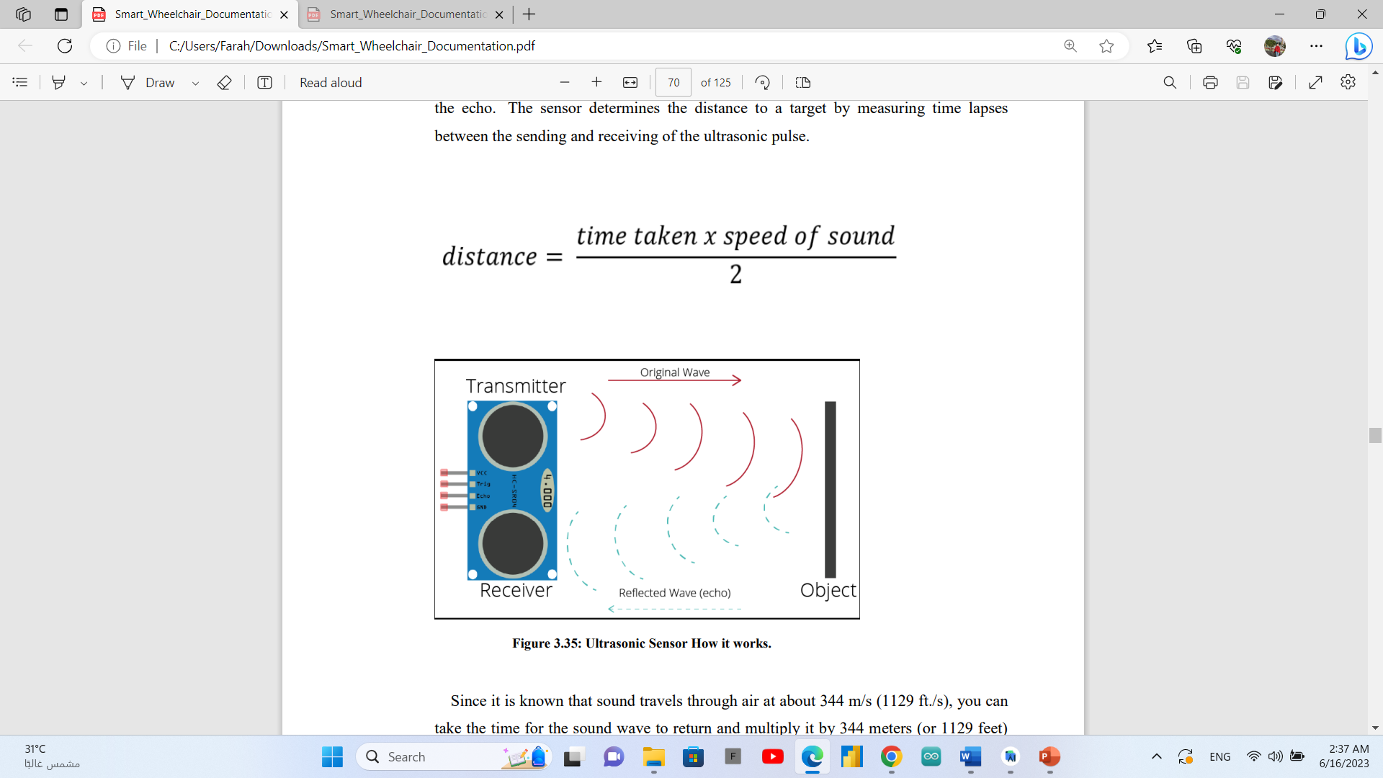

Since it is known that sound travels through air at about 344 m/s (1129 ft./s), you can take the time for the sound wave to return and multiply it by 344 meters (or 1129 feet) to find the total round-trip distance of the sound wave. Round-trip means that the sound wave traveled 2 times the distance to the object before it was detected by the sensor; it includes the 'trip' from the sonar sensor to the object AND the 'trip' from the object to the Ultrasonic sensor (after the sound wave bounced off the object). To find the distance to the object, simply divide the round-trip distance in half.

### Temperature and humidity sensors (DHT11)

DHT11 module is a Temperature and humidity sensing module, which uses Digital Signal Acquisition, which converts the Temperature and Humidity to a digital Reading, which can be easily read by a Microcontroller. Operating range of DHT11 is 0 to 50 degree Celsius which is quite sufficient for Home or Hobby purposes. And as we can guess by its cost and nature of use, this sensor module is not exactly accurate, but it works just fine for few simple Arduino projects. it works on Negative Temperature Coefficient, so it will basically change its resistance depending on the temperature.

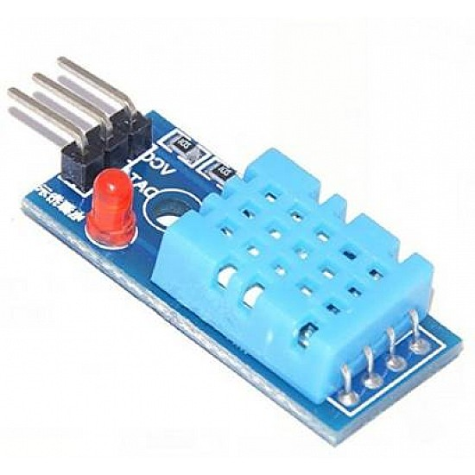

### Gyroscope MPU6050

Gyroscopes measure angular rotation. To accomplish this, they measure the force generated by the Coriolis Effect.

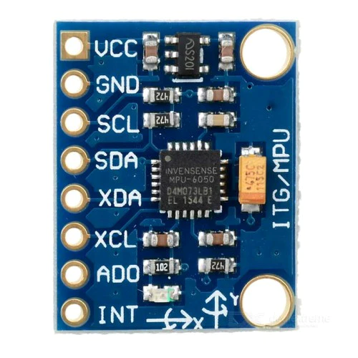

The Coriolis Effect states that when a mass (m) moves in a specific direction with a velocity (v) and an external angular rate (Ω) is applied (Red arrow), the Coriolis Effect generates a force (Yellow arrow) that causes the mass to move perpendicularly. The value of this displacement is directly related to the angular rate applied.

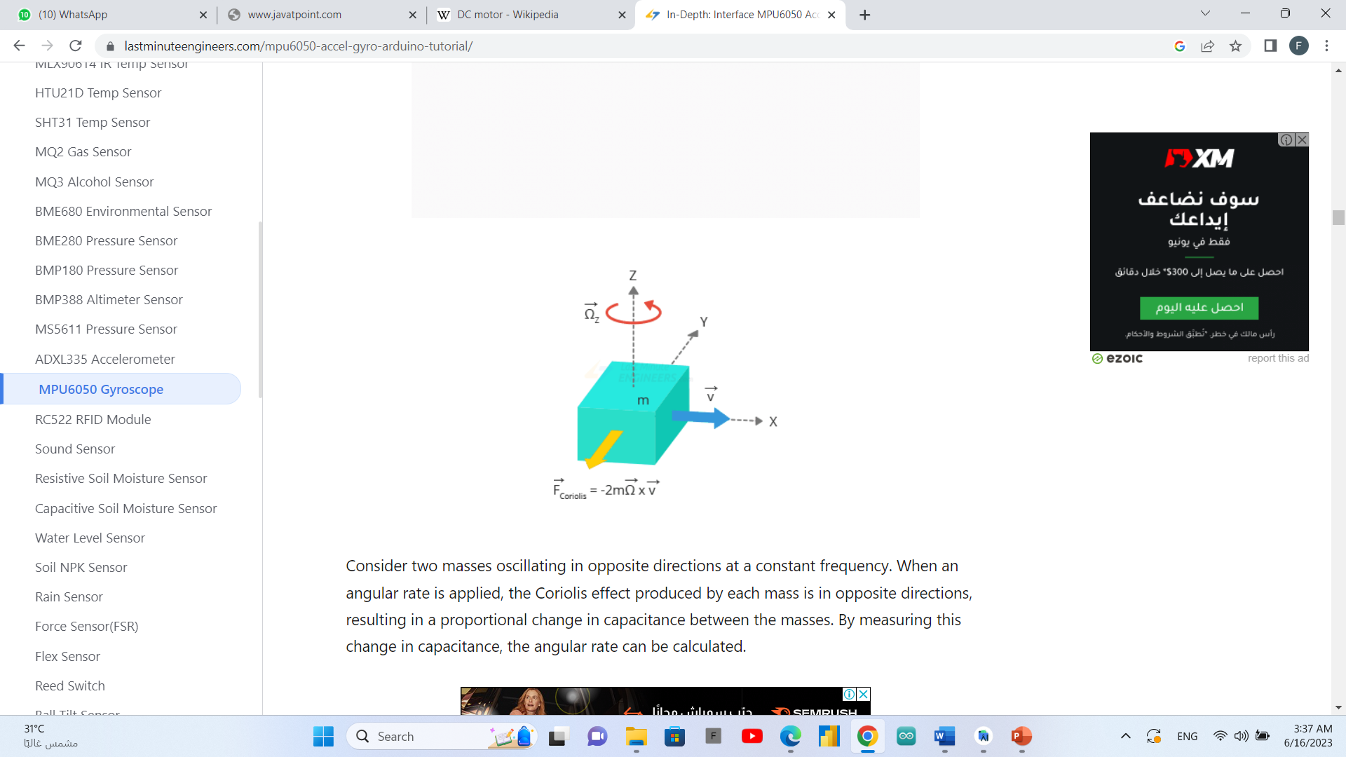

At the core of the module is a low-power, low-cost 6-axis MotionTracking chip – MPU6050 – that integrates a 3-axis gyroscope, 3-axis accelerometer, and a Digital Motion Processor (DMP) into a tiny 4mm x 4mm package.

It can measure angular momentum or rotation along all three axes, static acceleration caused by gravity, and dynamic acceleration caused by motion, shock, or vibration.

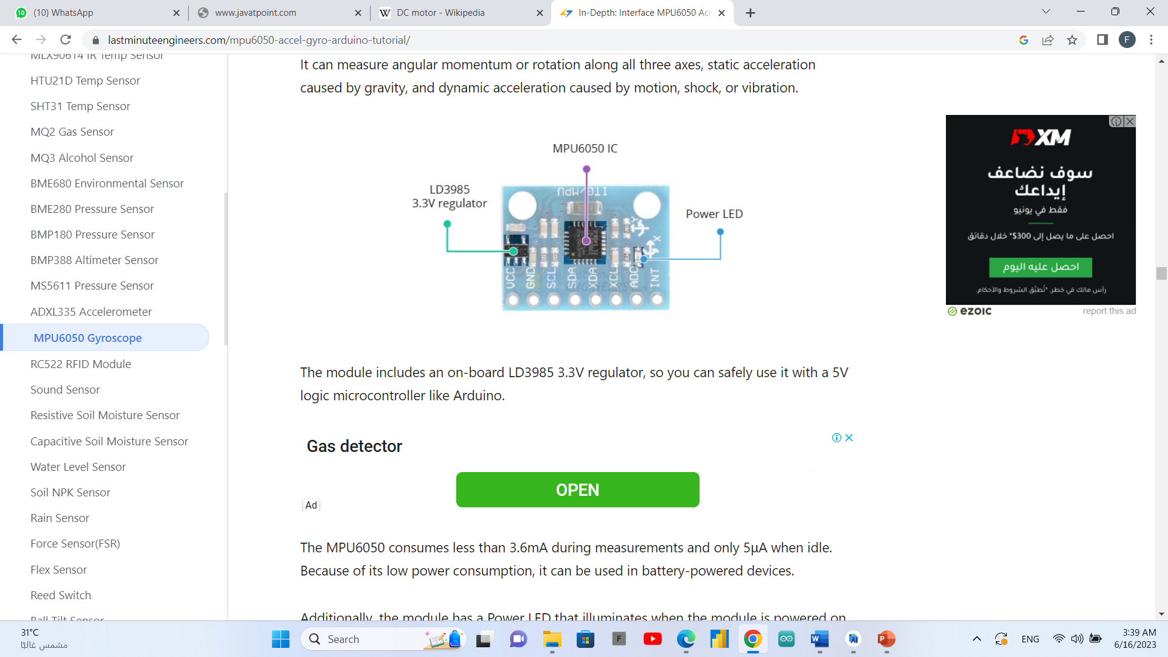

The module includes an on-board LD3985 3.3V regulator, so you can safely use it with a 5V logic microcontroller like Arduino.

### Arduino motor driver (L293)

The L293D is a 16-pin Motor Driver IC which can control a set of two DC motors simultaneously in any direction. The L293D is designed to provide bidirectional drive currents of up to 600 mA (per channel) at voltages from 4.5 V to 36 V (at pin 8!). You can use it to control small dc motors - toy motors. Sometimes it can be extremely hot.

### Raspberry pi camera

The Raspberry Pi camera module can be used to take high-definition video, as well as stills photographs. That the module has a five mega pixel fixed-focus camera that supports 1080p30, 720p60 and VGA90 video modes, as well as stills capture. It attaches via a 15cm ribbon cable to the CSI port on the Raspberry Pi. It can be accessed through the MMAL and V4L APIs, and there are numerous third-party libraries built for it, including the Picamera Python library. The camera module is very popular in-home security applications, and in wildlife camera traps. You can also use it to take snapshots.

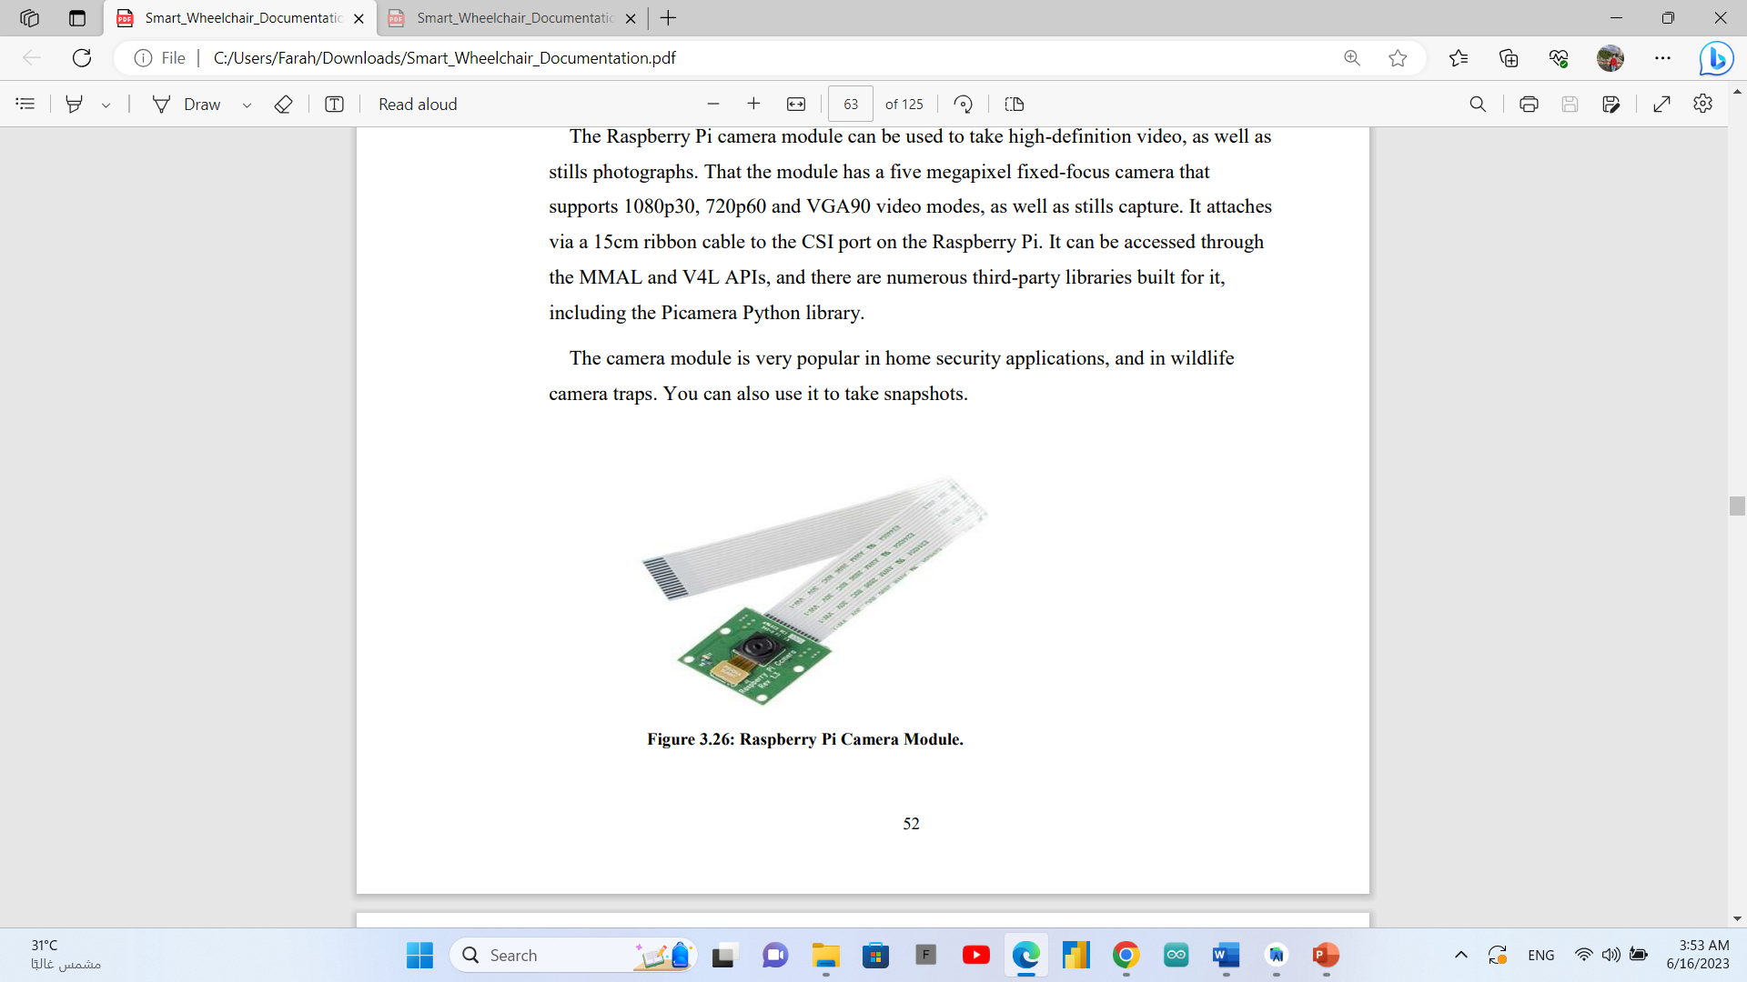

The camera consists of a small (25mm by 20mm by 9mm) circuit board, which connects to the Raspberry Pi's Camera Serial Interface (CSI) bus connector via a flexible ribbon cable. The camera's image sensor has a native resolution of five megapixels and has a fixed focus lens. The software for the camera supports full resolution still images up to 2592x1944 and video resolutions of 1080p30, 720p60 and 640x480p60/90.

We used raspberry pi camera in our project to make live object detection model.

# Chapter Three: Deliverable and evaluation

## Introduction

First, we designed our rover and control its movement with Arduino uno, we used yolo v5 model and its trained dataset for object detection to make rover able to detect obstacles and avoid them on road and on unknown environments to it.

Rover able to move by motors and sensors programmed by Arduino, we use ultrasonic sensor for measuring distances, gyroscope sensor for balancing the rover, and DHT 11 sensor for measuring temperature and humidity.

We create a database for each mission with its ID, records of temperature, humidity, distances are gathered from the mission to get the map and send these records for the user.

The project provides the expected output with some limitation in time of response where the model work on 4 frames in sec.; it is slow response.

## User manual

**Application design**

The user can control the rover using our application " Rover Altaif ".

After opening the application a splash screen appears which shows our special icon for

" Rover Altaif ".



After that when user opens the application for the first time, onboarding screens appeared. Onboarding screen typically consist of quick walkthroughs, tooltips, or other UI elements and end with the user taking key steps in the application.

First screen is a welcome screen:

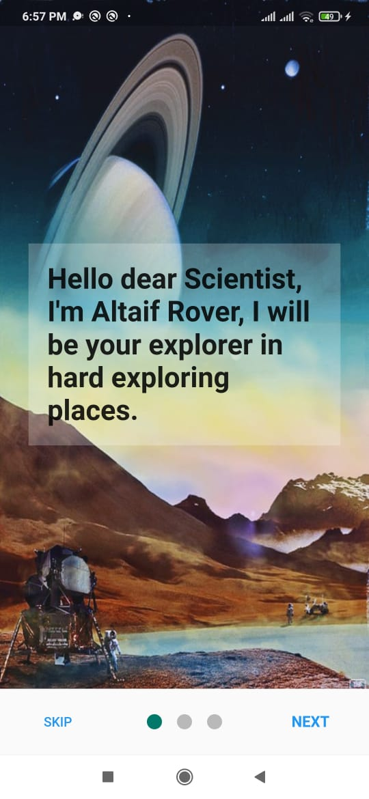

Second and third screens are about the application’s topic.

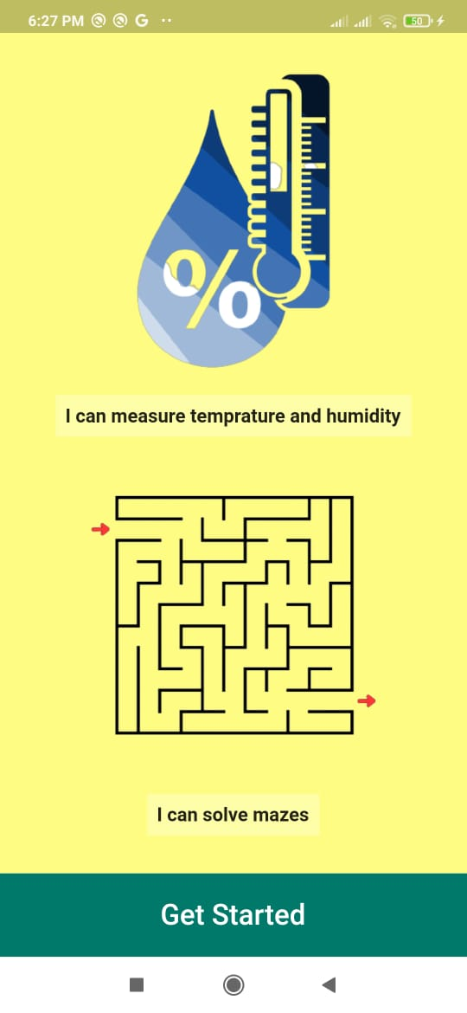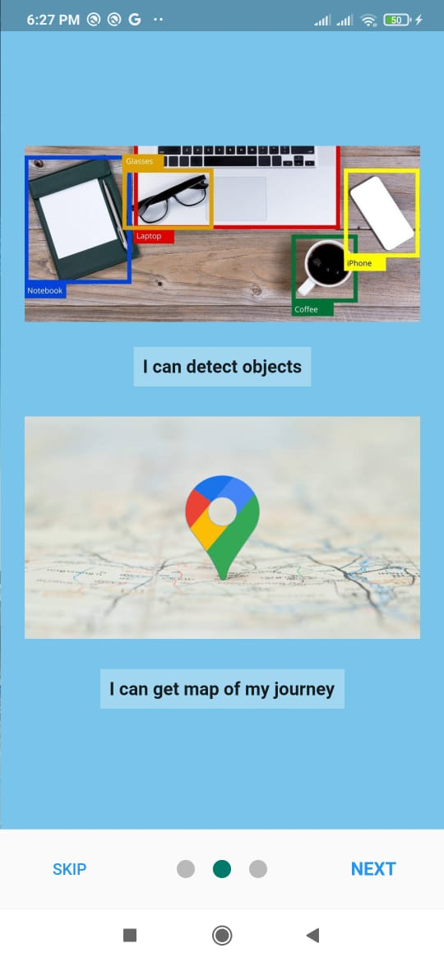

Then, when the user Get Started he will find the log in screen and have options to log in or to register new account and this option will open the sign in screen.

Log in screen:

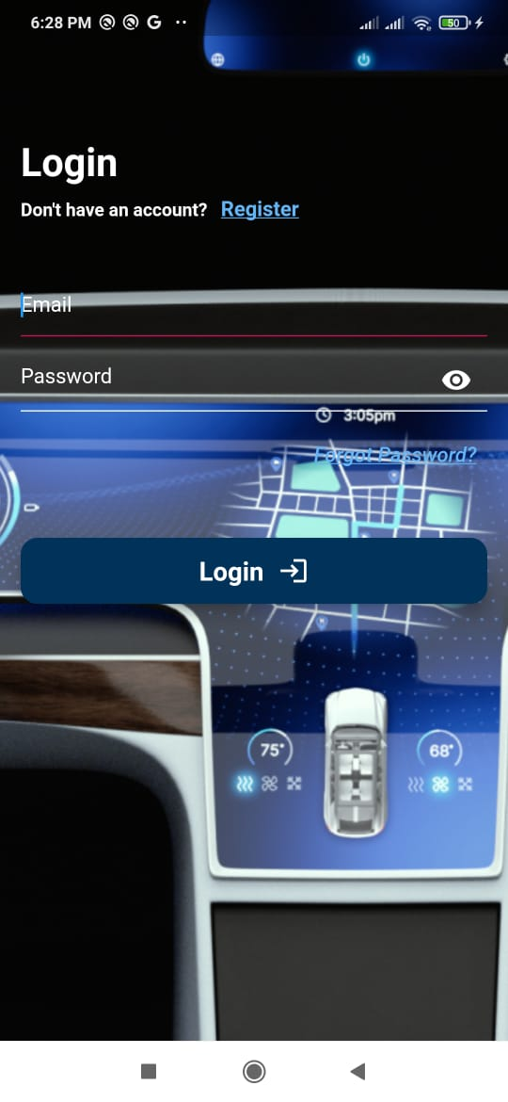

If the user didn’t satisfy the login conditions an error must appear prevent him from login.

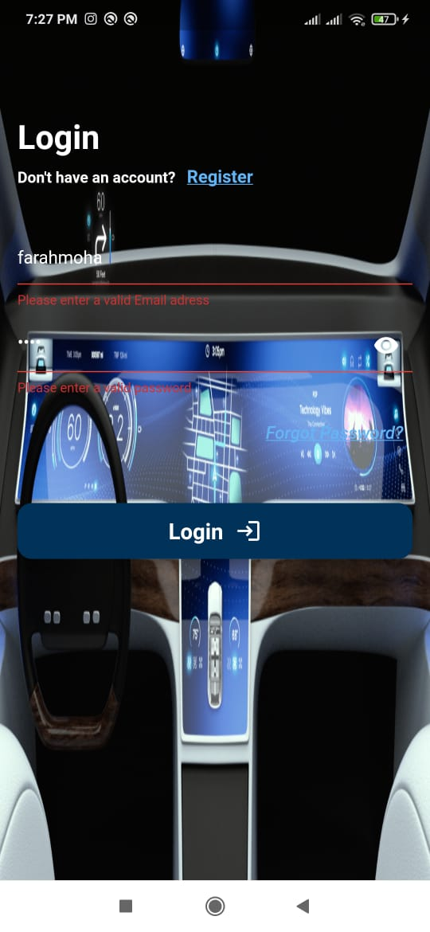

If the user writes wrong password the app will send a dialog box to show the error.

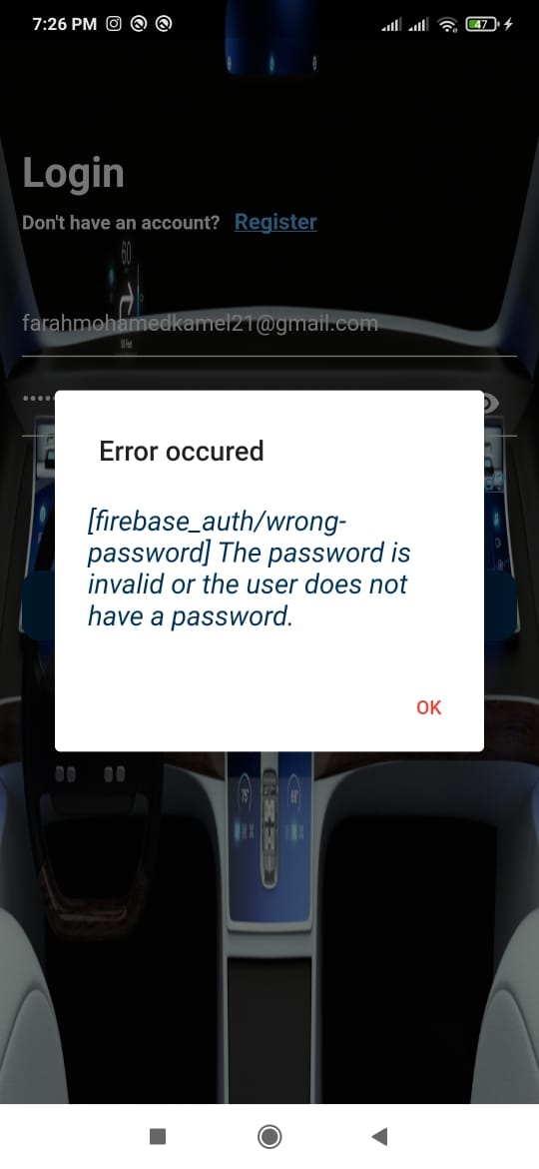

If the user has no account he will register for a new account by filling his information.

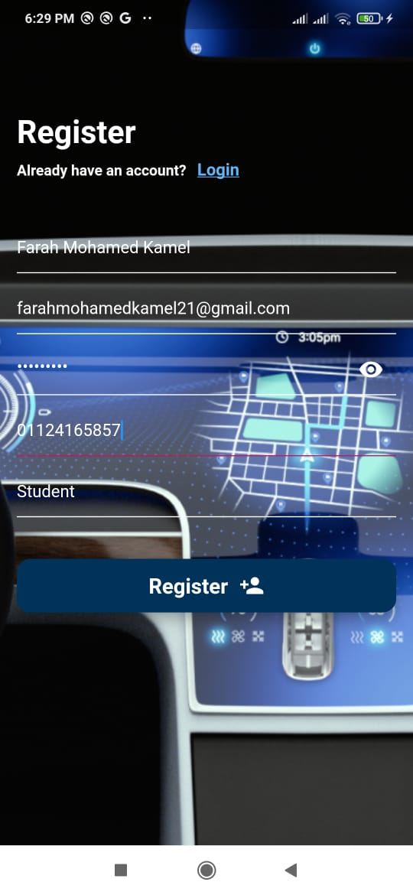.

If the user forgot his password he can press on “Forgot Password?”, and the forgot password screen will appear.

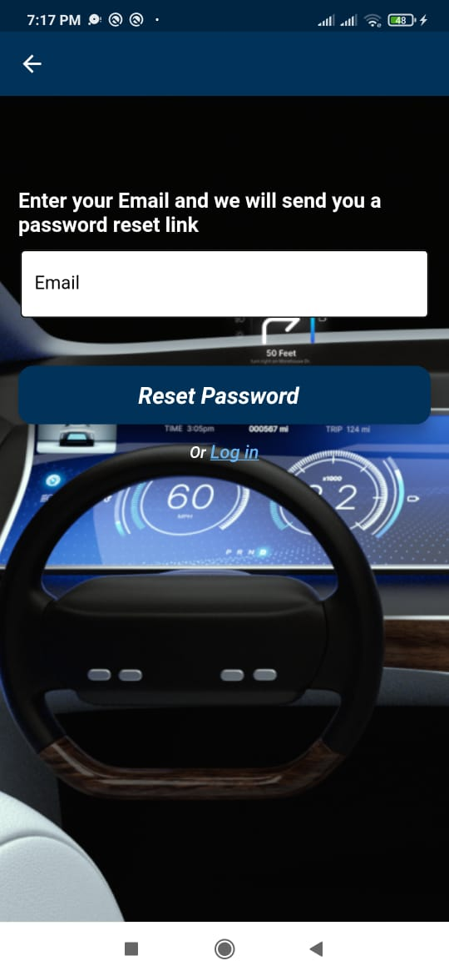

Then, he will write his registered email and an email of re-entering new password will be sent to him.

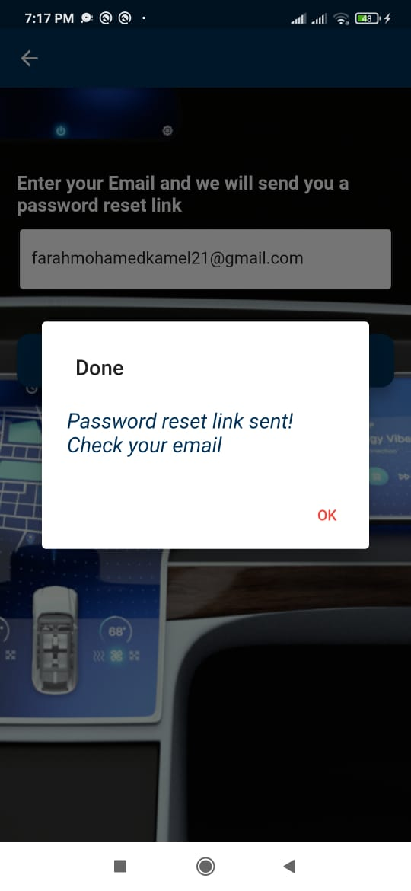

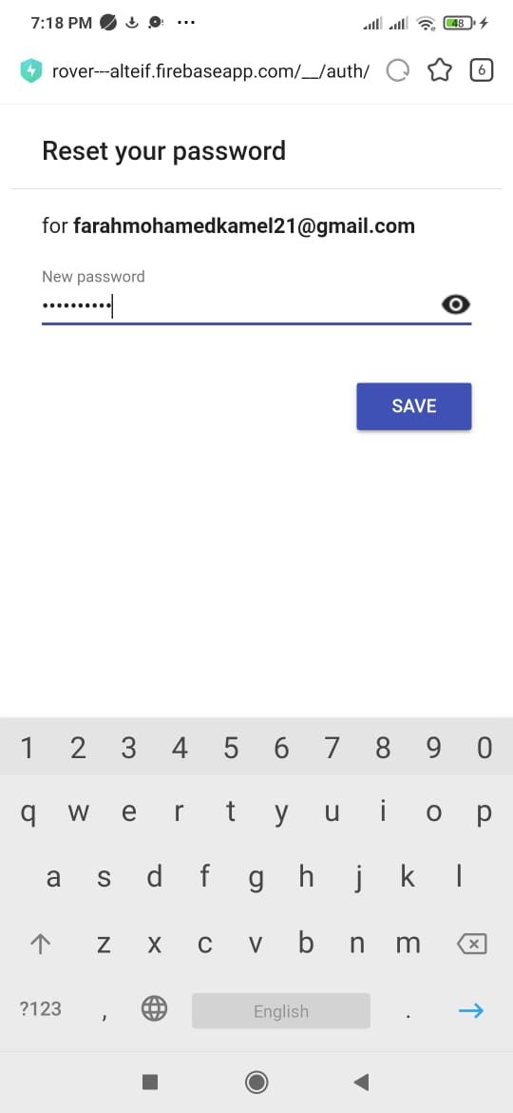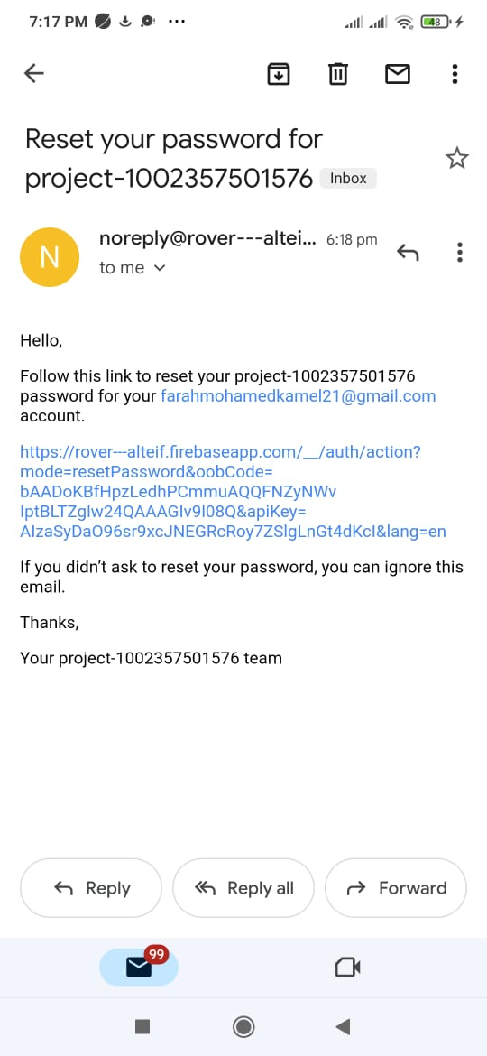

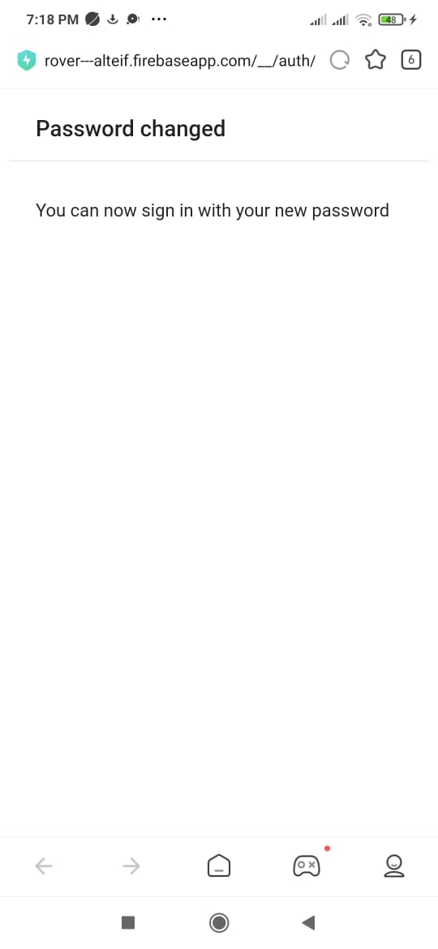

After logging in the user now is in the “Main screen”, the user can control the movement of the rover by pressing “Start Rover” button to start moving Forword until it find an obstacle and change its direction to avoid crashing in and by pressing on “Stop Rover” button the rover stops.

Also, the user can navigate to “Preview” or “Report” screens.

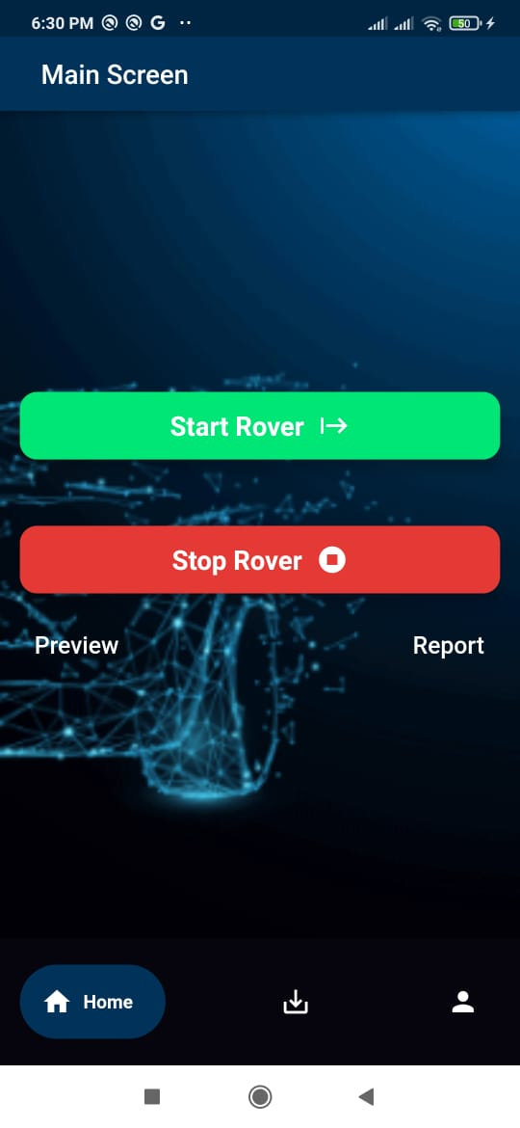

The user can show his own data by pressing on “My Profile” icon.

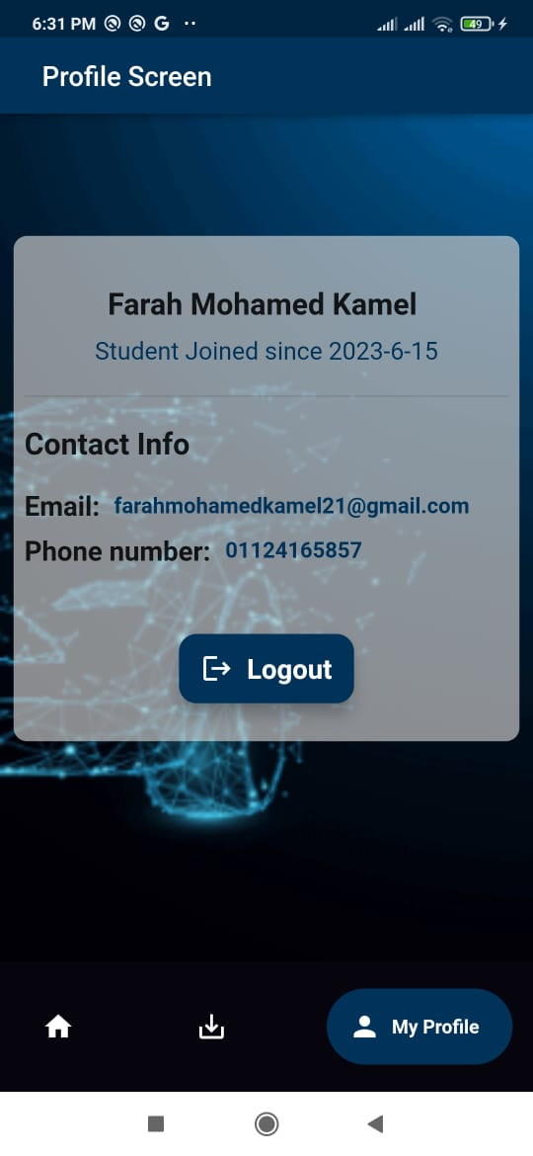

Returning back to the “Main screen” by pressing on “Home” icon.

By pressing on “Preview” the user will have two options:

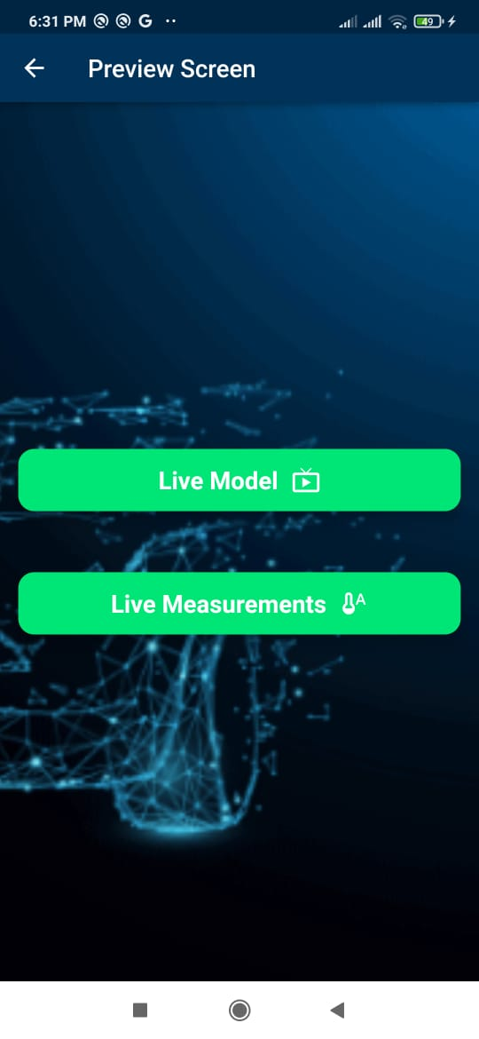

1. “Live Model”: to get a live video from the raspberry pi.

while moving the camera connected to the raspberry pi will start to detect objects.

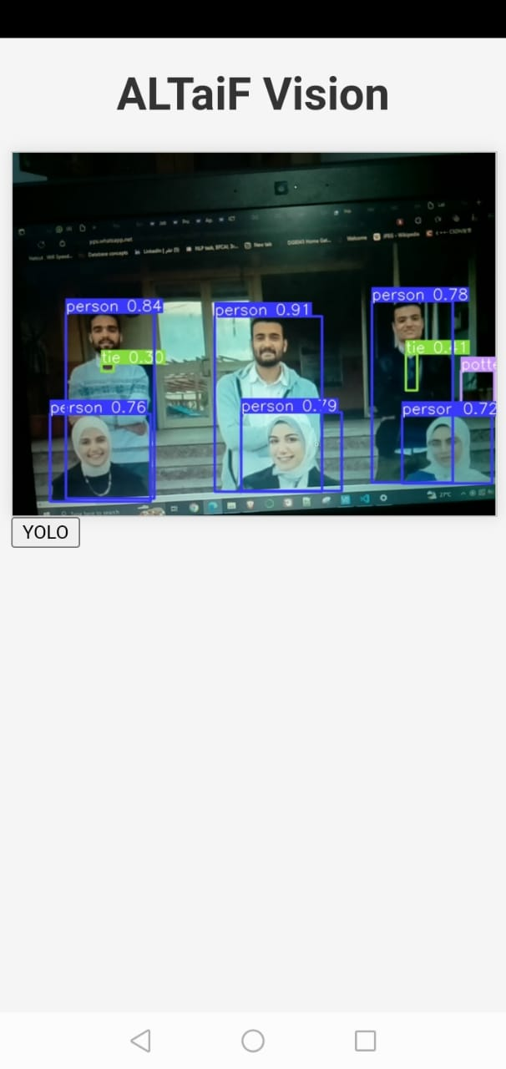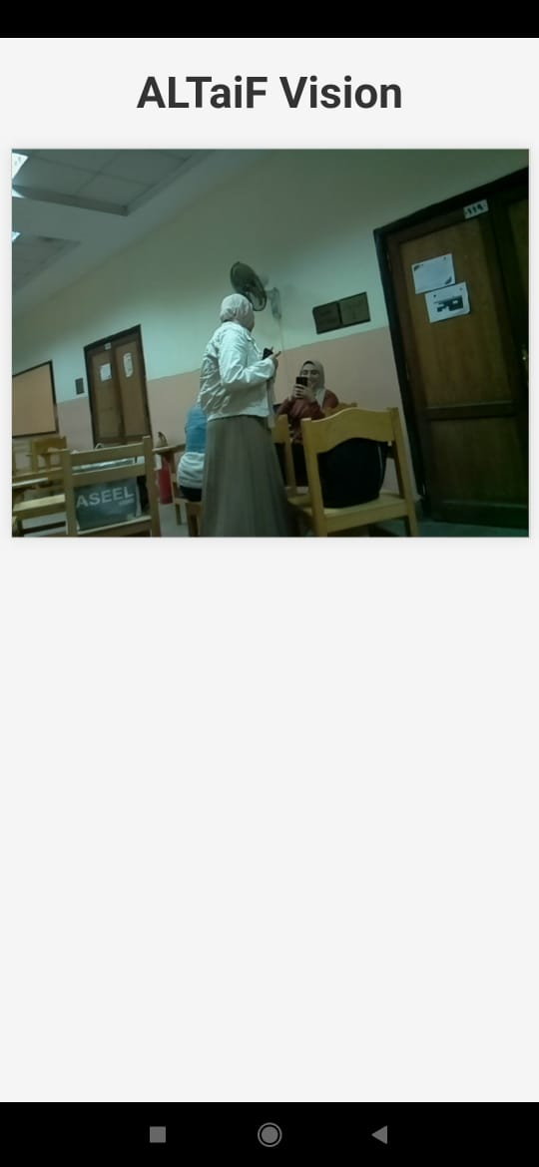

1. “Live Measurements”: to get Temperature and Humidity reading from sensors.

The user can request the temperature and humidity measurements that measured by the Arduino sensors and send to the raspberry pi to save it in the database then send it to the user in form of report.

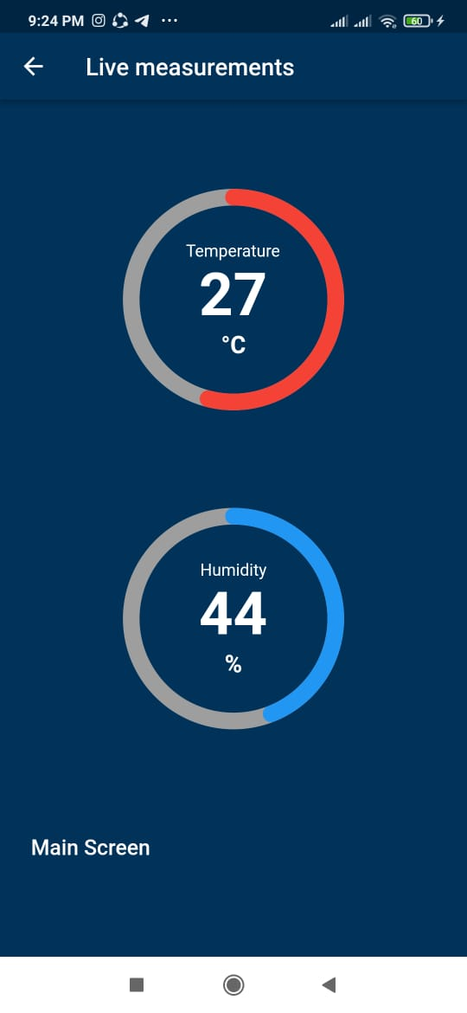

By pressing on “Report” the user will have two options:

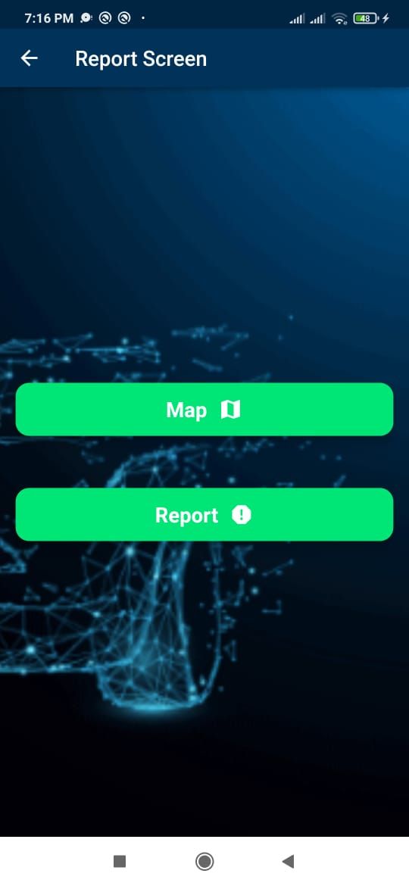

1. “Map”: to show the whole trip of the rover with directions.

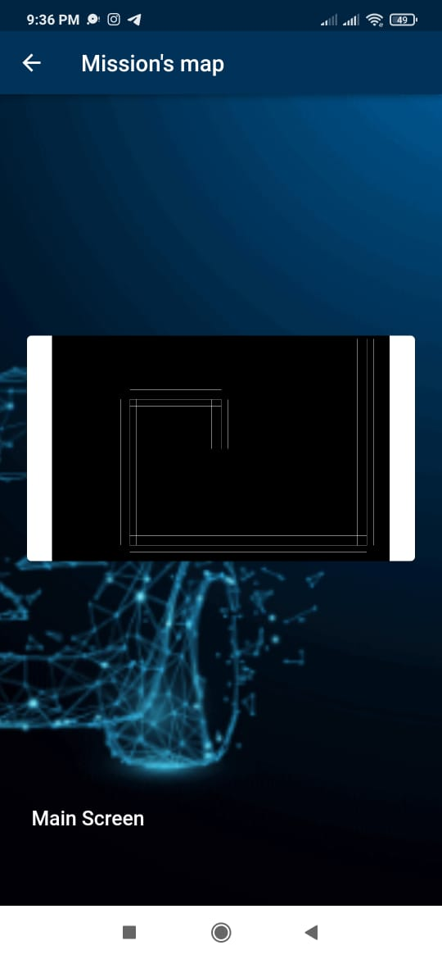

1. “Report”: to receive all data from sensors.

The user can return back to main screen and then navigate to “All Maps” icons in the bottom navigation bar to show all the maps the rover made.

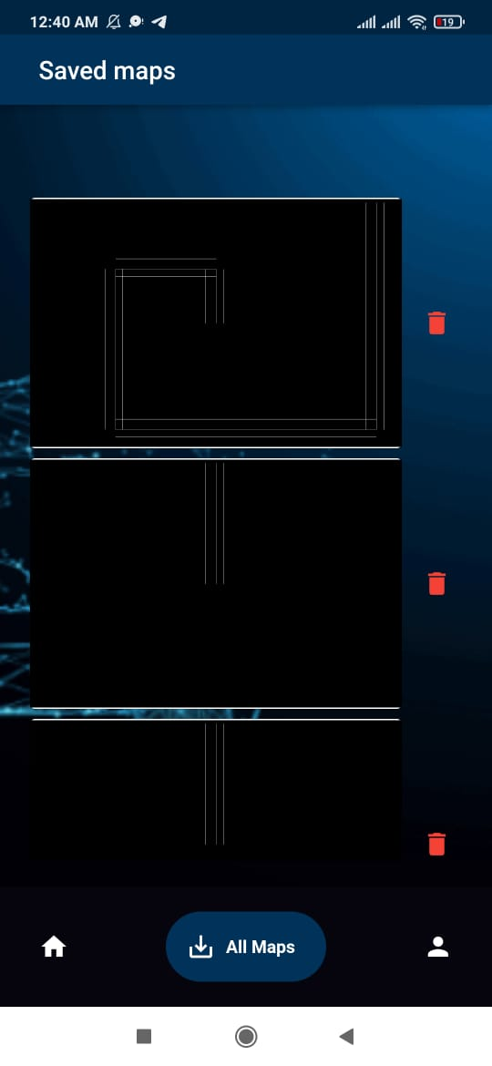

## procedures

### Connection to form rover

**We used:**

* Arduino UNO
* Smart Car Chassis 4WD
* L298N DC MOTOR CONTROLER
* 3 Ultrasonic sensors (HC- SR04)
* Servo motor
* Dc motor
* Jumper wires

**Connections:**

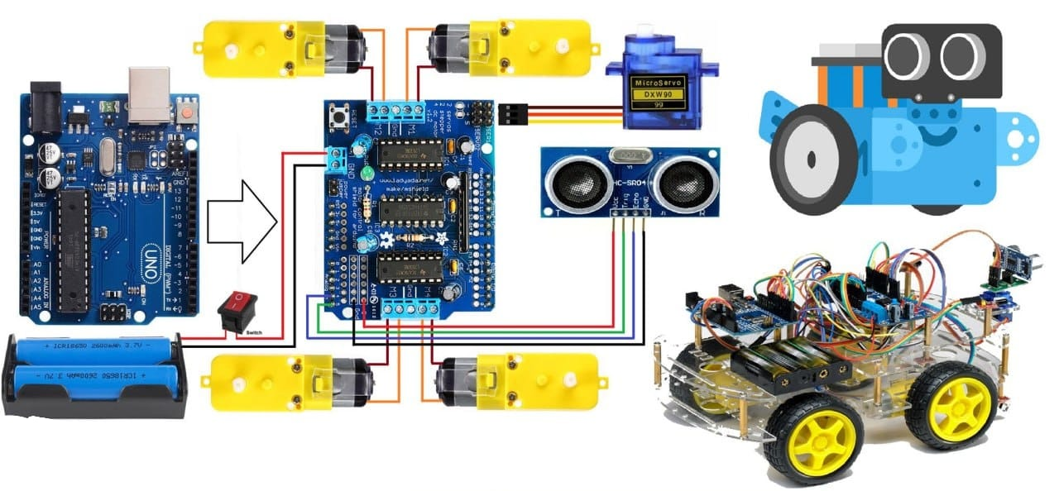

* Connect Power supply (batteries) pin (gnd) to motor driver controler pin (gnd)
* Connect Power supply (batteries) pin (+) to motor driver controler pin (+)
* Connect Power supply (batteries) pin (+) to Arduino pin (VIN)
* Connect GND from Arduino to motor driver controler pin (gnd)
* Connect digital pin(6) from Arduino to motor driver pin (IN1)
* Connect digital pin(8) from Arduino to motor driver pin (IN2)
* Connect digital pin(10) from Arduino to motor driver pin (IN3)
* Connect digital pin(11) from Arduino to motor driver pin (IN4)
* Connect DC motors (on the right side of the robot) to one side of motor driver
* Connect DC motor (on the left side of the robot) to other side of motor driver
* Connect Ultrasonic module pin (VCC) to Arduino pin [+5V]
* Connect Ultrasonic module pin (GND) to Arduino pin [GND]
* Connect Ultrasonic module pin (ECHO) to Arduino pin digital (4)
* Connect Ultrasonic module pin (TRIG) to Arduino pin digital (3)
* Connect Servo motor "Orange" (signal) pin to Arduino Digital pin[2]
* Connect Servo motor "Red" pin to Arduino positive pin[5V]
* Connect Servo motor "Brown" pin to Arduino negative pin[GND]

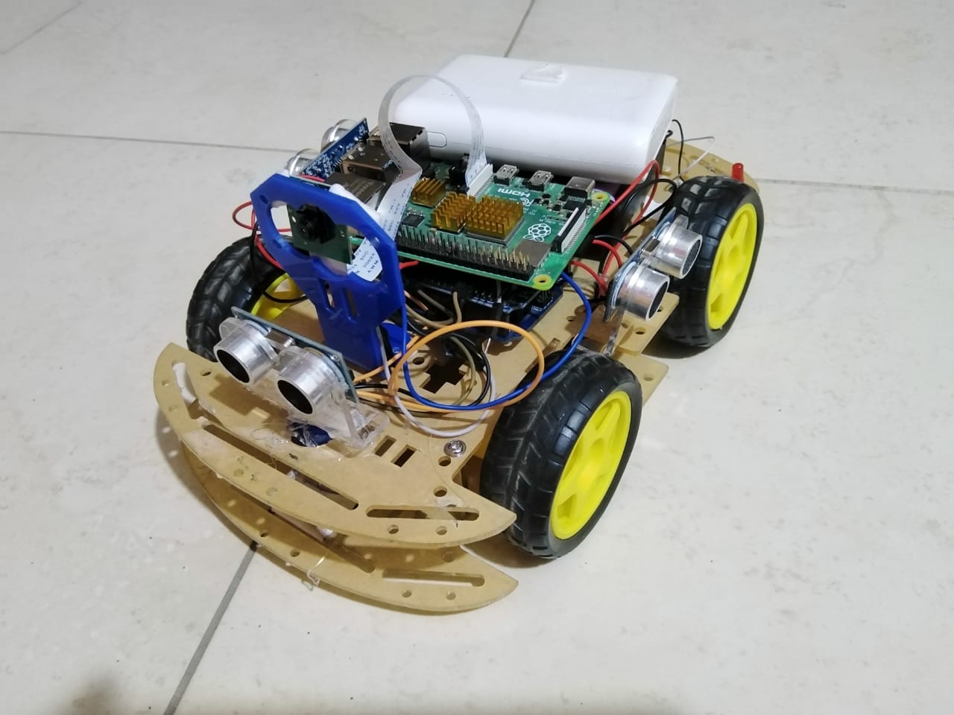

### Arduino rule for self-driving car

* The micro-controller drives the DC motors to move the vehicle to a manually entered destination coordinates.
* Arduino is a micro controller used in our rover to control motion and sensors.
* Arduino is connected to driver to control power distribution.
* We connect to the driver four wheels with four DC motors which are programmed to move in the direction that doesn't contain obstacles or if the rover sees anything will make it crash with it the wheels will change their directions to an empty space.
* A switch used for powering on or off the rover.
* Three batteries as a power supply.
* DHT11 sensor to measure temperature and humidity of the environment and send it to firebase through raspberry pi.
* Light sensor and LEDS when the sensor read that there is no light around it the LEDS will be turned on to make the rover sees at night or in closed dark areas,
* Speed sensor that can read the speed of the car at an interval of time so we can compute the distances which the rover moves in.
* By Arduino we can observe and control the motions of our rover and know when rover move forward or backward and when, where it take turns

**Arduino flowchart:**

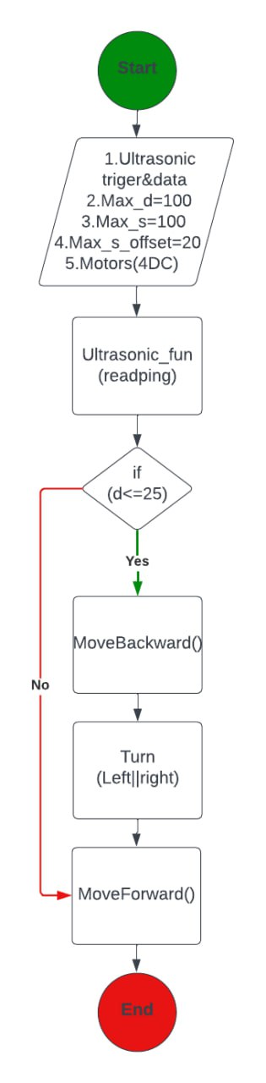

**Arduino tasks:**



### Setup raspberry pi

Micro SD card:

The micro SD card acts as Raspberry Pi‘s permanent storage; all the files we create and software we install, along with the operating system itself, are stored on the card. Connecting the micro SD card To install the micro SD card, which is Raspberry Pi‘s storage, turn Raspberry Pi (in its case if using one) over and we slide the card into the micro SD slot with the label facing away from Raspberry Pi. It can only go in one way and should slide home without too much pressure.

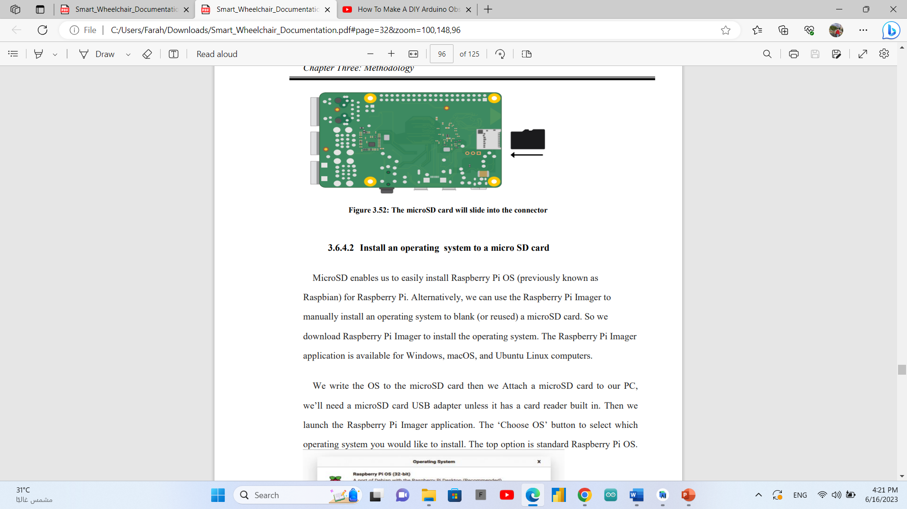

**Install an operating system to a micro SD card:**

MicroSD enables us to easily install Raspberry Pi OS (previously known as Raspbian) for Raspberry Pi. Alternatively, we can use the Raspberry Pi Imager to manually install an operating system to blank (or reused) a microSD card. So we download Raspberry Pi Imager to install the operating system. The Raspberry Pi Imager application is available for Windows, macOS, and Ubuntu Linux computers. We write the OS to the microSD card then we Attach a microSD card to our PC, we‘ll need a microSD card USB adapter unless it has a card reader built in. Then we launch the Raspberry Pi Imager application. The ‗Choose OS‘ button to select which operating system you would like to install. The top option is standard Raspberry Pi OS.

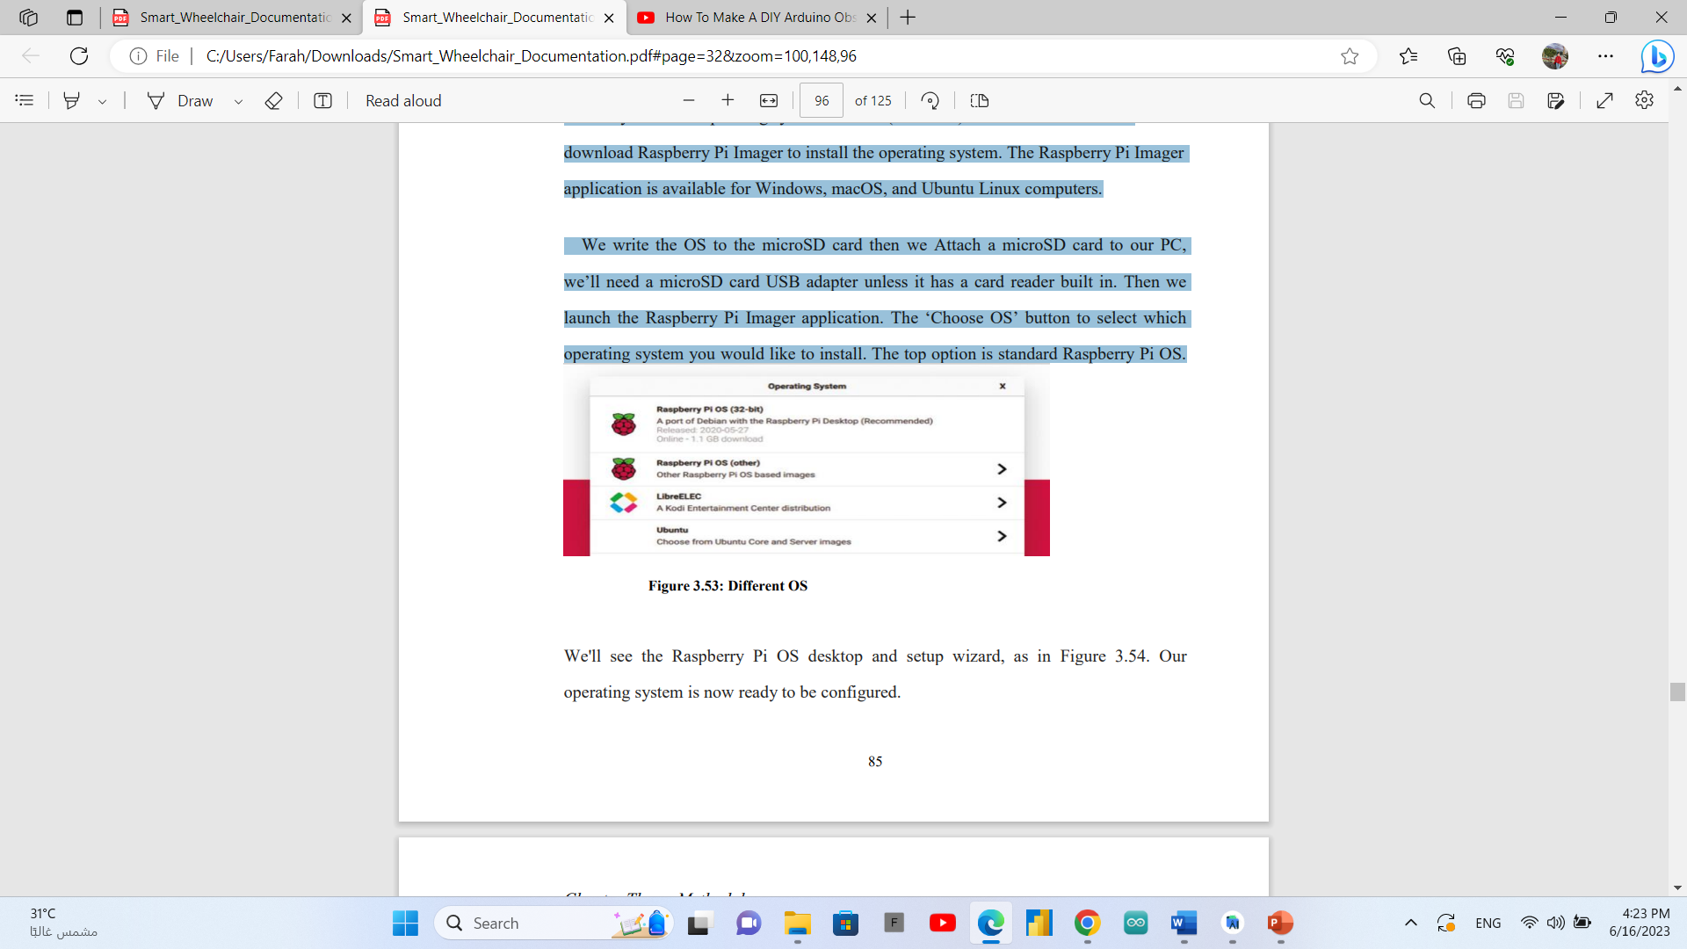

We'll see the Raspberry Pi OS desktop and setup wizard, as in Figure 3.54. Our operating system is now ready to be configured.

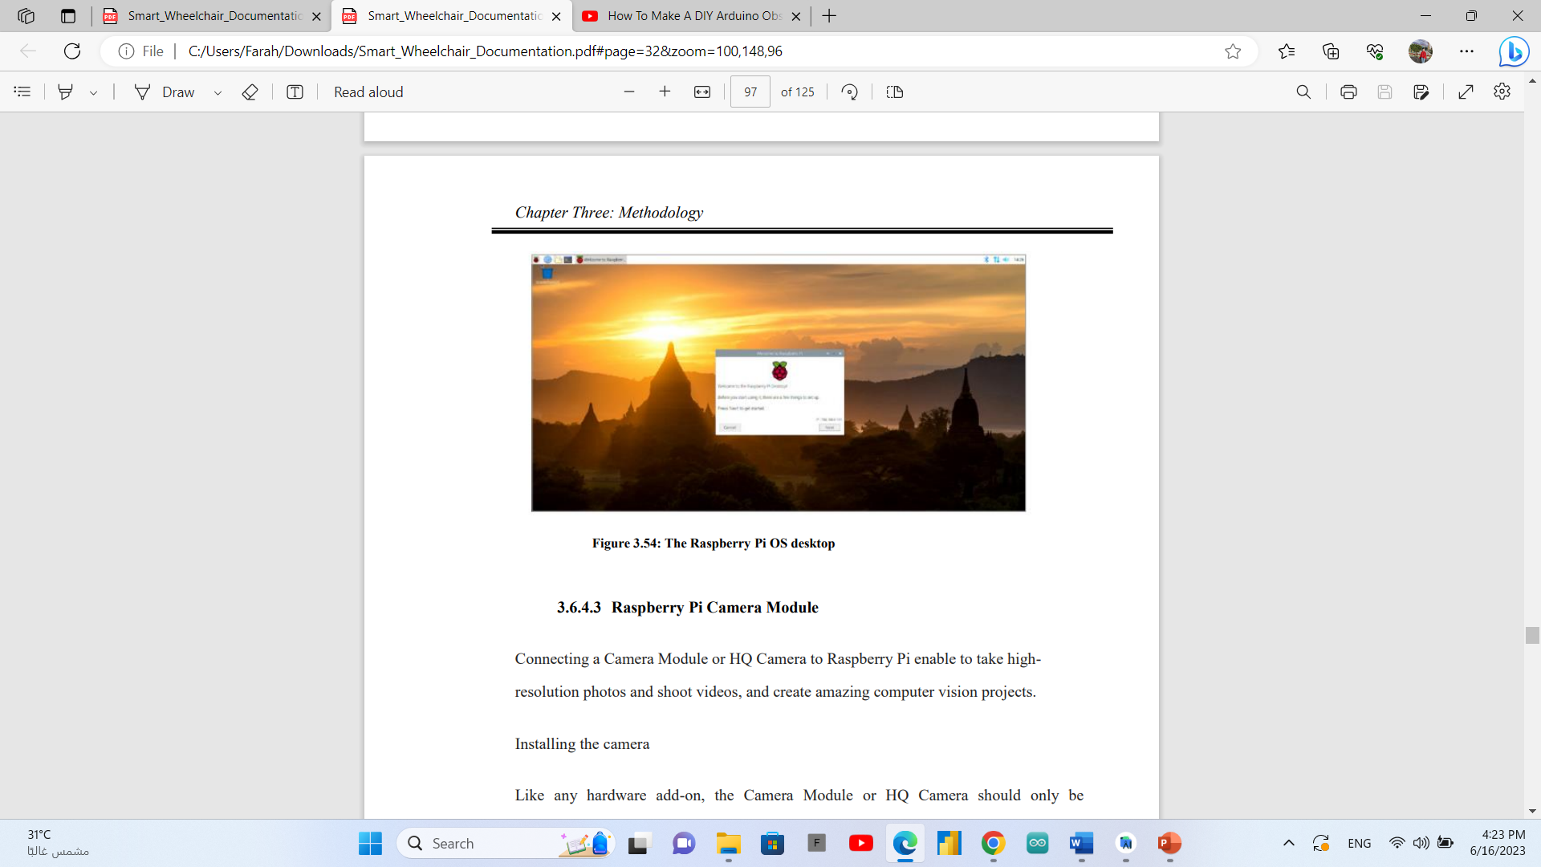

**Raspberry Pi Camera Module:**

Connecting a Camera Module or HQ Camera to Raspberry Pi enable to take high resolution photos and shoot videos, and create amazing computer vision projects. Installing the camera Like any hardware add-on, the Camera Module or HQ Camera should only be connected to or disconnected from Raspberry Pi when the power is off and the power cable unplugged.

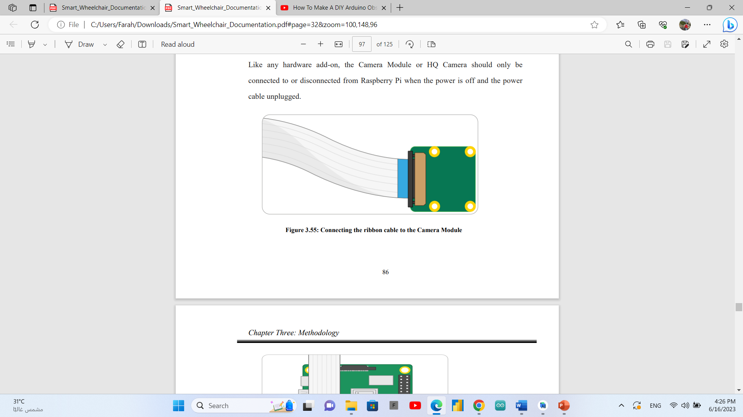

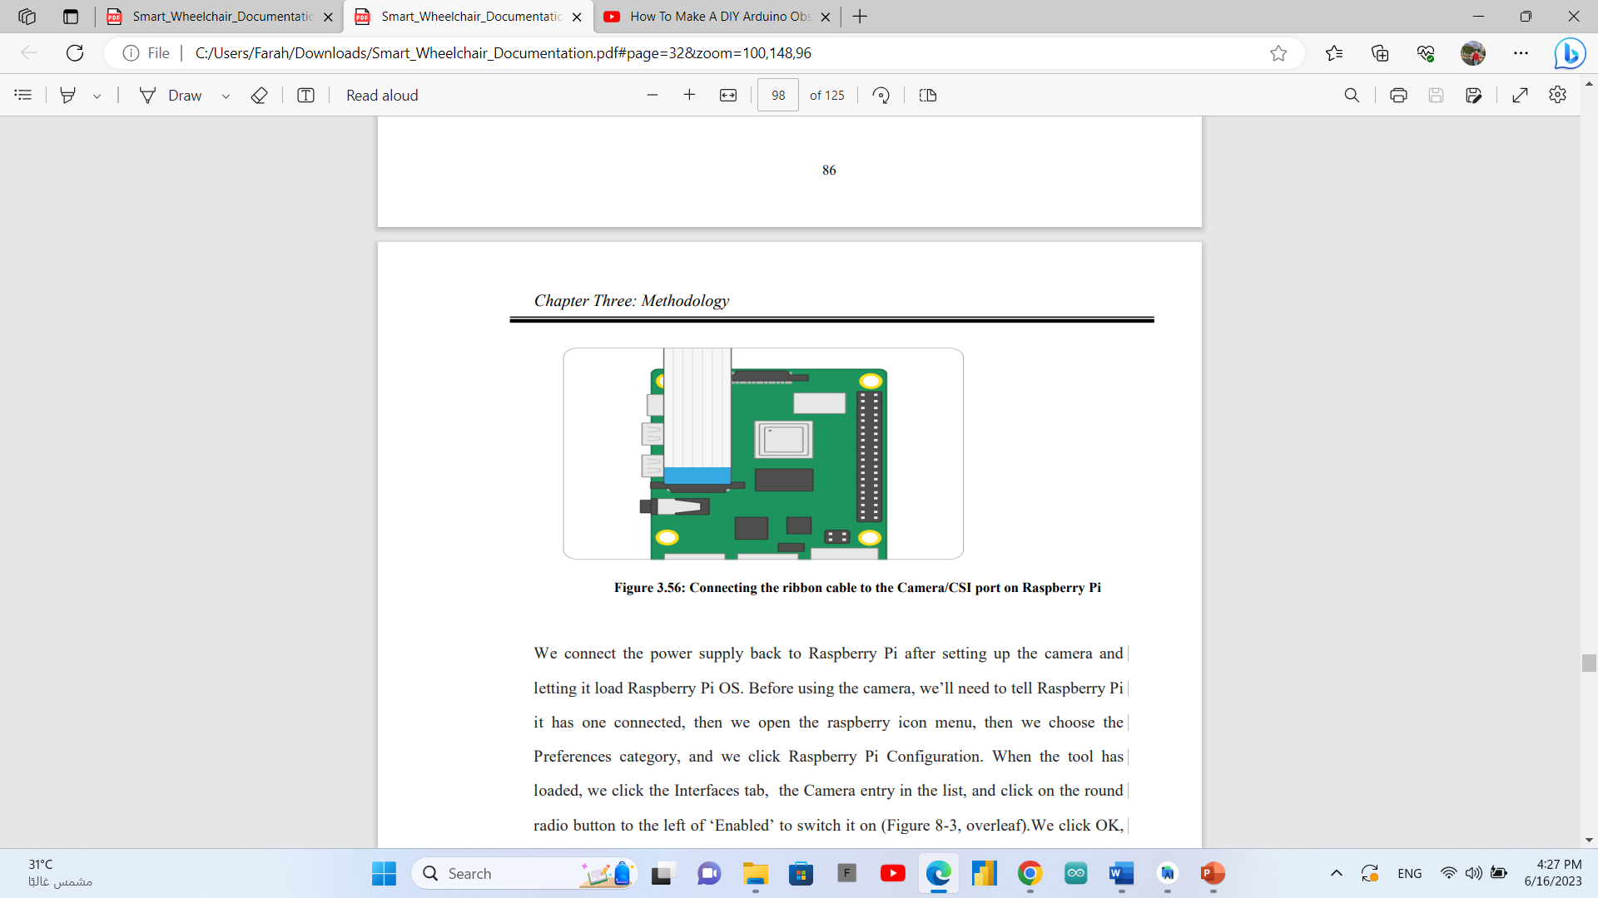

We connect the power supply back to Raspberry Pi after setting up the camera and letting it load Raspberry Pi OS. Before using the camera, we’ll need to tell Raspberry Pi it has one connected, then we open the raspberry icon menu, then we choose the Preferences category, and we click Raspberry Pi Configuration. When the tool has loaded, we click the Interfaces tab, the Camera entry in the list, and click on the round radio button to the left of ‗Enabled‘ to switch it on (Figure 8-3, overleaf).We click OK, and the tool will prompt to reboot the Raspberry Pi. Then the camera will be ready to use.

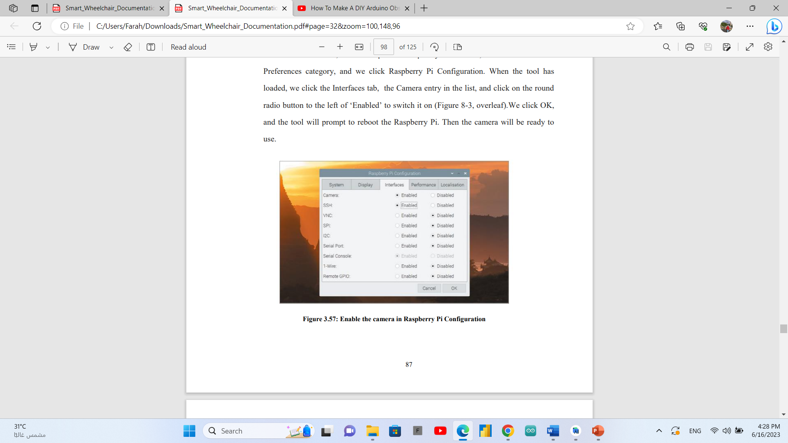

### YOLO (You Only Look Once)

YOLO is an abbreviation for the term ‗You Only Look Once‘. This is an algorithm that detects and recognizes various objects in a picture (in real-time). Object detection in YOLO is done as a regression problem and provides the class probabilities of the detected images. YOLO algorithm employs convolutional neural networks (CNN) to detect objects in real-time. As the name suggests, the algorithm requires only a single forward propagation through a neural network to detect objects. This means that prediction in the entire image is done in a single algorithm run. The CNN is used to predict various class probabilities and bounding boxes simultaneously. YOLO is an algorithm that uses neural networks to provide real-time object detection. This algorithm is popular because of its speed and accuracy. It has been used in various applications to detect traffic signals, people, parking meters, and animals. It is one of the faster object detection algorithms out there. It is a very good choice when we need realtime detection, without loss of too much accuracy.

### Why we used YOLO

YOLO algorithm is important because of the following reasons:

Speed: This algorithm improves the speed of detection because it can predict objects in real-time.

High accuracy: YOLO is a predictive technique that provides accurate results with minimal background errors.

Learning capabilities: The algorithm has excellent learning capabilities that enable it to learn the representations of objects and apply them in object detection.

### How the YOLO algorithms work?

YOLO algorithm works using the following three techniques:

* 1. Residual blocks:
  2. Bounding box regression
  3. Intersection over Union (IOU)
  + **Residual blocks:**

First, the image is divided into various grids. Each grid has a dimension of S x S. The following image shows how an input image is divided into grids.

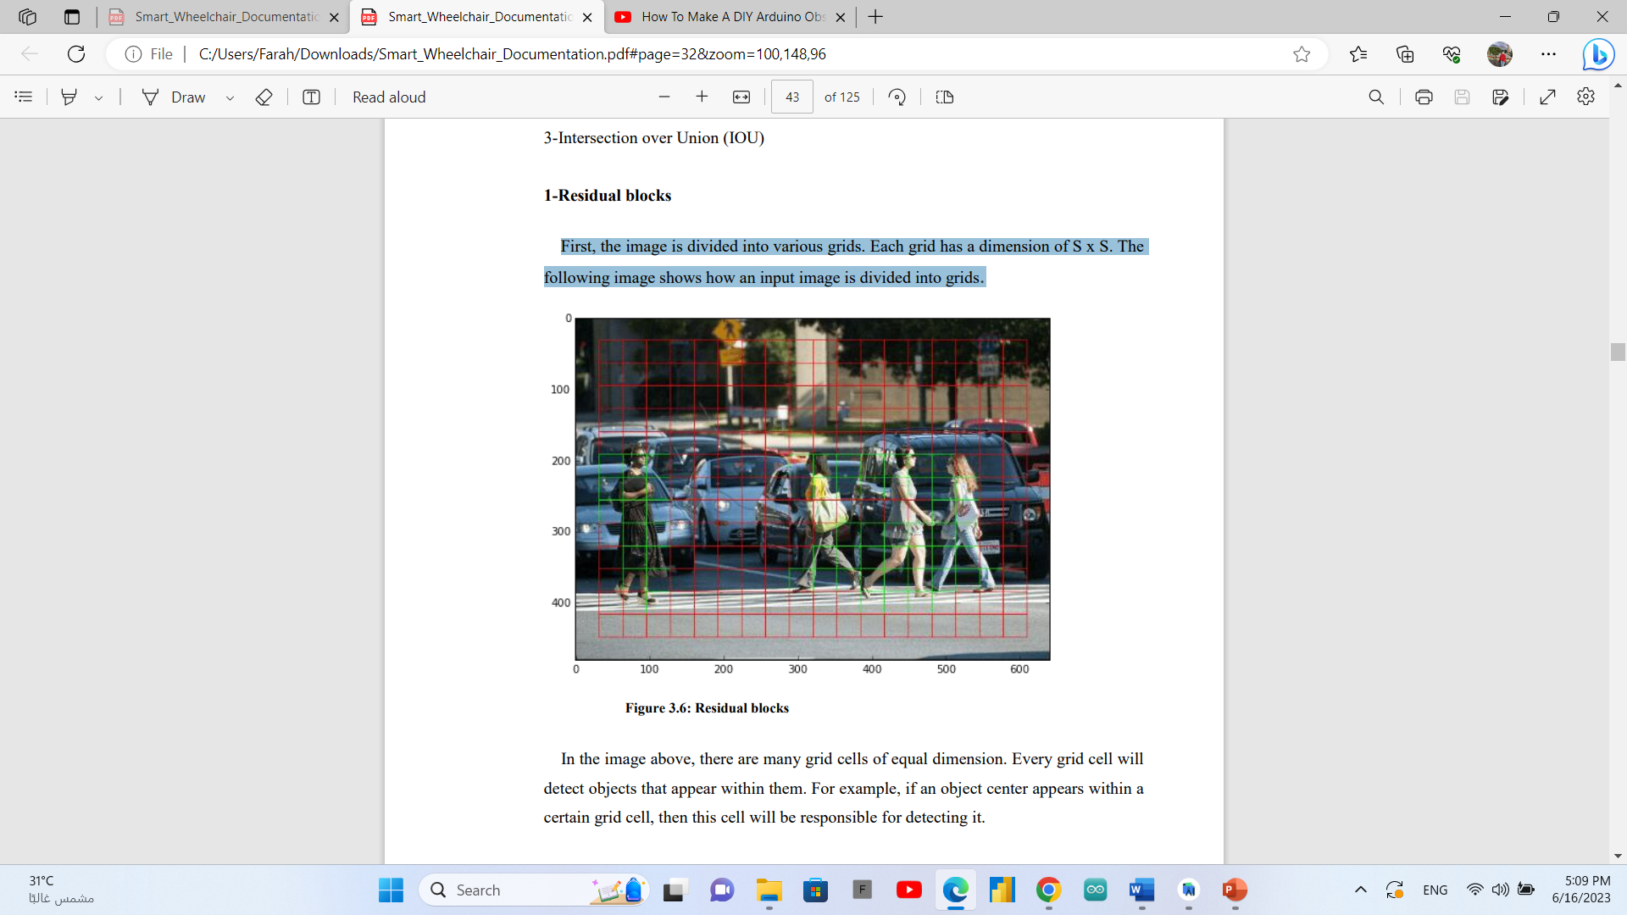

In the image above, there are many grid cells of equal dimension. Every grid cell will detect objects that appear within them. For example, if an object center appears within a certain grid cell, then this cell will be responsible for detecting it.

* + **Bounding box regression:**

A bounding box is an outline that highlights an object in an image. Every bounding box in the image consists of the following attributes: • Width (bw) • Height (bh) • Class (for example, person, car, traffic light, etc.)- This is represented by the letter c. • Bounding box center (bx,by) The following image shows an example of a bounding box. The bounding box has been represented by a yellow outline.

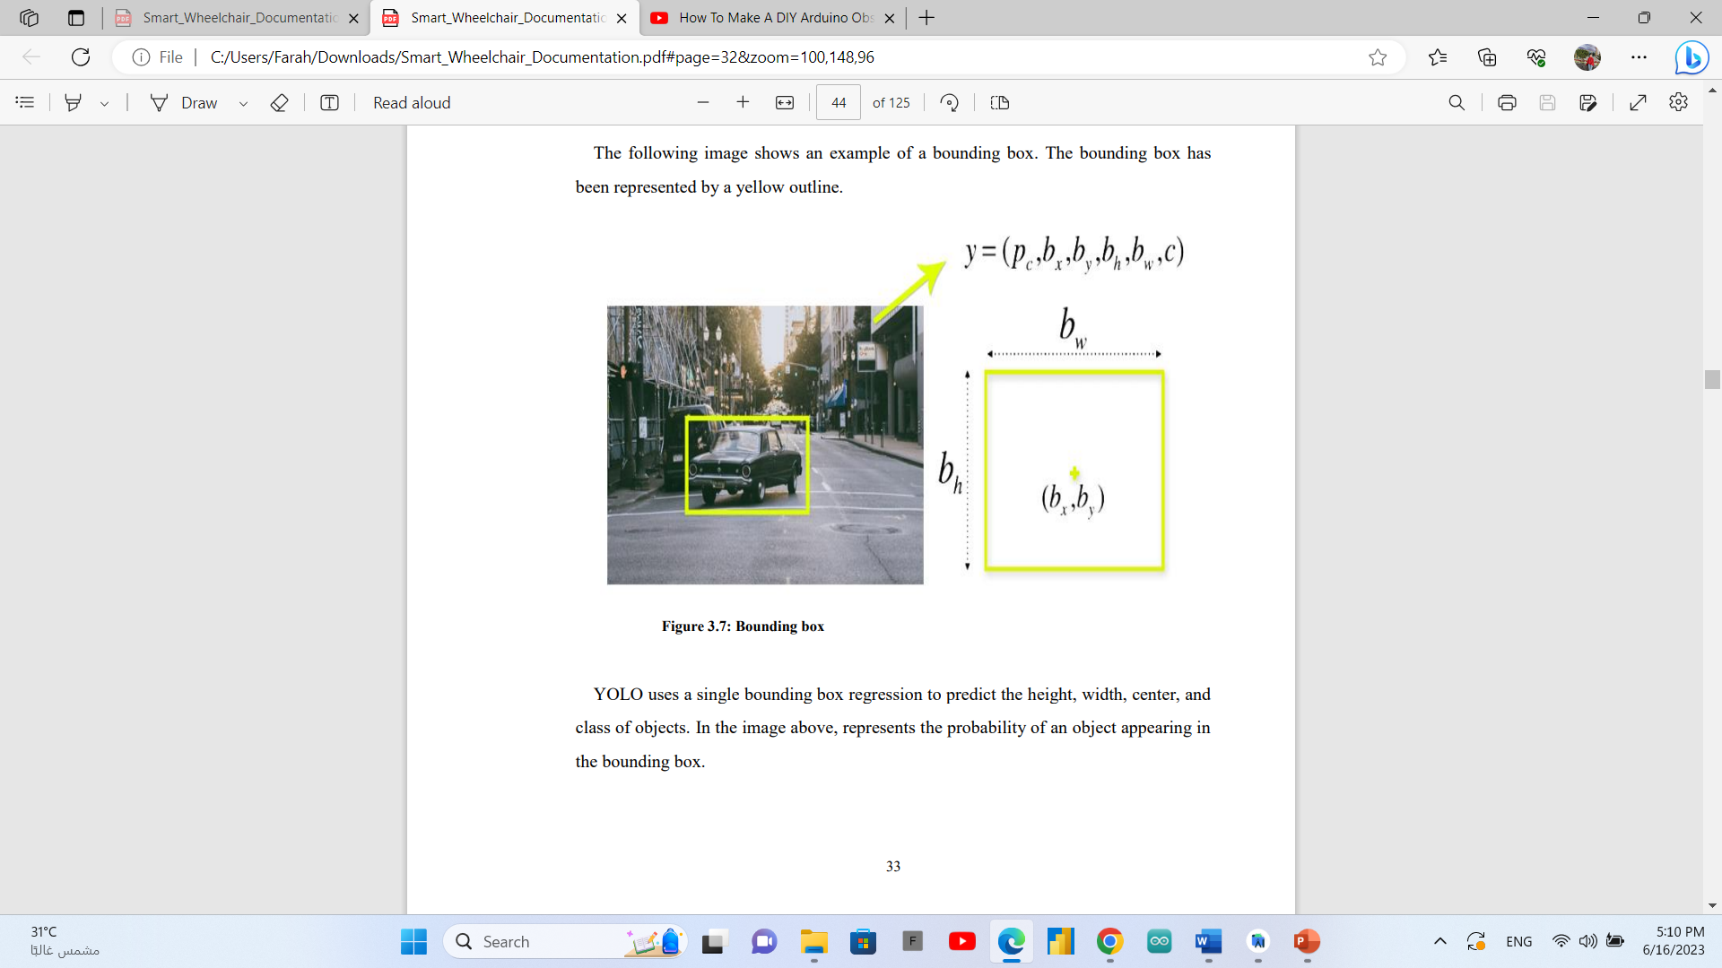

YOLO uses a single bounding box regression to predict the height, width, center, and class of objects. In the image above, represents the probability of an object appearing in the bounding box.

* + **Intersection over union (IOU)**

Intersection over union (IOU) is a phenomenon in object detection that describes how boxes overlap. YOLO uses IOU to provide an output box that surrounds the objects perfectly. Each grid cell is responsible for predicting the bounding boxes and their confidence scores. The IOU is equal to 1 if the predicted bounding box is the same as the real box. This mechanism eliminates bounding boxes that are not equal to the real box. The following image provides a simple example of how IOU works.

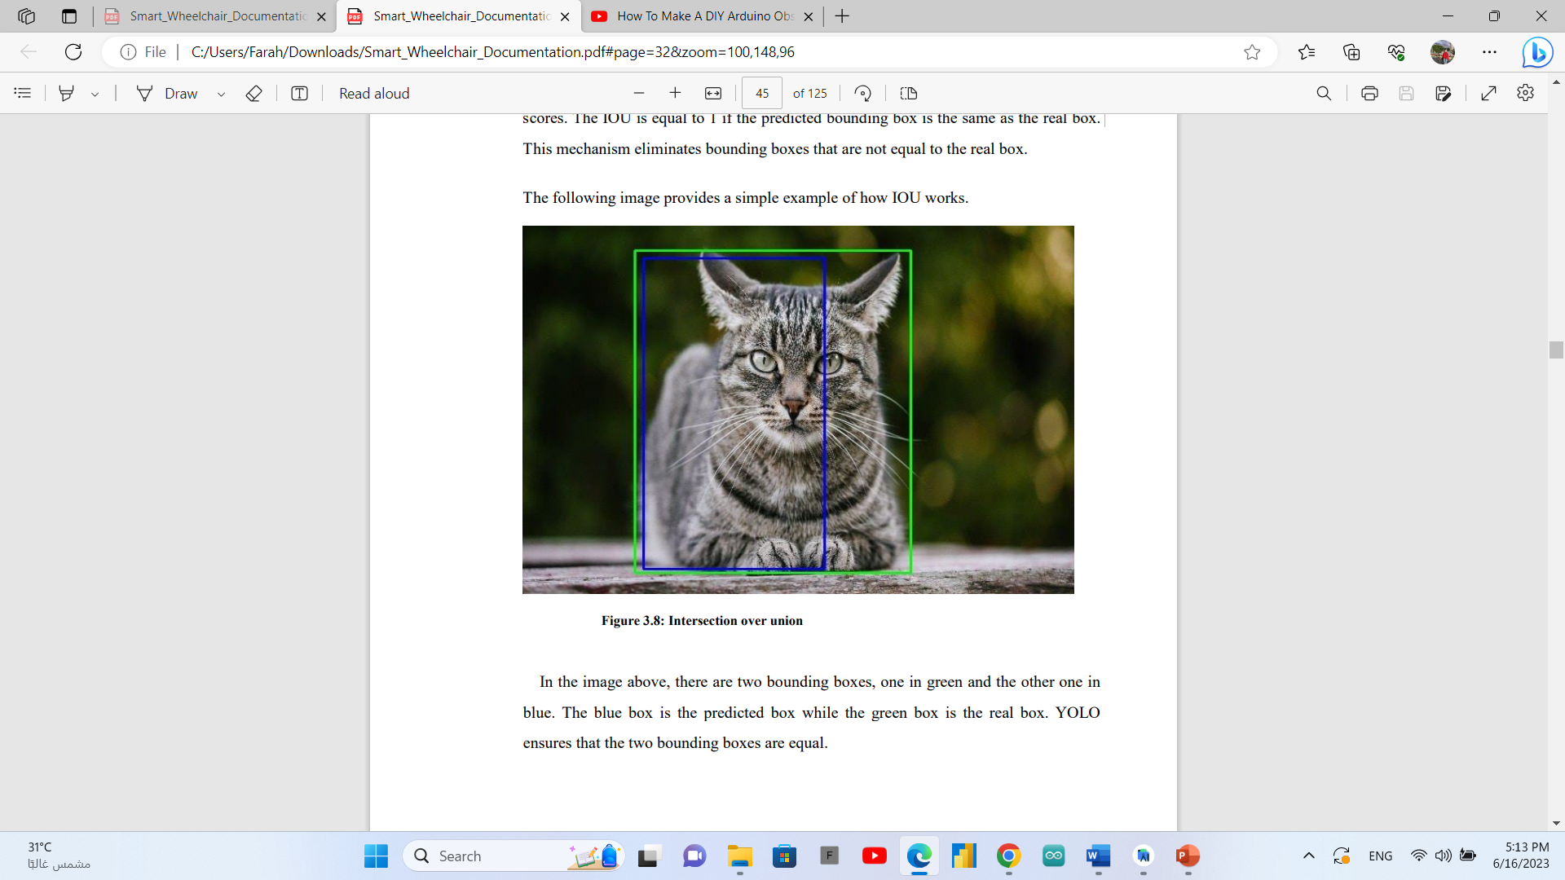

In the image above, there are two bounding boxes, one in green and the other one in blue. The blue box is the predicted box while the green box is the real box. YOLO ensures that the two bounding boxes are equal.

* + **Combination of the three techniques**

The following image shows how the three techniques are applied to produce the final detection results.

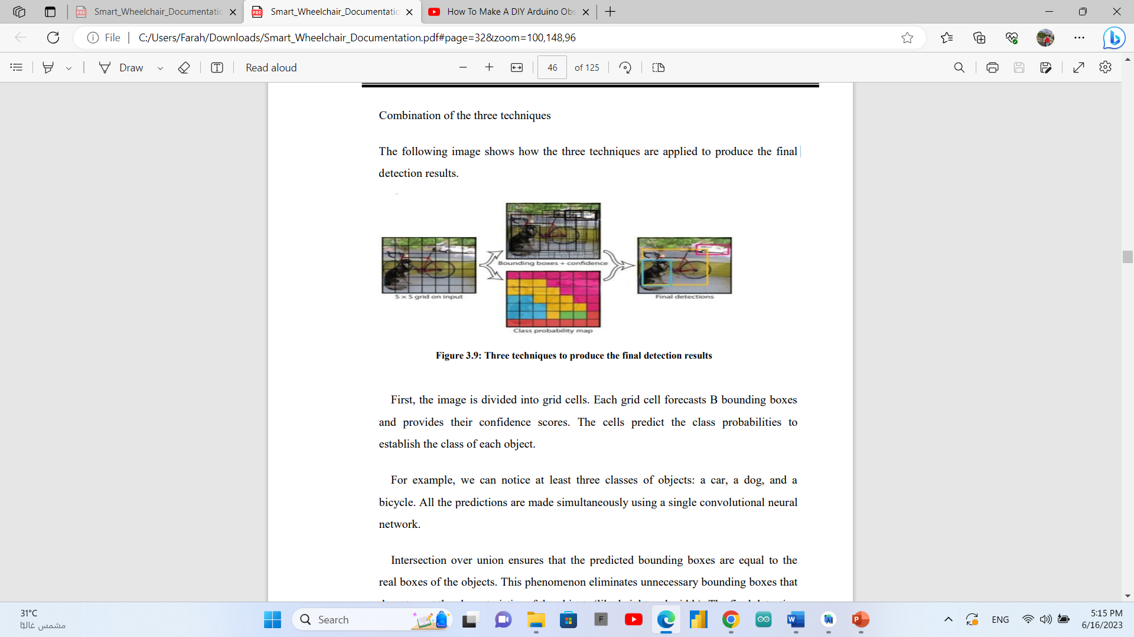

First, the image is divided into grid cells. Each grid cell forecasts B bounding boxes and provides their confidence scores. The cells predict the class probabilities to establish the class of each object.

For example, we can notice at least three classes of objects: a car, a dog, and a bicycle. All the predictions are made simultaneously using a single convolutional neural network.

Intersection over union ensures that the predicted bounding boxes are equal to the real boxes of the objects. This phenomenon eliminates unnecessary bounding boxes that do not meet the characteristics of the objects (like height and width). The final detection will consist of unique bounding boxes that fit the objects perfectly.

For example, the car is surrounded by the pink bounding box while the bicycle is surrounded by the yellow bounding box. The dog has been highlighted using the blue bounding box.

* + **Interpreting the YOLO Output**

The input is a batch of images of shape (608, 608, 3). The output is a list of bounding boxes along with the recognized classes. Each bounding box is represented by 6 numbers(pc ,bx ,by ,bh ,bw , c). If we expand c into an 80-dimensional vector (The number of classes), each bounding box is then represented by 85 numbers. To do that, we divide the input image in to a grid of dimensions equal to that of the final feature map. For example, the input image is 608 x 608, and the dimensions of the feature map are 19 x 19. So the stride of the network will be 32(608/19=32).

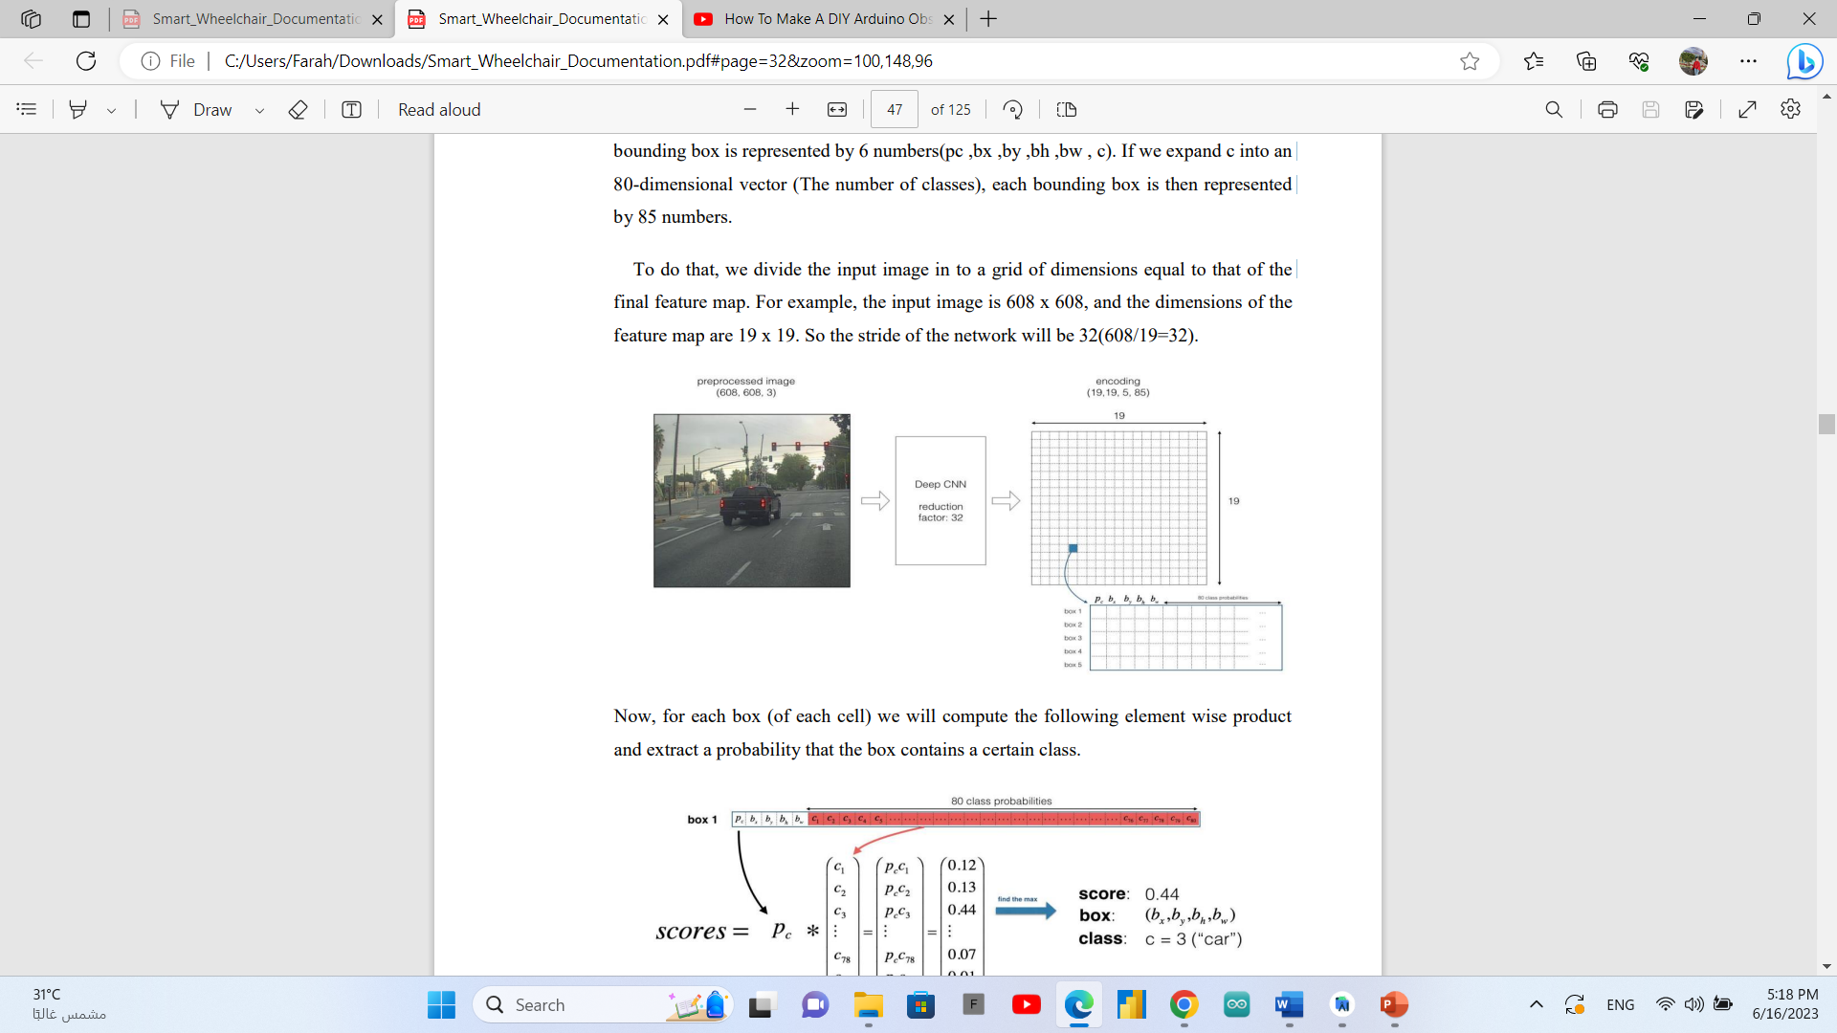

Now, for each box (of each cell) we will compute the following element wise product and extract a probability that the box contains a certain class.

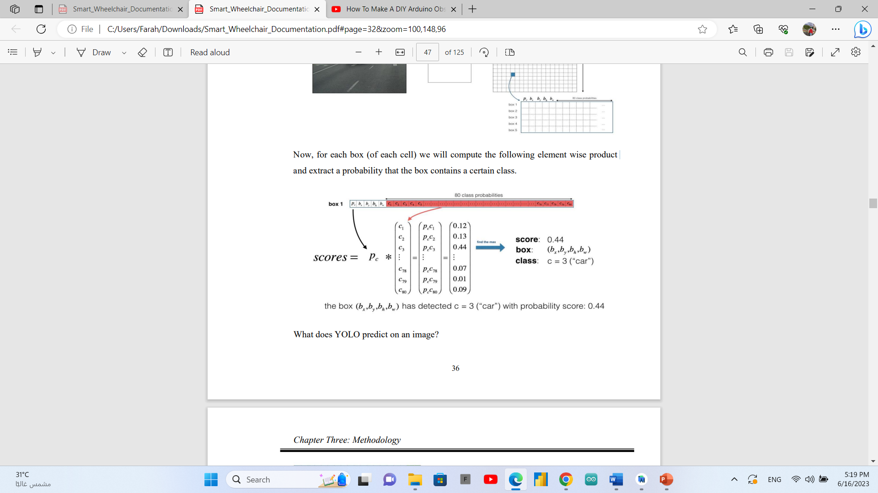

What does YOLO predict on an image?

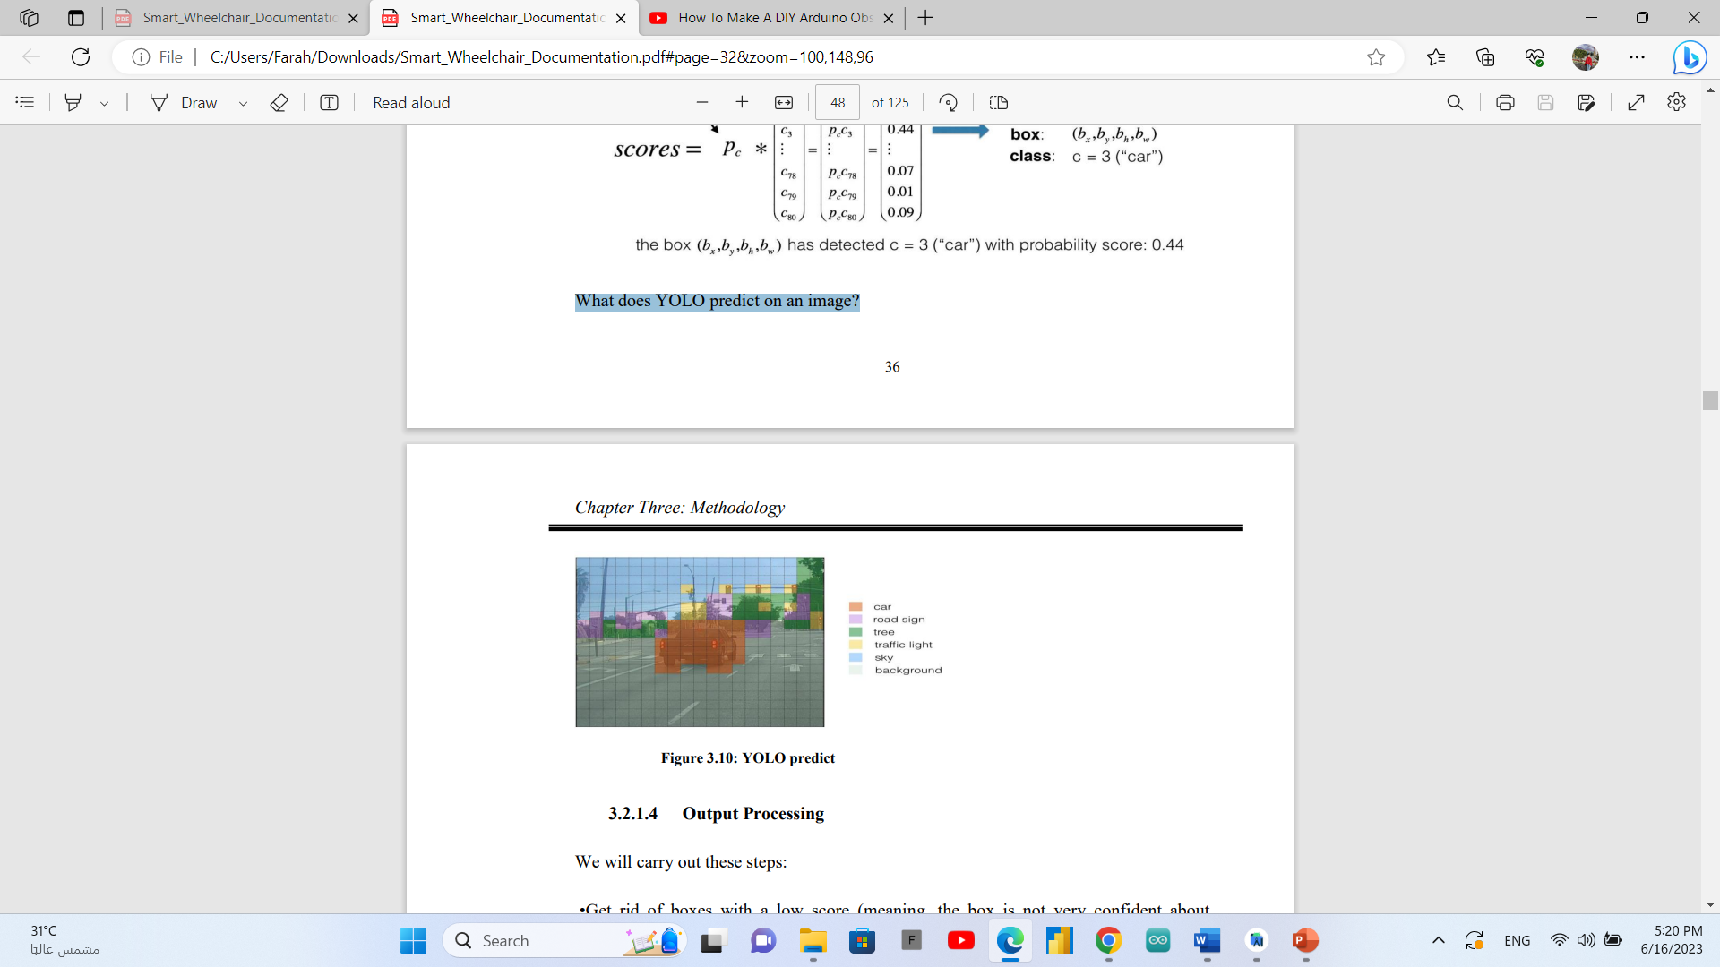

* + **Output Processing**

We will carry out these steps: •Get rid of boxes with a low score (meaning, the box is not very confident about detecting a class (exp: pc < 0.5)). Select only one box when several boxes overlap with each other and detect the same object (Non-max suppression).

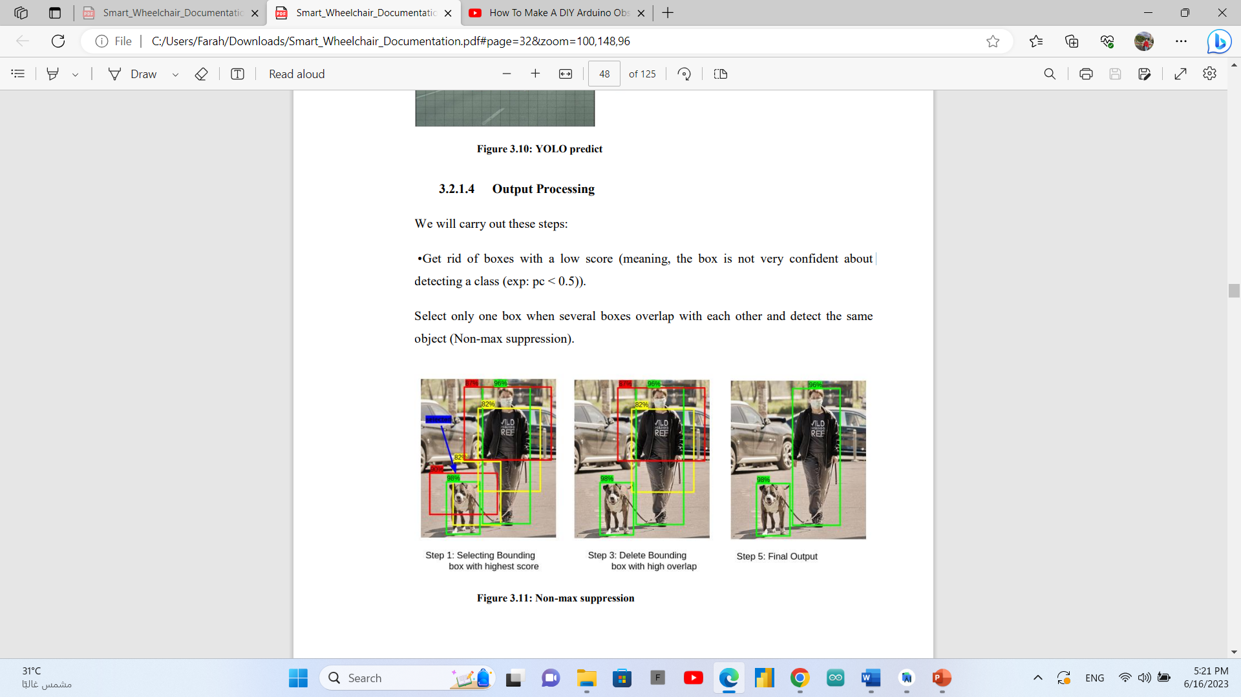

* + **YOLO Architecture:**

Our detection network has 24 convolutional layers followed by 2 fully connected layers. Alternating 1 x 1 convolutional layers reduce the features space from preceding layers. We pretrain the convolutional layers on the ImageNet classification task at half the resolution (224 x 224 input image) and then double the resolution for detection.



**The training** was on coco dataset consists of 80 different classes, data set consists of image and label file the label file consist of class number and box of object in form of (x, y, w, h) the x and y axis of middle point and the width and height of the box

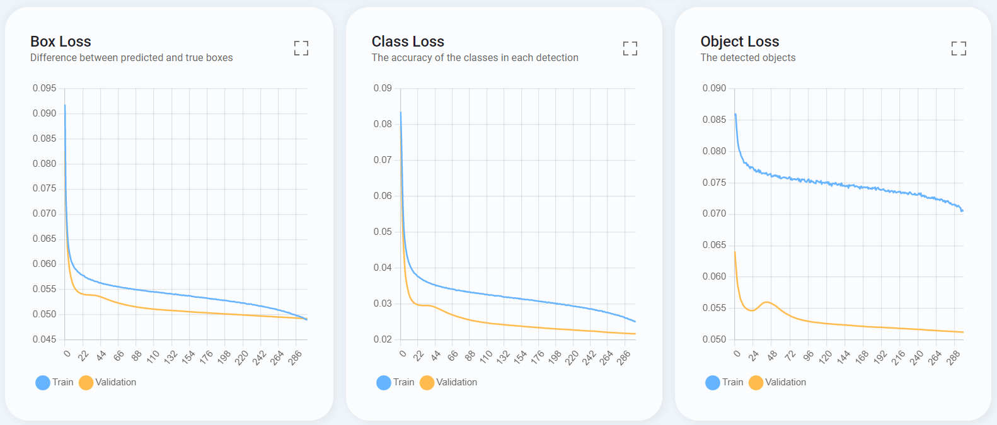

In time there was improvement in different versions of yolo:

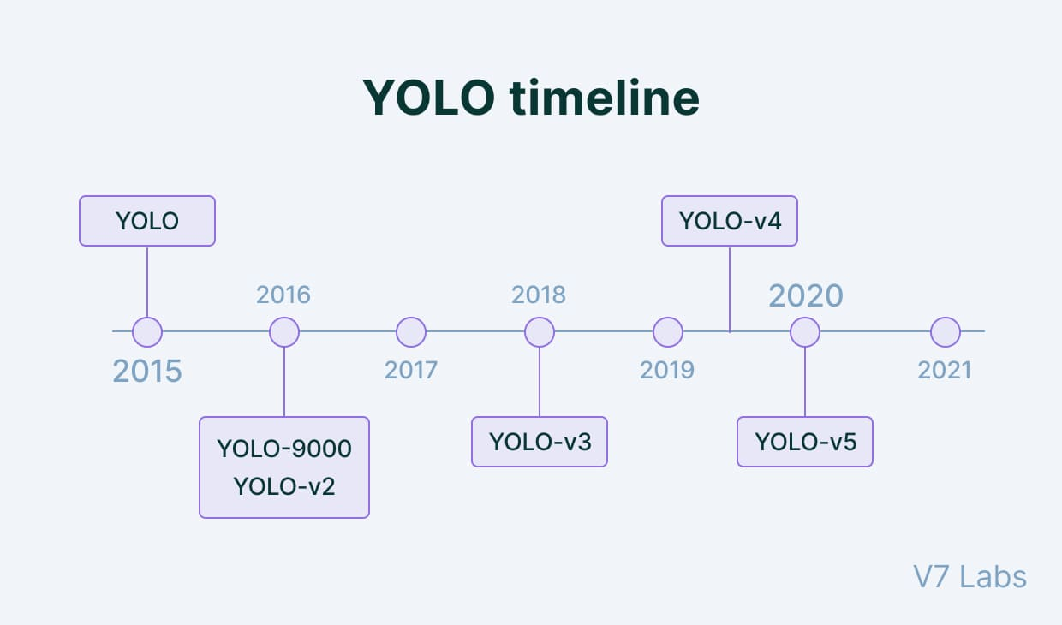

in this project we used Yolo v8 which is more faster and more acuter.



### Raspberry pi and Arduino connection

Both the Raspberry Pi and Arduino Uno are very powerful devices, good at different things. The Arduino boards are awesome at reading inputs and outputs from various different things.

The Raspberry Pi is basically a mini, open-source Linux computer. If you put these two together, your options are limitless. he Raspberry Pi’s computational muscle and the Arduino Uno’s precision and I/O capabilities mean that together, they’re an excellent team.

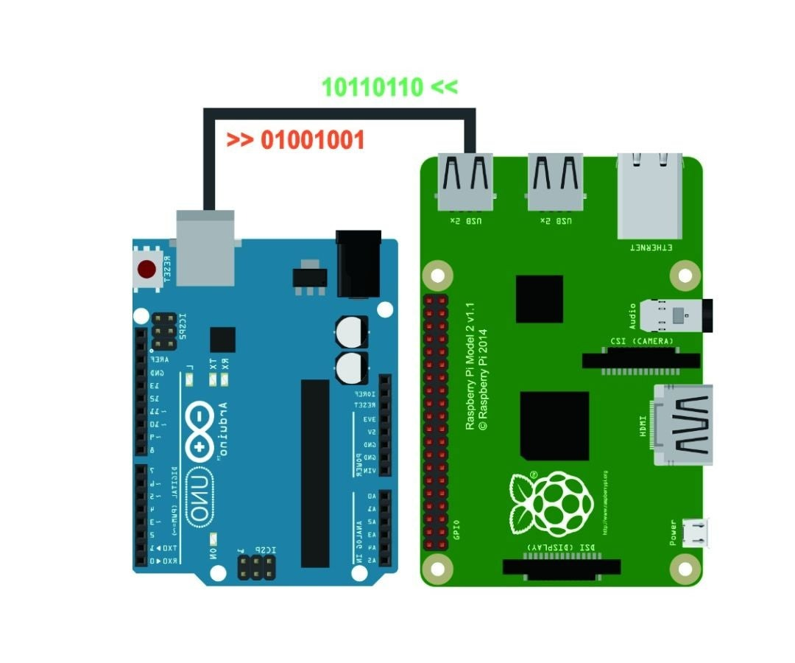

### DH11 sensor connection

First, the DH11 sensor is connected to Arduino.

The wiring diagrams/schematics below show you how to connect 3 or 4 pin temperature and humidity sensors to the Arduino Uno. A 10 kΩ pull-up resistor is needed between the signal line and 5 V to make sure the signal level stays high by default.

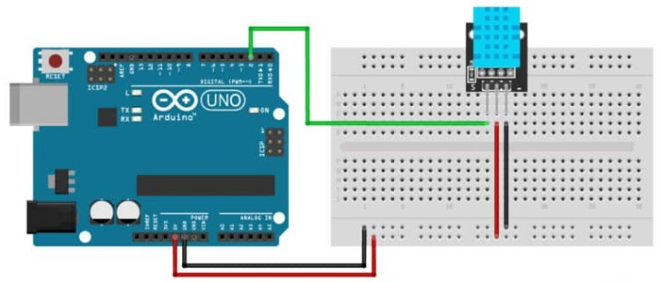

Pin (+) connected to 5v in Arduino, pin(s) signal pin that will send the reads connected to digital pin 2 and to 5 V via 10 kΩ resistor and pin (-) connected to GND in Arduino.

Then we connect the Arduino to raspberry pi to send the sensor data to firebase to make connection with flutter app.

Through connection of the Arduino with raspberry pi and connection of raspberry pi with firebase the reads will send to the database collection.

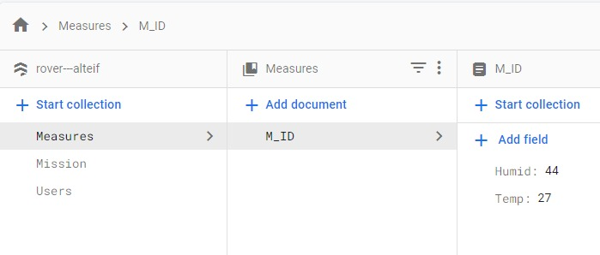

### Live video creation

With the Raspberry Pi powered off.

1. Open the camera port by gently lifting the plastic lock upwards.

2. Insert the ribbon connector with the blue tab facing the USB / Ethernet ports.

3. Close the lock on the connector and give it a very gentle pull to make sure it is in place.

4. Power up your Raspberry Pi and then go to Preferences >> R

5. Click on the Enable button for the Camera found in the Interfaces tab raspberry Pi Configuration, and click on Enable button for the VNC

6. Click Ok and reboot the Pi.

7. Take the IP address of the wan

8. Install pi camera stream flask library dependencies:

Open a terminal window an paste in it the installing dependencies commands.

9. In a terminal git clone pi-camera-stream-flask

Open the folder -> and run main.py file

10. Add a model of object detection YOLO V5 to the live video streaming.

11. Go to the browser and search for the IP address even in any other devices has connected to same wan the live video stream will appear.

12. We paste this IP to the URL launch flutter code to get the live video in our flutter application.

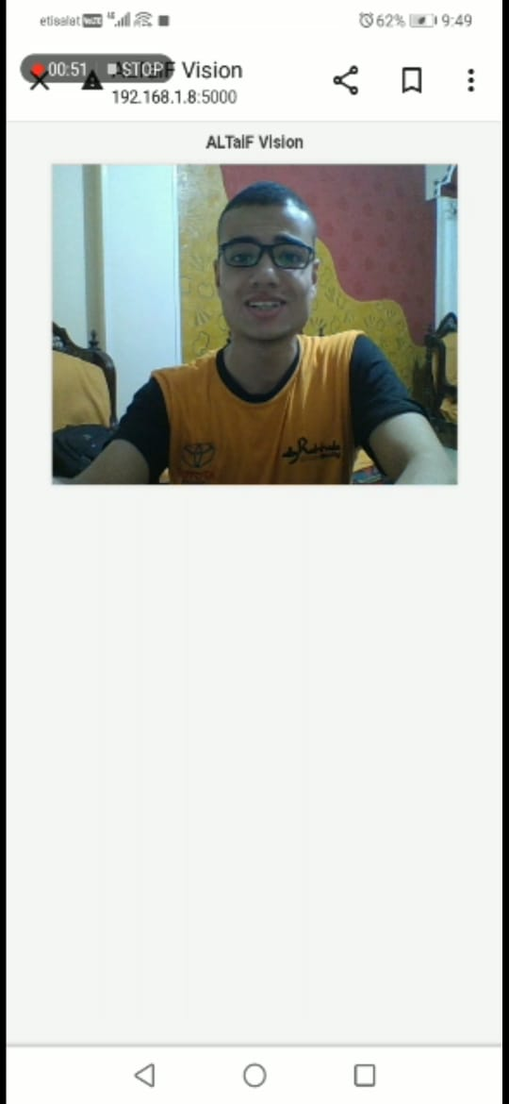



### Map generation

The map is the line that the rover moves in, it is represented as an image and the line is white dots in black background, and these are the steps that followed to do it:

1- generate a zero matrix that represents the background of the map.

2- initialize the start point in the center of the matrix.

3- initialize the middle line

4- the two lines right and left determined be two ultrasonic sensors reads.

5- if the rover moves forward, we decrease the X axis value and two ultrasonic sensors reads putting in right and left value in y axis.

6- if the rover moves right, we increase the y axis value and two ultrasonic sensors reads putting in right and lift value in X axis.

7- if the rover moves left we decrease the y axis value and two ultrasonic sensors reads putting in right and lift value in X axis.

8- if the rover moves right and then right or left and then left we increase the X axis value and two ultrasonic sensors reads putting in right and left value in y axis.

9- if the rover moves right and then left or left and then right, this is tha same case of moving forward and it do the same function ...etc.

1. after we generate the matrix of movement we convert it to binary image.

the process is done as the Arduino sends through the serial port to raspberry pi a message consists of 3 things. first, the direction that Altaif takes. The second and third things are the distances that ultrasonics read from the right and left of the rover.



### Report by power pi

### Power pi overview

Power BI is a Business Intelligence tool developed by Microsoft. It helps you interactively.

visualize your data and make intelligence-based business decisions as a result.

Key features of Power BI:

• Quick set up comparative to traditional BI

• Interactive visualizations

• Supports different data sources (Microsoft or otherwise)

• The ability to publish to web (app.powerbi.com)

• Cloud-based, no on-premises infrastructure needed

• Scalable

• Accessibility - view the dashboards/reports on iPad, iPhone, Android, and Windows devices Scheduled data refresh.

### Power pi Desktop

Power BI Desktop is used to access data sources, shape, analyse and visualize data, and publish reports to the Power BI service. Once installed on your local computer, it lets you connect to data from different sources, transform, and visualize your data.

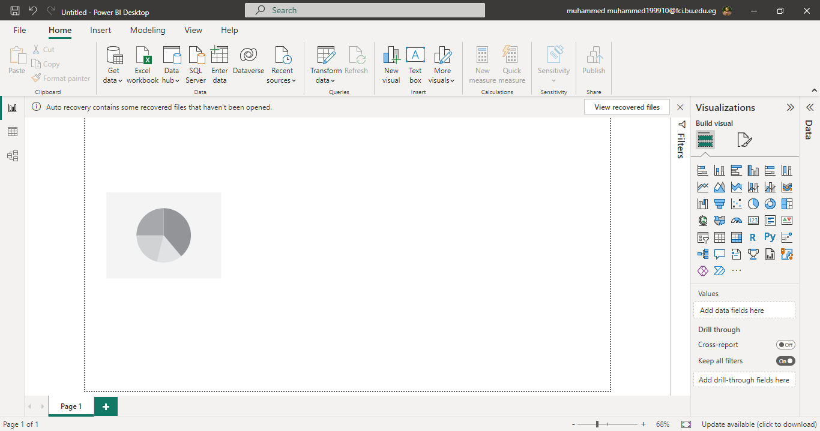

### Sample data

You will have received the sample files in your email (alongside this guide).

1. Follow the link “You’ll also need to download these sample files”.

2. Download the sample files (called Adventure Works DW Scripts).

3. Save the compressed file to your local computer and unzip the content into a folder

that can be accessed by Power BI Desktop.

Then

• Browse to the saved data files. Dim Customer, Dim Date, Dim Product,

DimProductCategory, DimProductSubcategory, FactInternetSales.

### Phases in Development

Power BI visual design is easy. Once you connect to a data source, you can shape.

the data (remove columns, change data types, and so on), do data modelling (create

relations) and design visuals.

This guide steps you through the following phases:

• Connecting to data sources

• Shape the data

• Model the data

• Report on the data

### Connection to data source

This process is followed at the start of a new project, to import the data that you’ll be working with, and at any point in the future when you need to add new data to the project.

• When you launch Power BI Desktop, a welcome splash screen is displayed.

• To connect to the sample data for this exercise, select Get Data on the left-hand menu of the splash screen or from the home ribbon.

• Select Text/CSV from the list and click Connect.

• Browse to the unzipped data files you saved in step 3.2, select the first file

DimCustomer.csv and click Open.

• When you click Open, the below window appears, displaying sample data from the selected file.

• Repeat the same process and load all other sample files (DimDate, FactInternetSales,

DimProduct, DimProductCategory, and DimProductSubCategory).

Note that you will have to load these one at a time.

• At this point it would be useful to Save the Power BI Desktop model.

The data has now been loaded into the Power BI model and you have a blank canvas to

start working with.

Let’s take a moment to explore this report canvas, the Power BI Desktop application:

1. The left menu is used to switch between, Report Design, Data Transformations

and Data Modelling (creating relationships within your data).

2. The Report Canvas is for Visual Design and Layout.

3. The Application ribbons contain all options and settings, visual or page level

properties, and another settings configuration.

4. The report building panes contain all the components that may be added to a

report. You can:

a. Select fields and data from imported tables on the Fields pane.

b. Select different ways to display this data from the Visualizations pane.

c. Apply filtering to the data in the Filters pane.

### Reporting on the Data – Creating Visualizations

Now that the data has all been uploaded and modelled, we can begin reporting on that data.

### Building Basic Visualizations

Let’s start with a graph to support a simple business case.

to track the value of our website bike sales over the last few years.

• Switch to the Report Design view

• Select the Stacked Column Chart visual from the Visualization pane

• This will add a grey “place holder” graphic to the Report Canvas.

• Using the Fields pane on the right of the screen.

### Visualization Interactivity

With multiple visualizations visible on a page, Power BI Desktop allows you to cross highlight data between visualizations. You would do this to further drill down into your

data.

• In the Report Design view, looking at the two visualizations created above, click on

the Professional slice of the Pie Chart.

• Not only is this slice highlighted, but the portion of Internet Sales related to

Professionals are also highlighted on the Stacked Column Chart.

### Date Dimension – Time Intelligence

We’ll now create a table that displays the sales amount and sales amount YTD.

Time intelligence provides richer analytics by providing measures that simplify time-based reporting, for example, time-based calculations for Year-to-Date (YTD), Month to-Date (MTD), and Previous Period comparisons. The Date dimension (Dim Date) is the

basis for time intelligence reporting in this example.

Initial Configuration

• Switch to the Data Transformation view.

• Select the Dim Date table from the Fields pane on the right.

• Check that the Full Date Alternate Key column has its Data Type set to Date.

### Adding a Time Intelligence Quick Measure

Power BI Quick Measures are pre-defined calculations provided by Microsoft and can be created on the fly.

• In the Data Transformation view, select the FactInternetSales table in the Fields pane.

• On the Home ribbon, click Quick Measure.

• In the Quick Measures dialog, go to the Calculation drop-down box, select Time

intelligence and then select the Year-to-date total.

• From Fields on the right

o Go to FactInternetSales table and then drag Sales Amount into the Base

value box.

o Go to Dim Date table and then drag FullDateAlternateKey into the Date box.

• Click OK.

• Power BI Desktop adds your new measure to the Fields pane and displays the DAX code that was generated

• Switch to the Report Design view

• Select the Table visual from the Visualization pane

• Using the Fields pane on the right of the screen, complete the following steps:

i) From Dim Date expand FullDateAlternateKey and tick Date Hierarchy, Year and

Quarter.

ii) From FactInternetSales, tick Sales Amount and Sales Amount YTD.

• Click Save

The Report Canvas now shows a table of Sales values, by Quarter, with the accumulated.

Year to Date values alongside.

### Firebase connection

- **Authentication:**

We create to our application users ID by registering options by email address may be gamil account, phone number and password. from log in options if you write wrong email or password, you will receive a warning message,

or if you forget the password you can reset it by receiving a mail with your new optional password. every registered user will be added to authentication users by his emil address and unique ID.

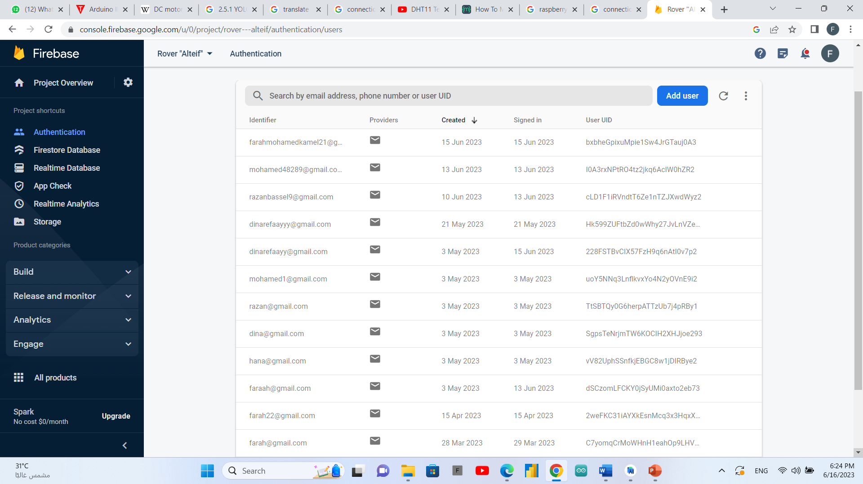

- **Storage:**

we use firebase storage to send and receive images through it to get the output map images from the rover to our flutter application automatically and make like a gallery of maps in our application, directly after ending each mission by clicking on map button on a preview page the user will receive the last uploaded map to the firebase storage, or by clicking on maps button the user will see all stored maps.

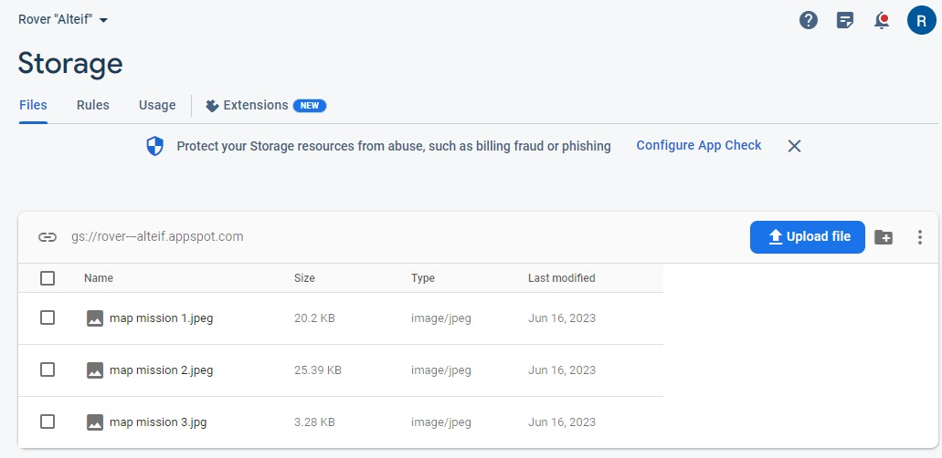

-**FireStore database:**

we made a collection of data that contain each mission with its user observer which are get from flutter application, and DHT11 sensor reads which are temperature and humidity by getting them from Arduino through connecting raspberry pi with our firebase project

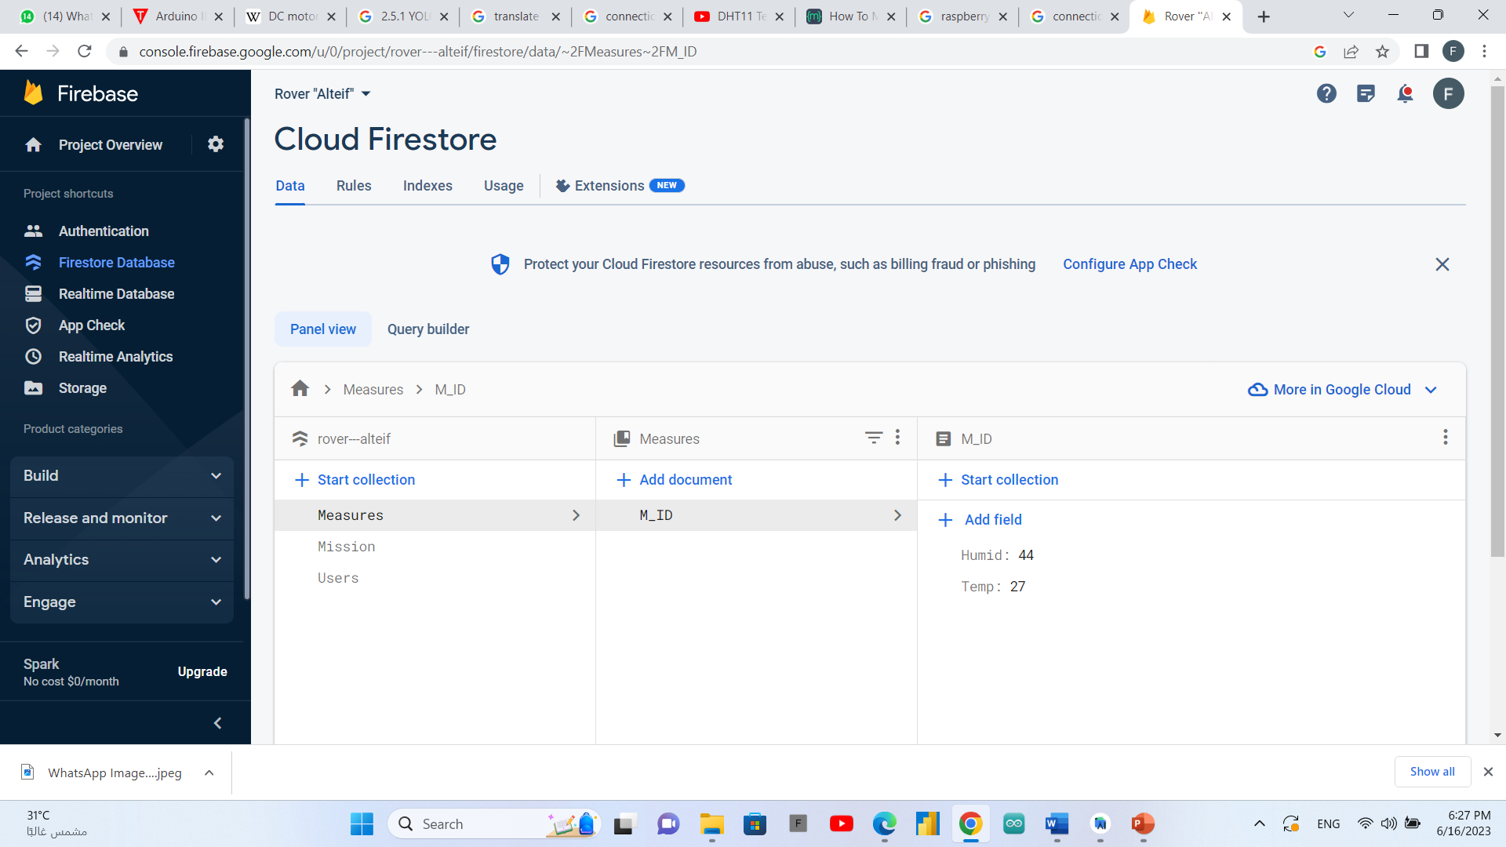

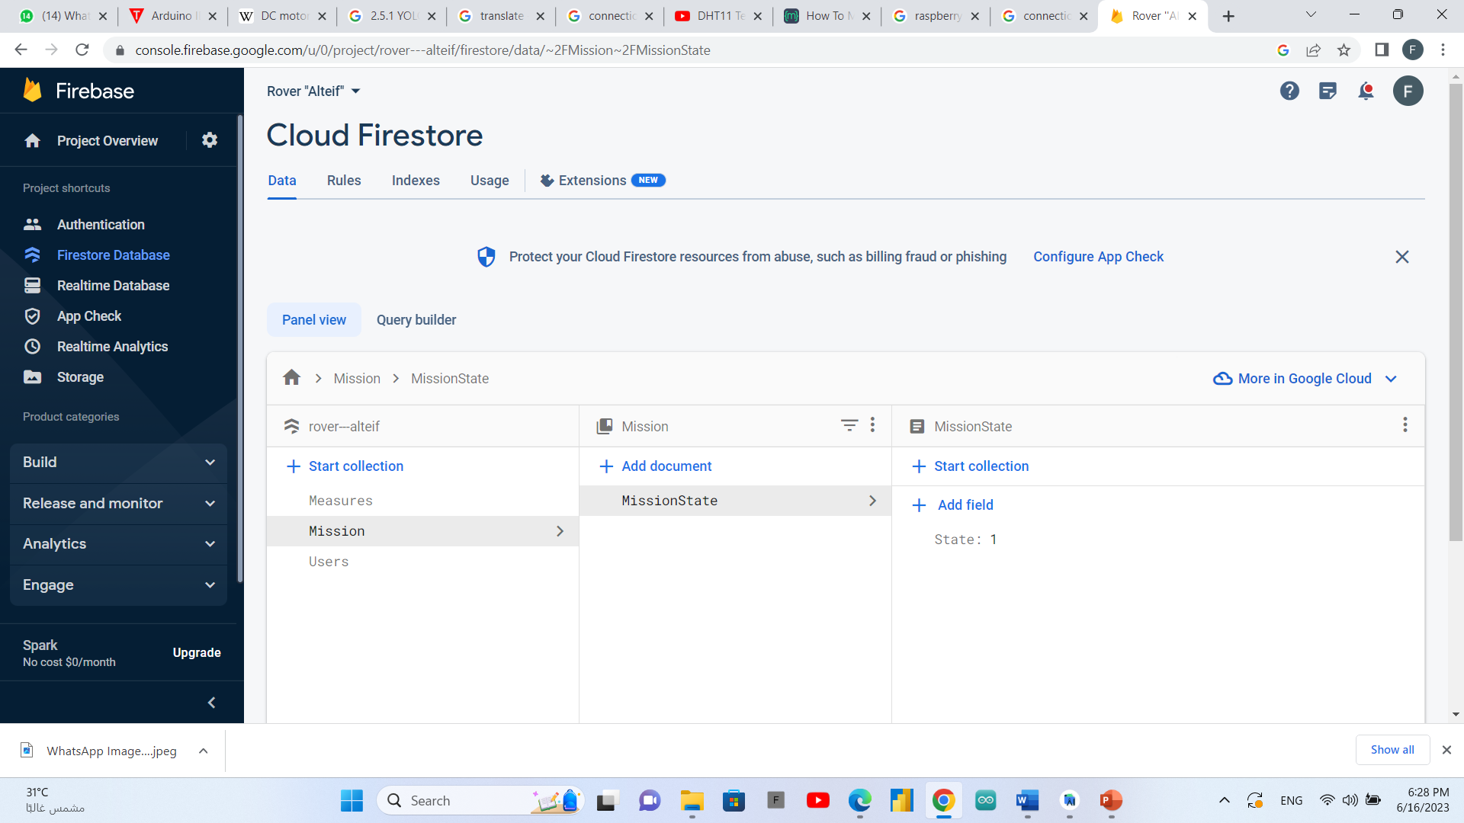

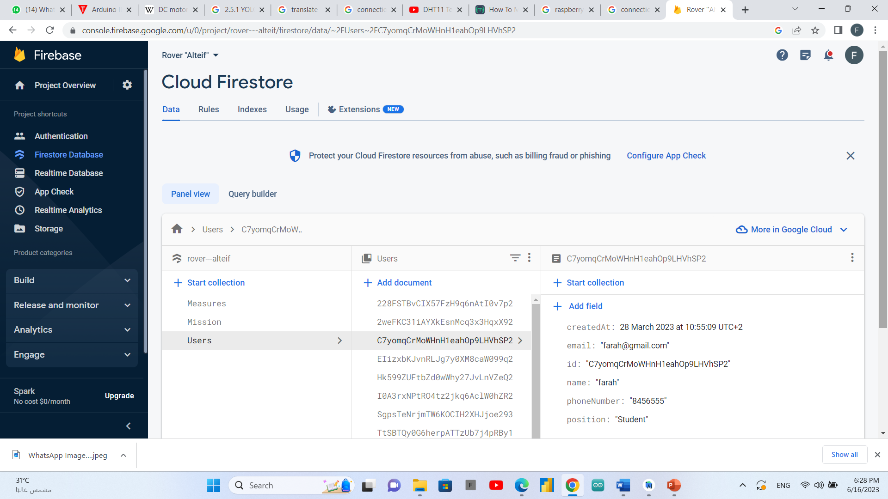

### Application to control rover

The rover starts its mission when the click on start button from the application,

start the live video and object detection by clicking on live video button,

getting a map by clicking on map button,

receives a temperature and humidity by clicking on measurements button,

to end the mission the user will click on the stop button so the rover will stop and creates the report.



## implementation

### Implementation of flutter code

* **Main page**

**We create two buttons in the main screen to control the start and stop of rover and connect them with firebase to send command to our raspberry pi.**

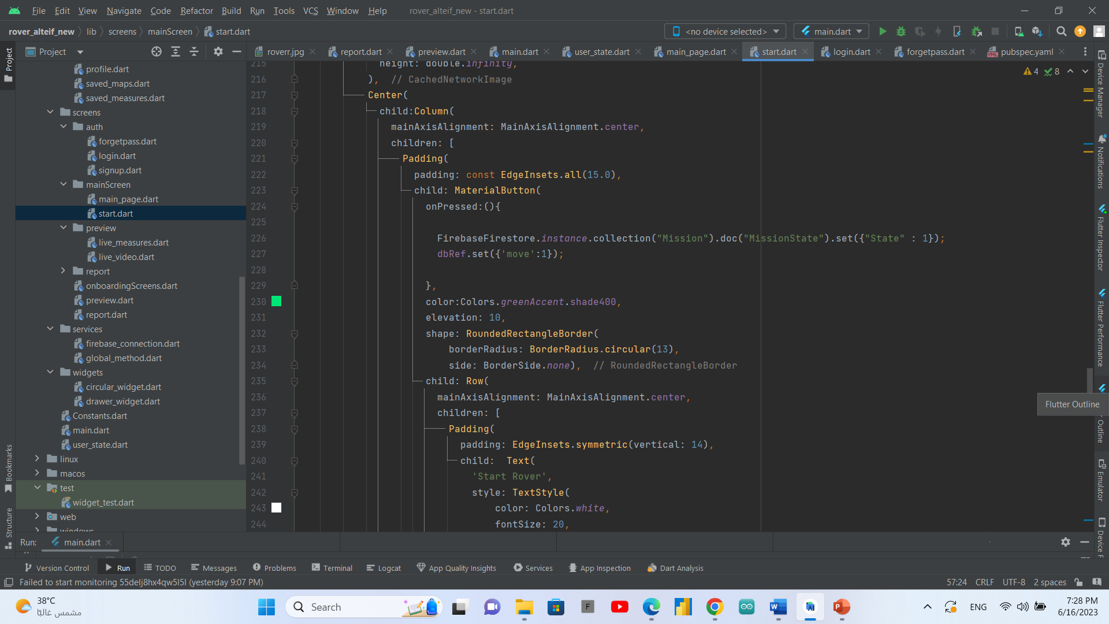

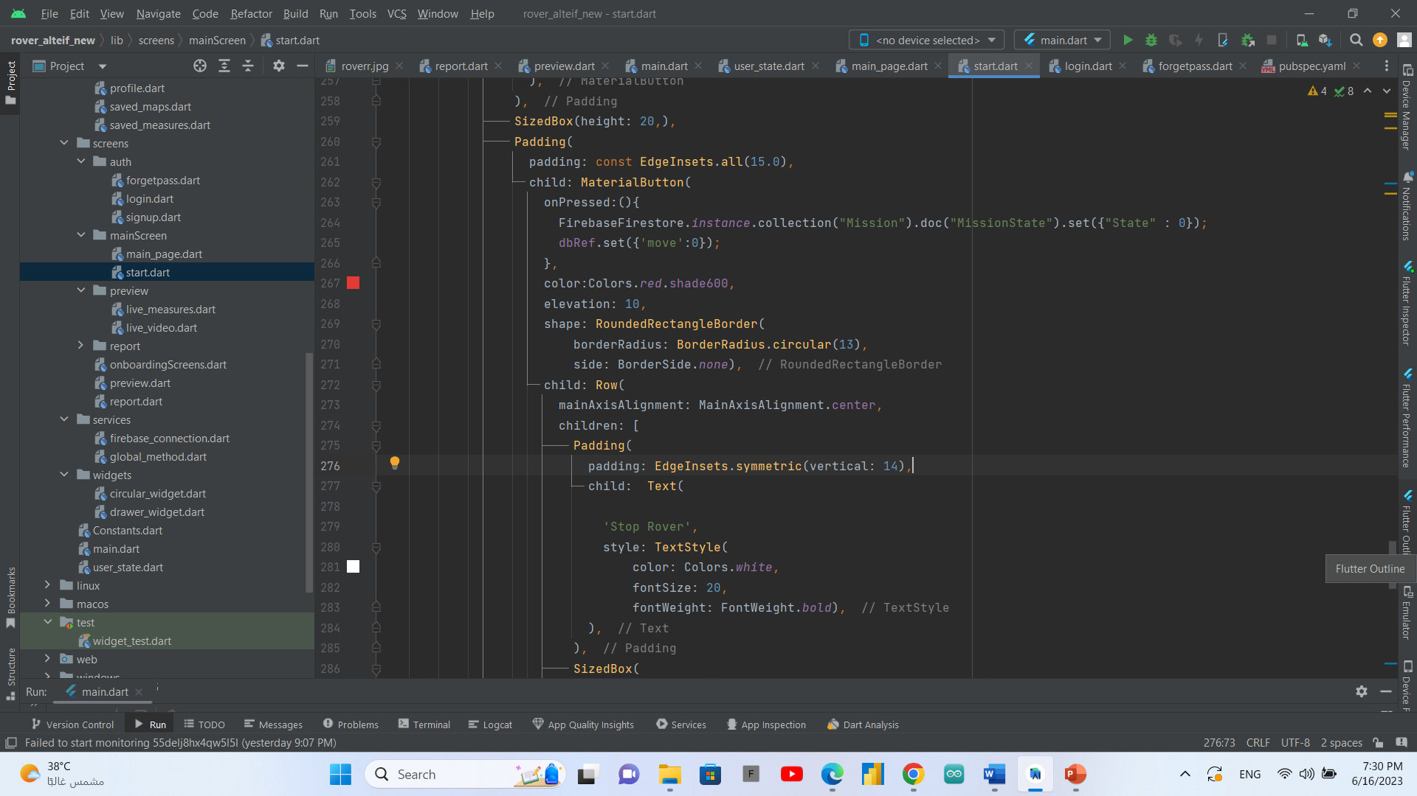

* **live video connection**

**We create a function witch launch the URL of our live video created from raspberry pi by flask**

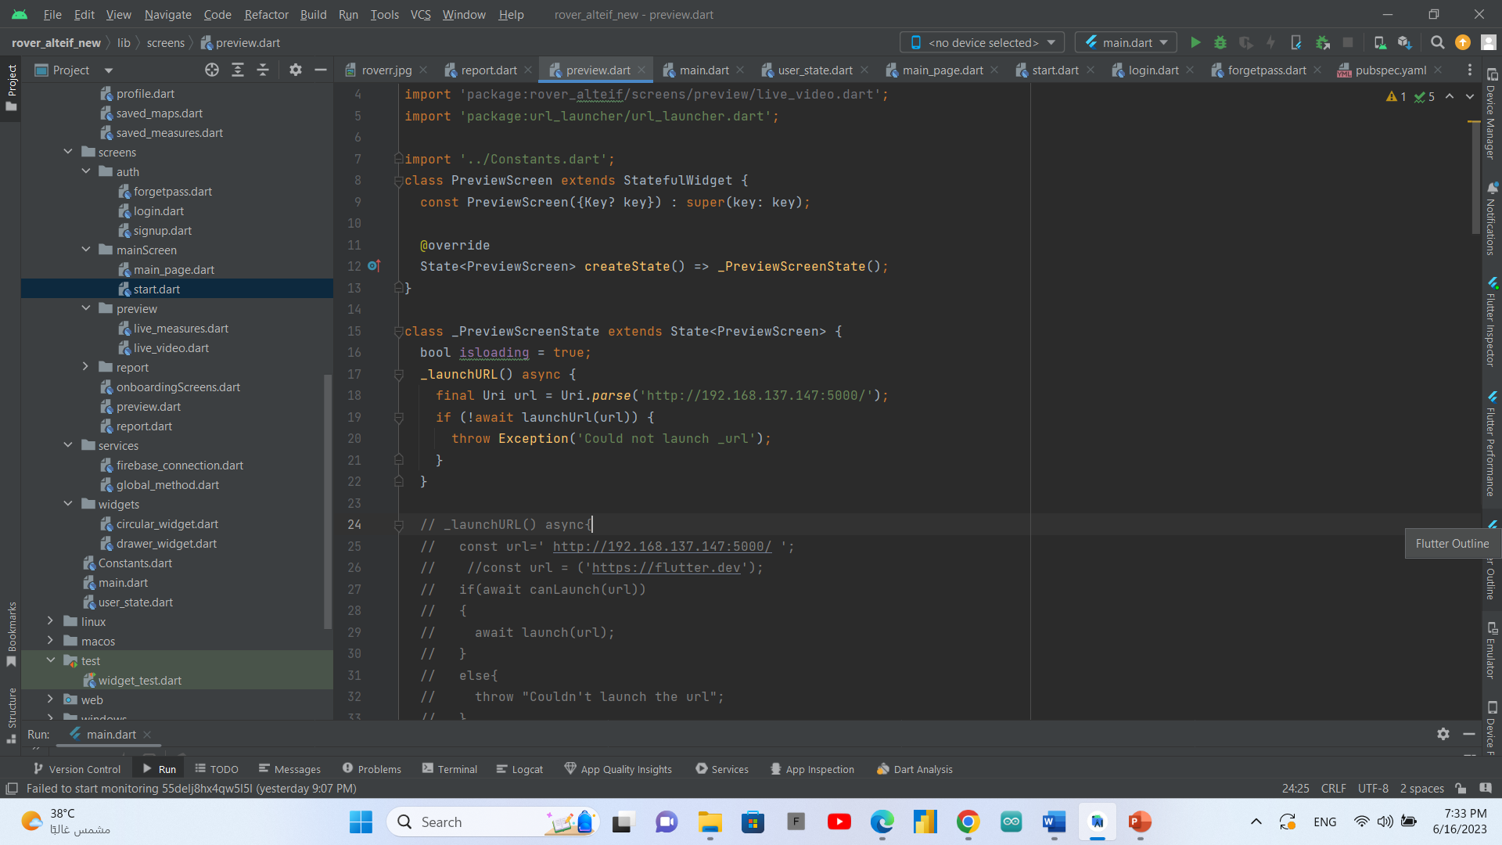

* **Receiving map**

**We uploaded missions’ maps to the firebase storage, we have created a map button on preview page to get the last saved map in the fire base storage, and a map button to get all saved maps from last mission each image has a deletion icon to remove it in need.**

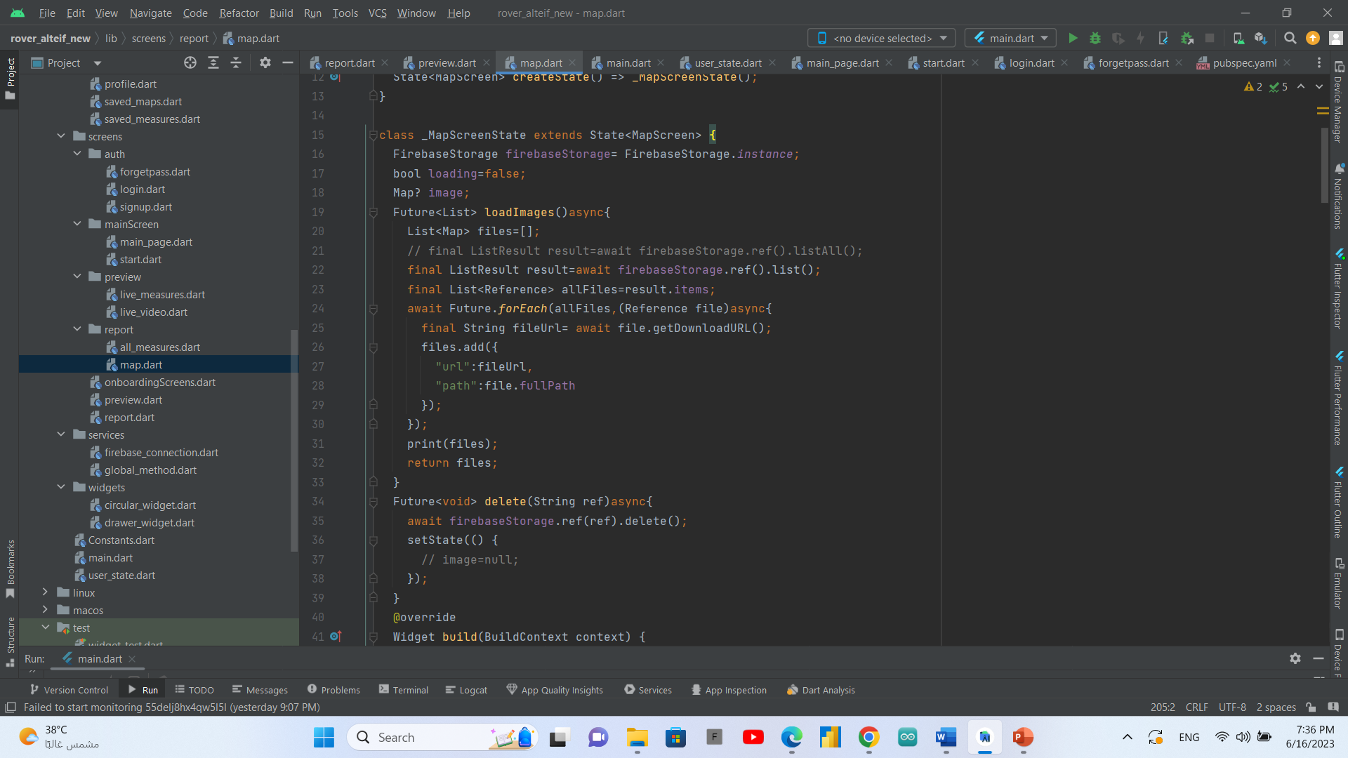

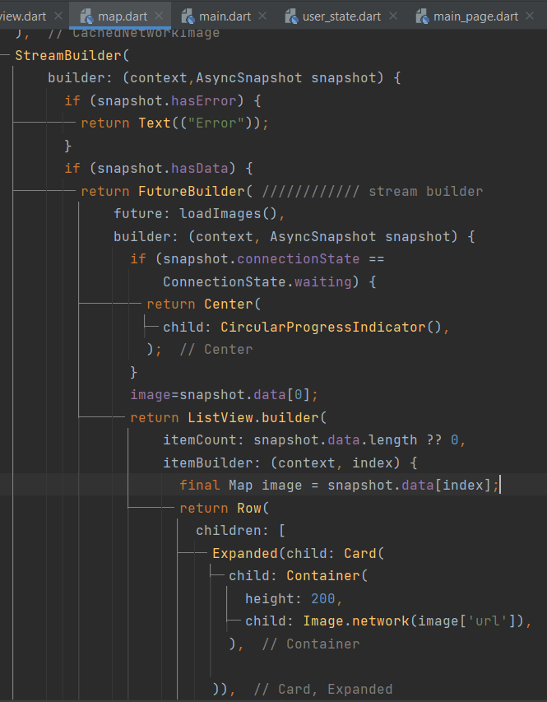

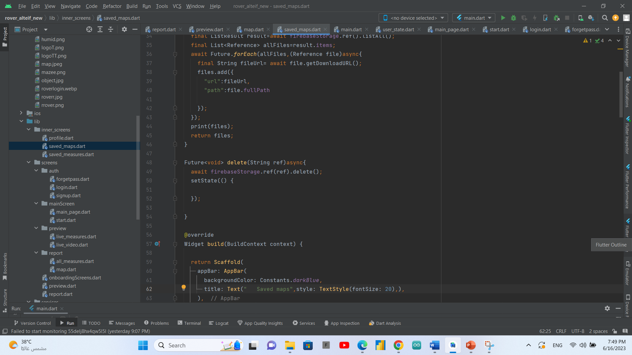

* **Live measurements**

**We created a function that used to get the measurements of temprature and humidity from the firestore database**

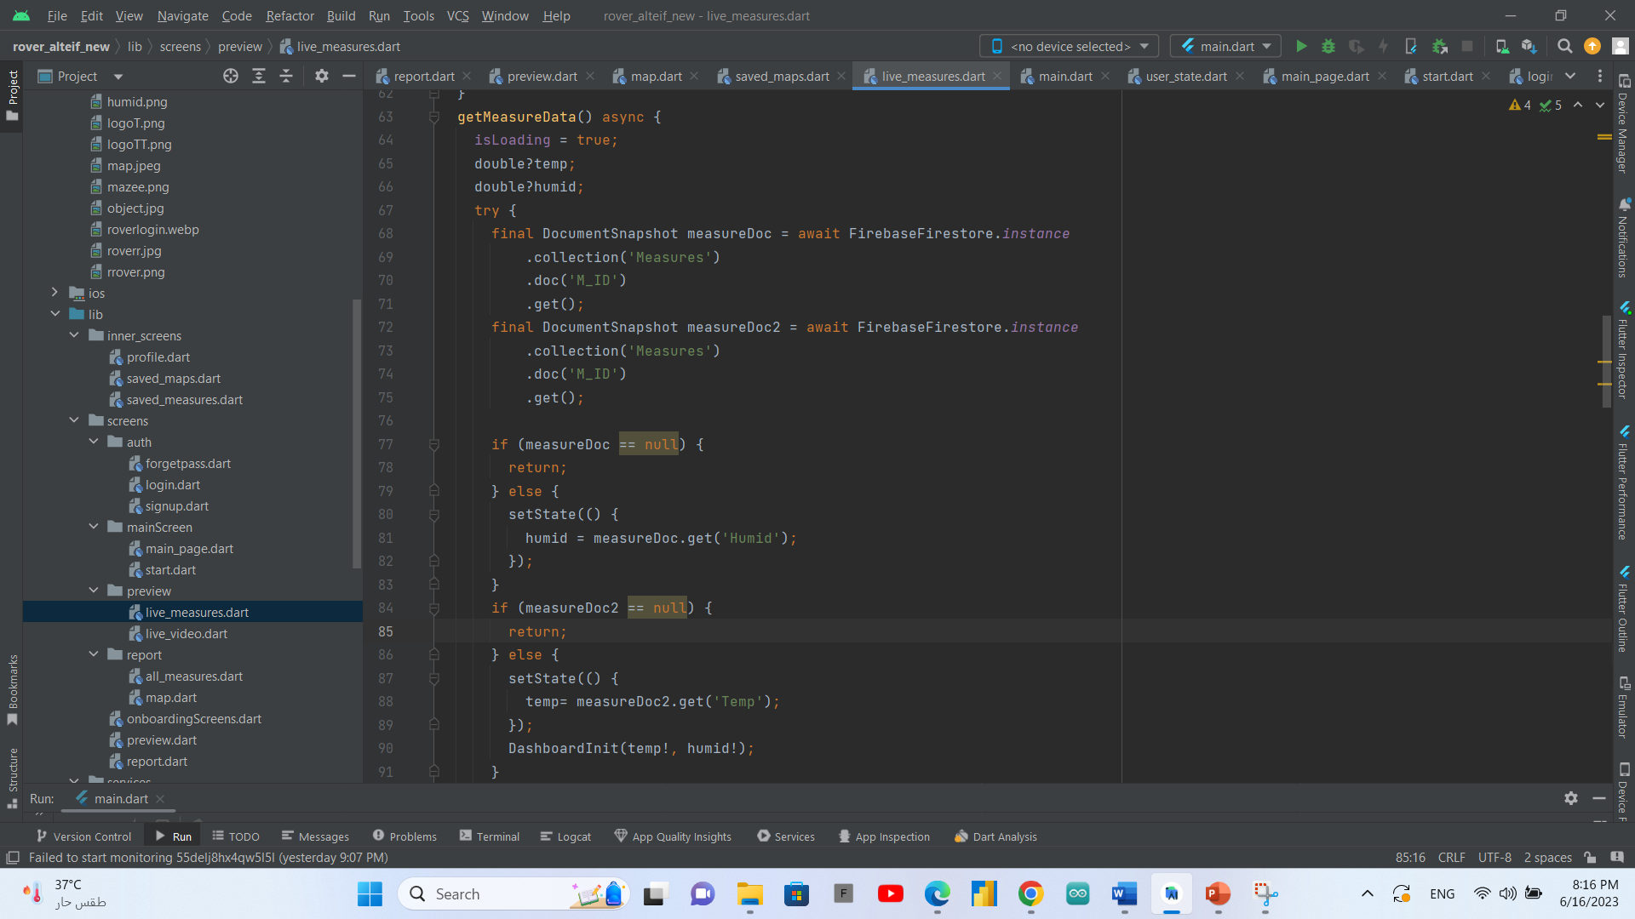

### Implementation of python code using raspberry pi

* **Live video**

**We used flask library to generate live video on raspberry pi**

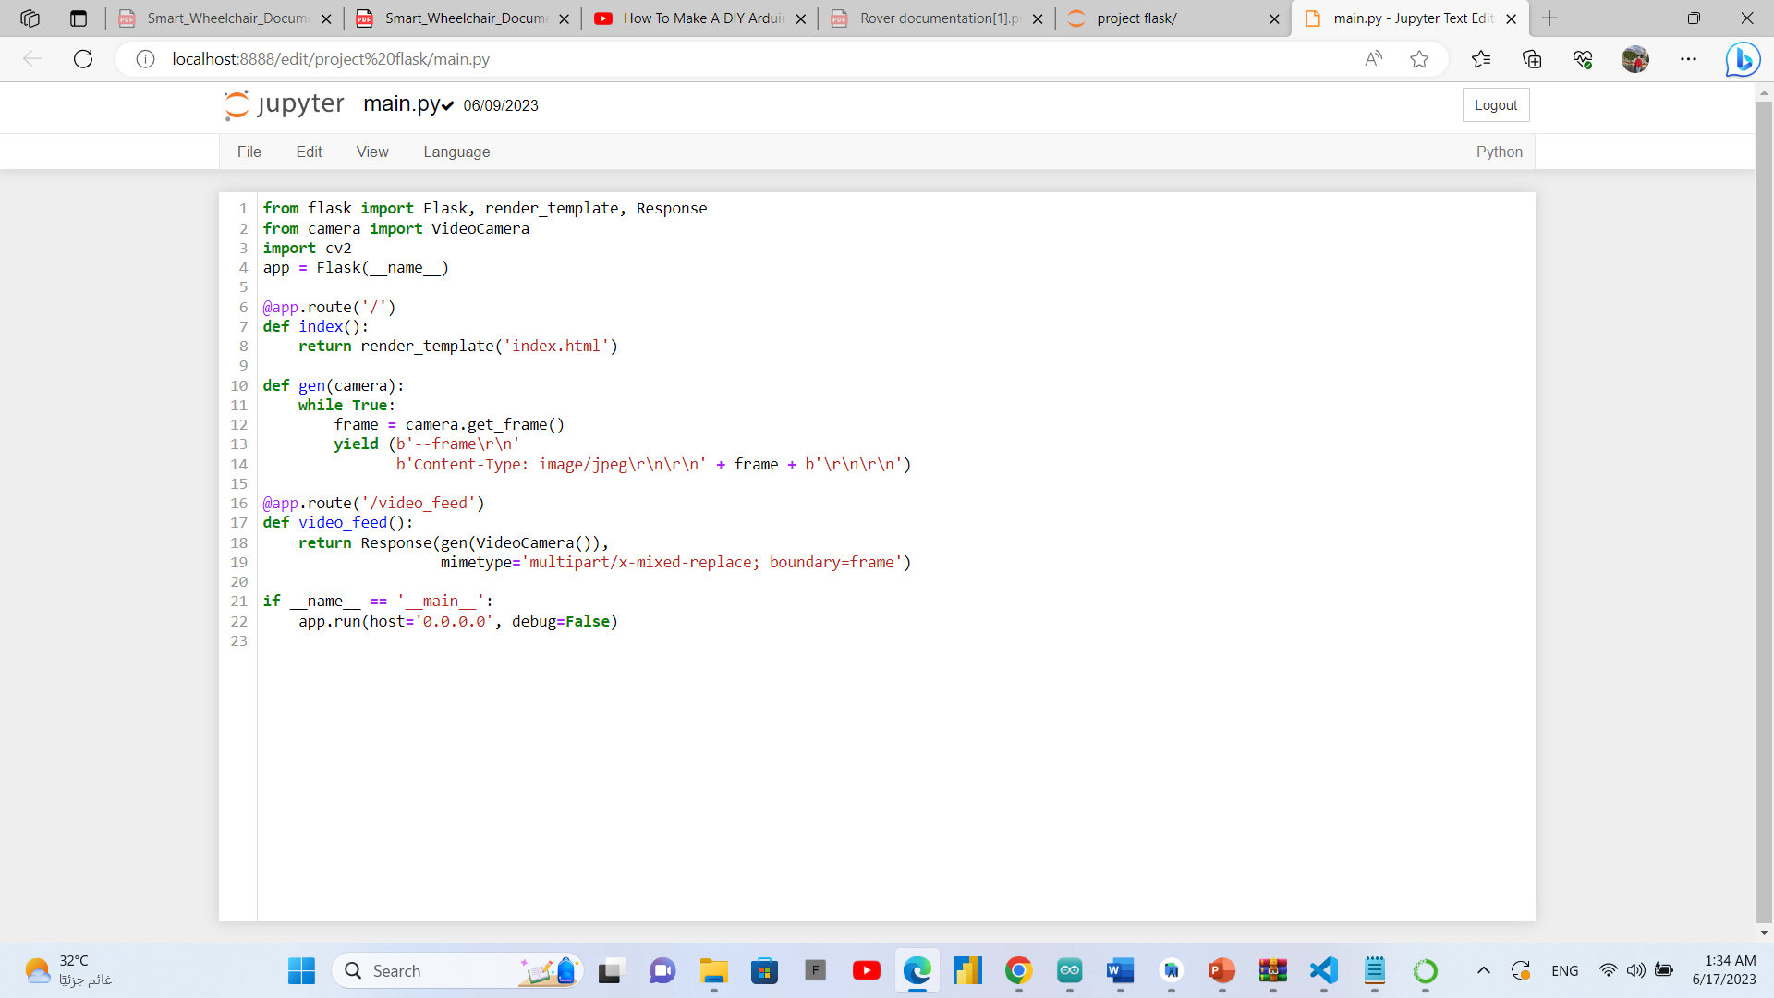

* **Object detection model**

**We used YOLO version 5 to detect objects using raspberry pi.**

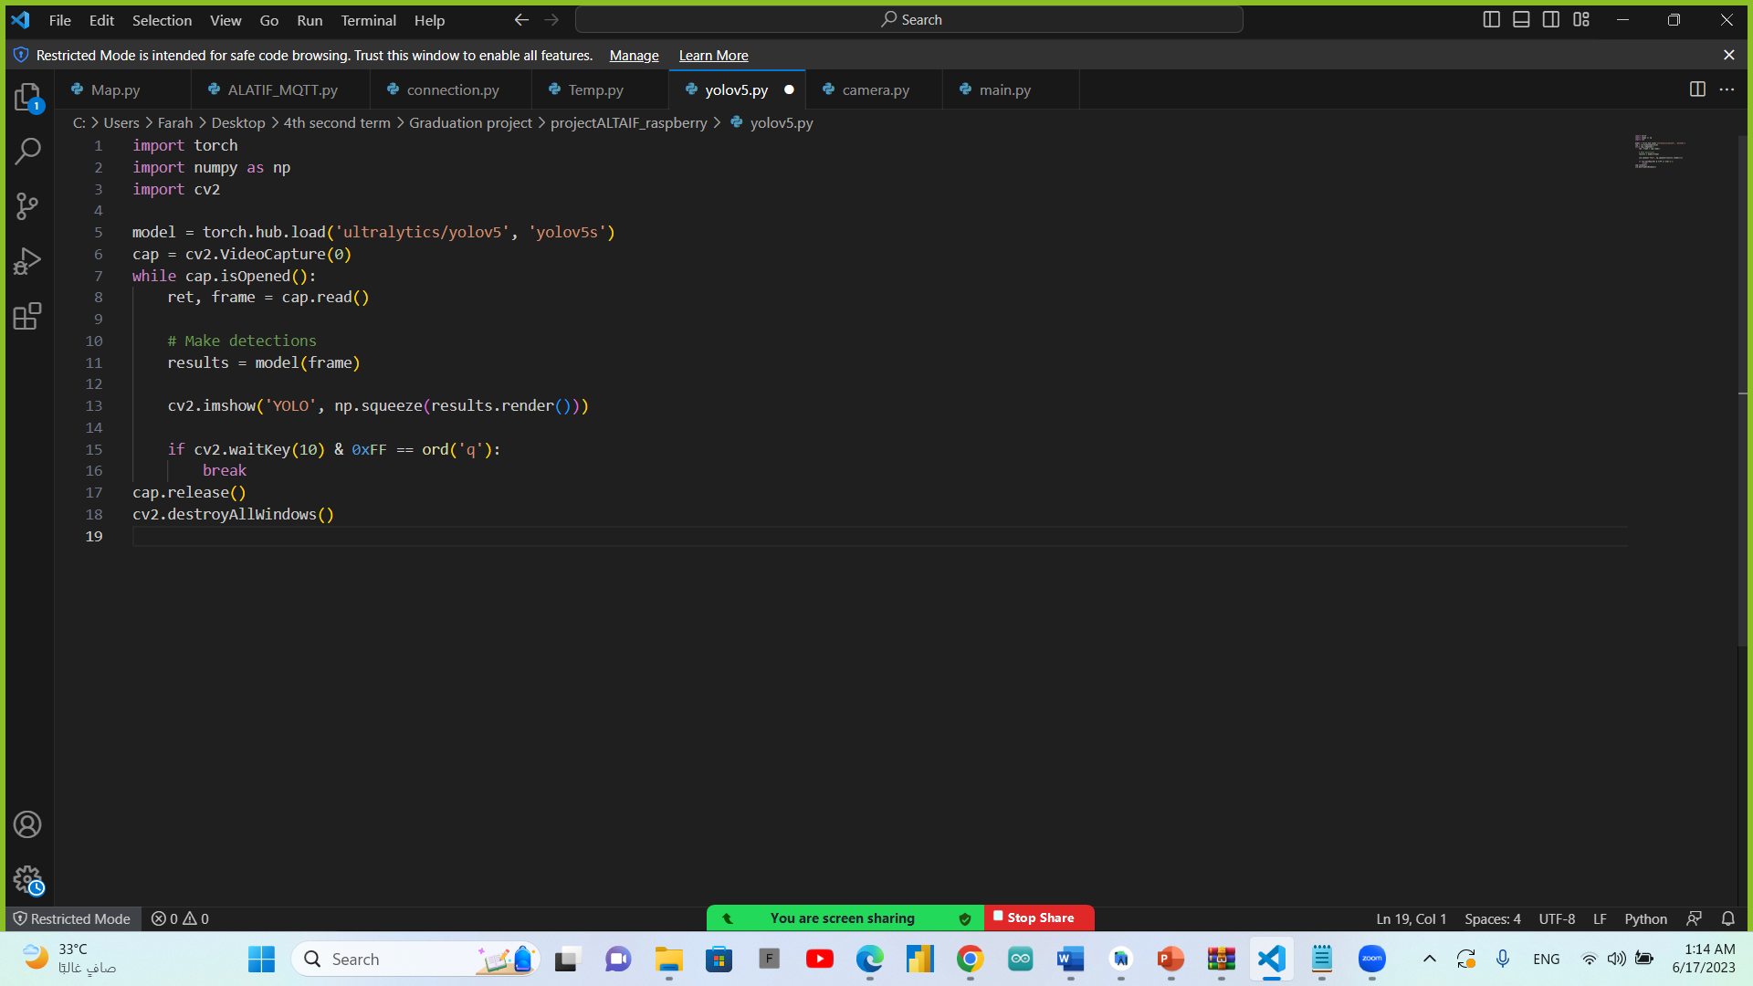

* **Map Generation**

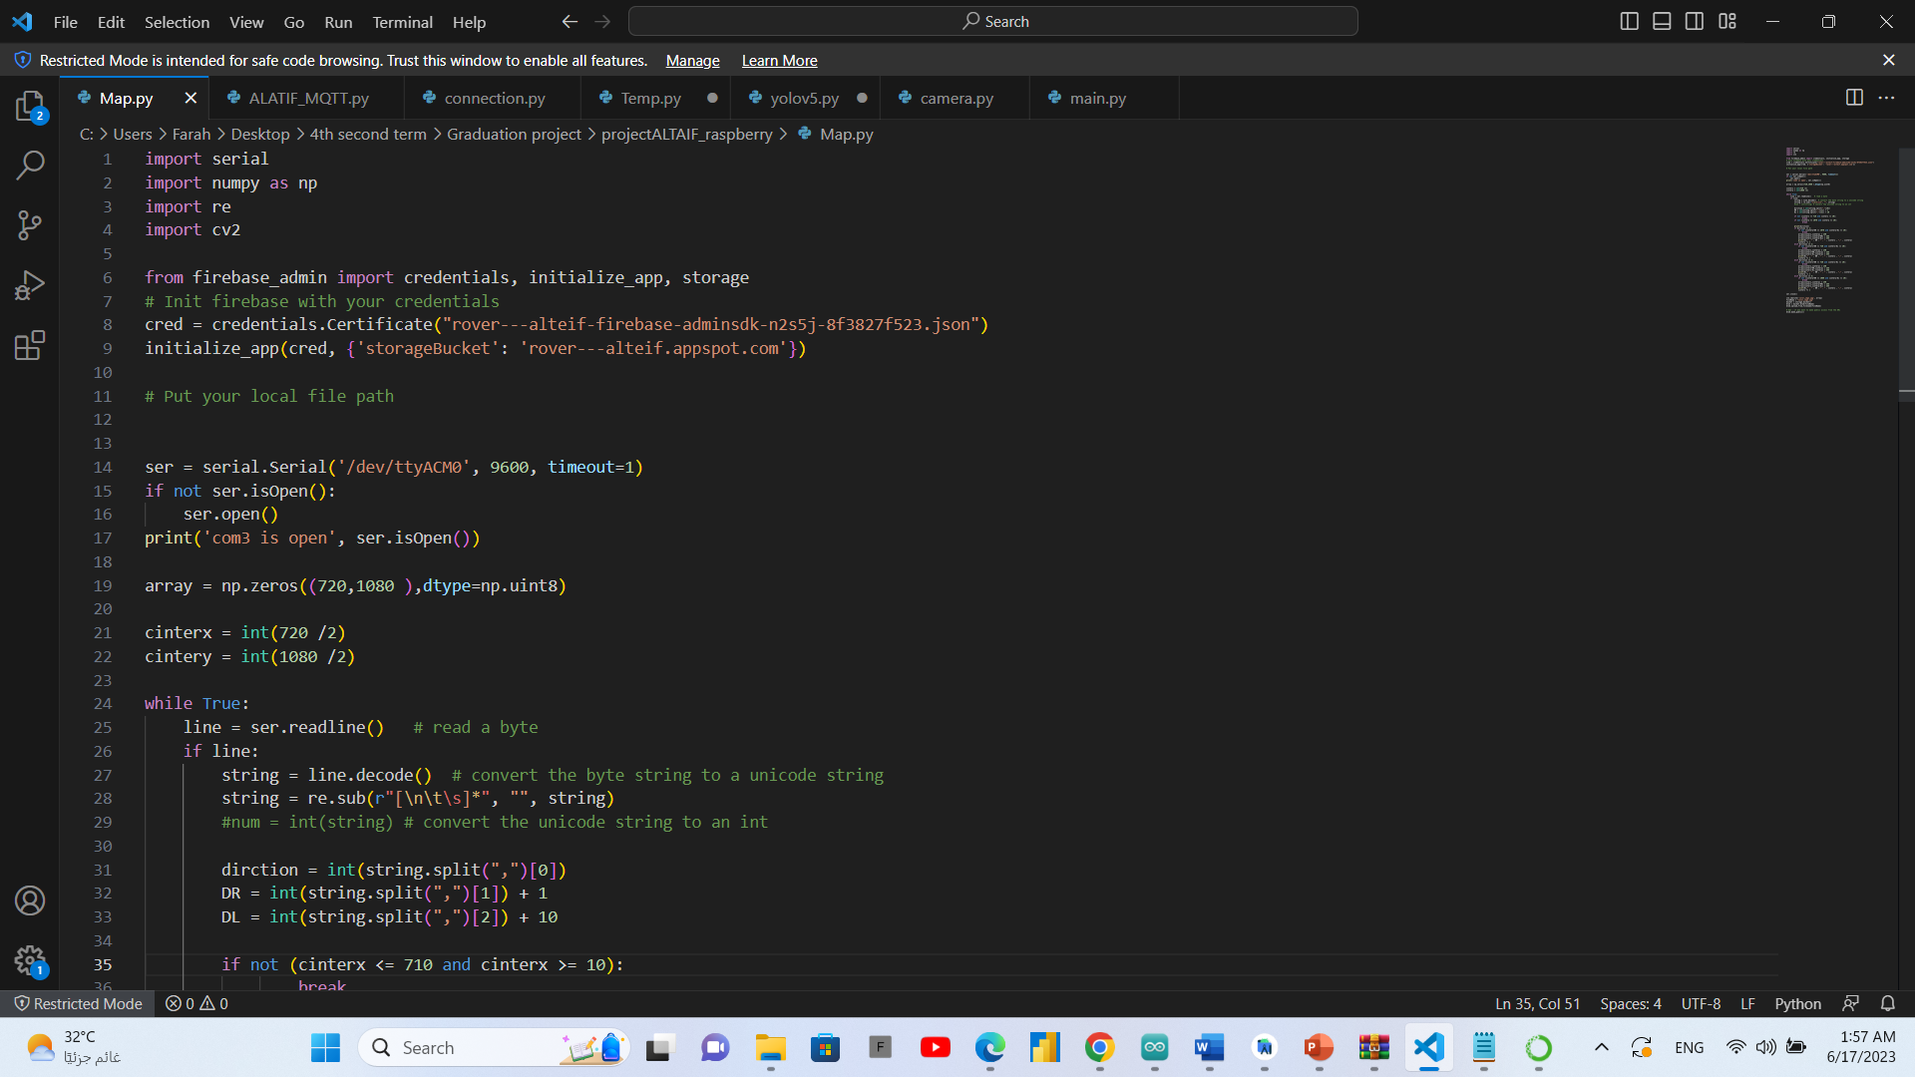

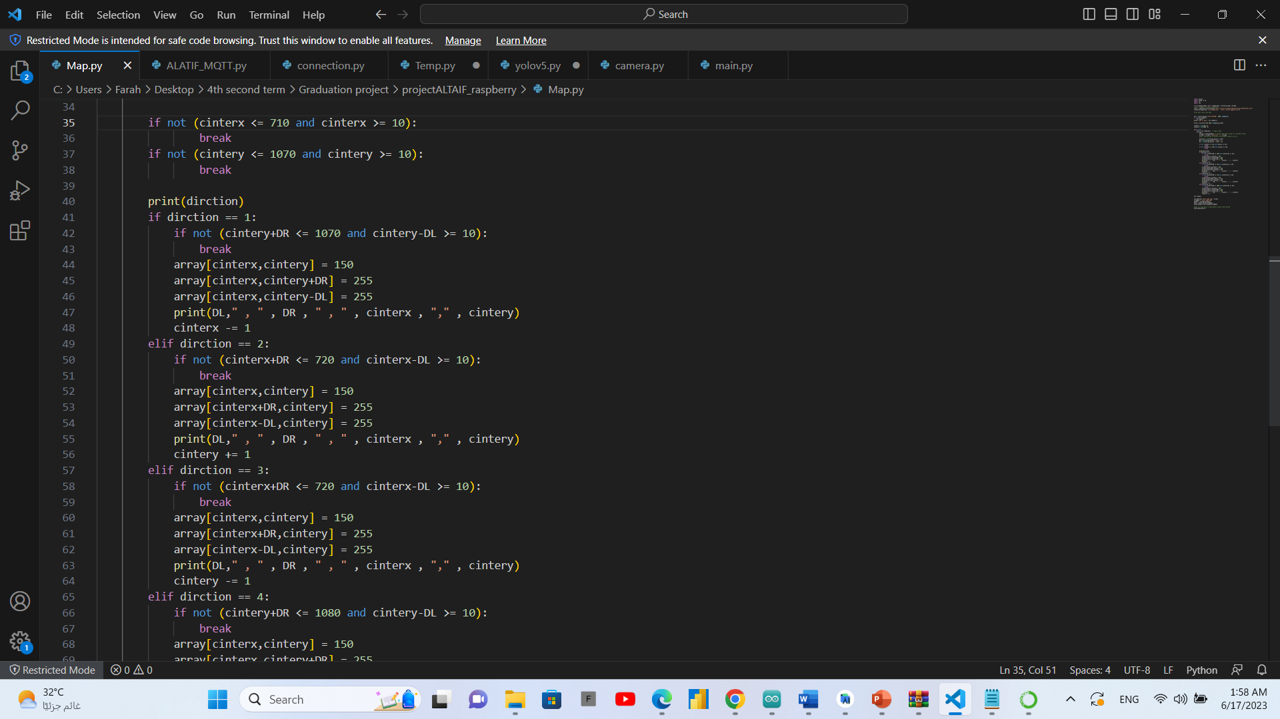

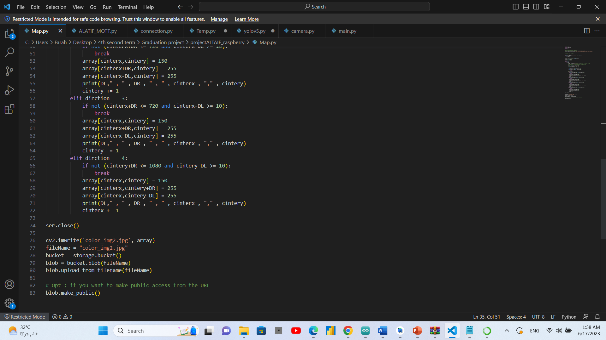

* **Connection with Arduino**

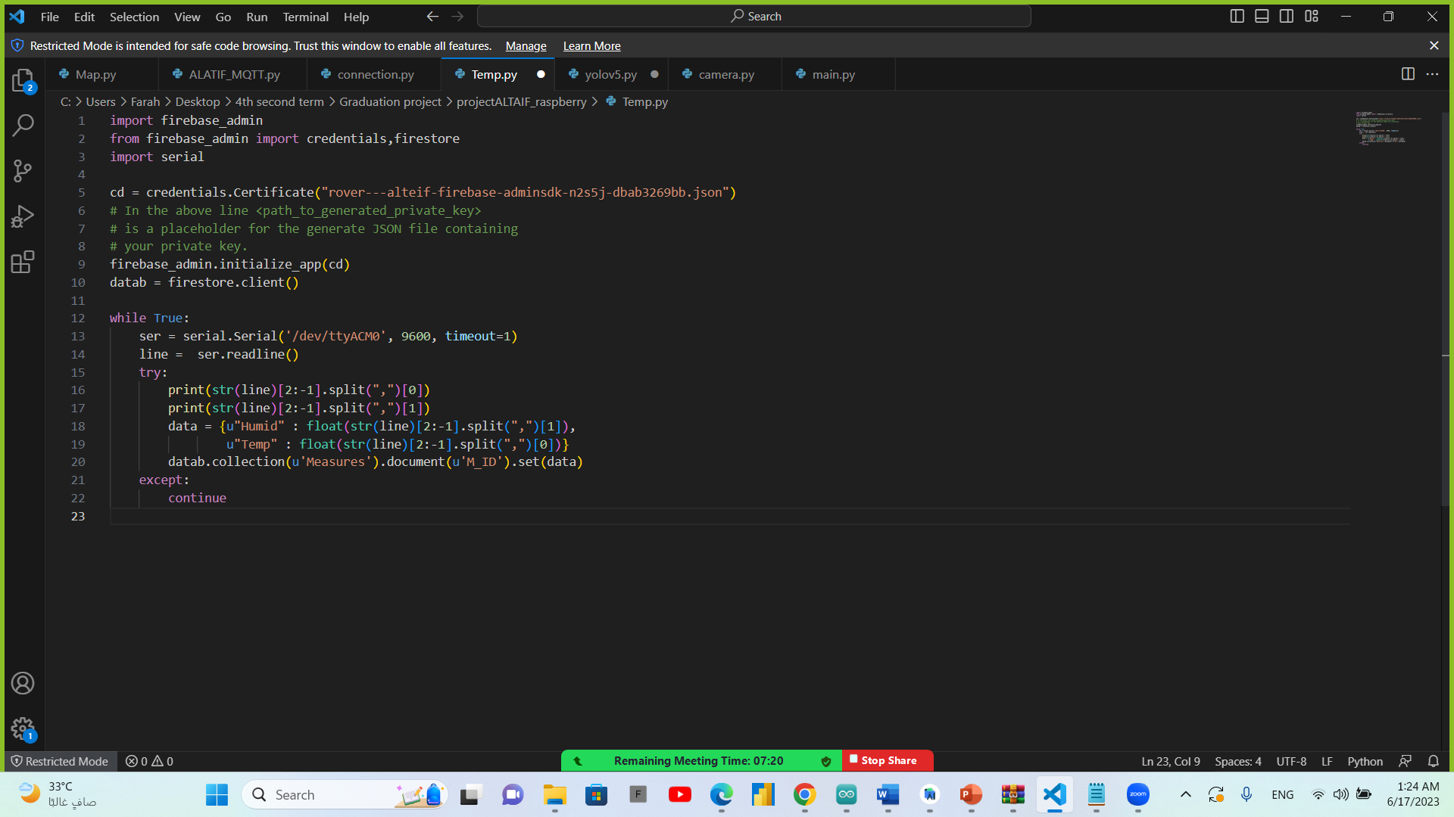

* **Connection with firebase**

We connect the raspberry pi to firebase in order to send or receive data to our flutter application.

In the code below the raspberry pi receives mission’s state from the flutter app through firebase.

If the state is 1 the raspberry pi sends order to Arduino to start moving the rover.

If the state is 0 the raspberry pi sends order to Arduino to stop the rover.

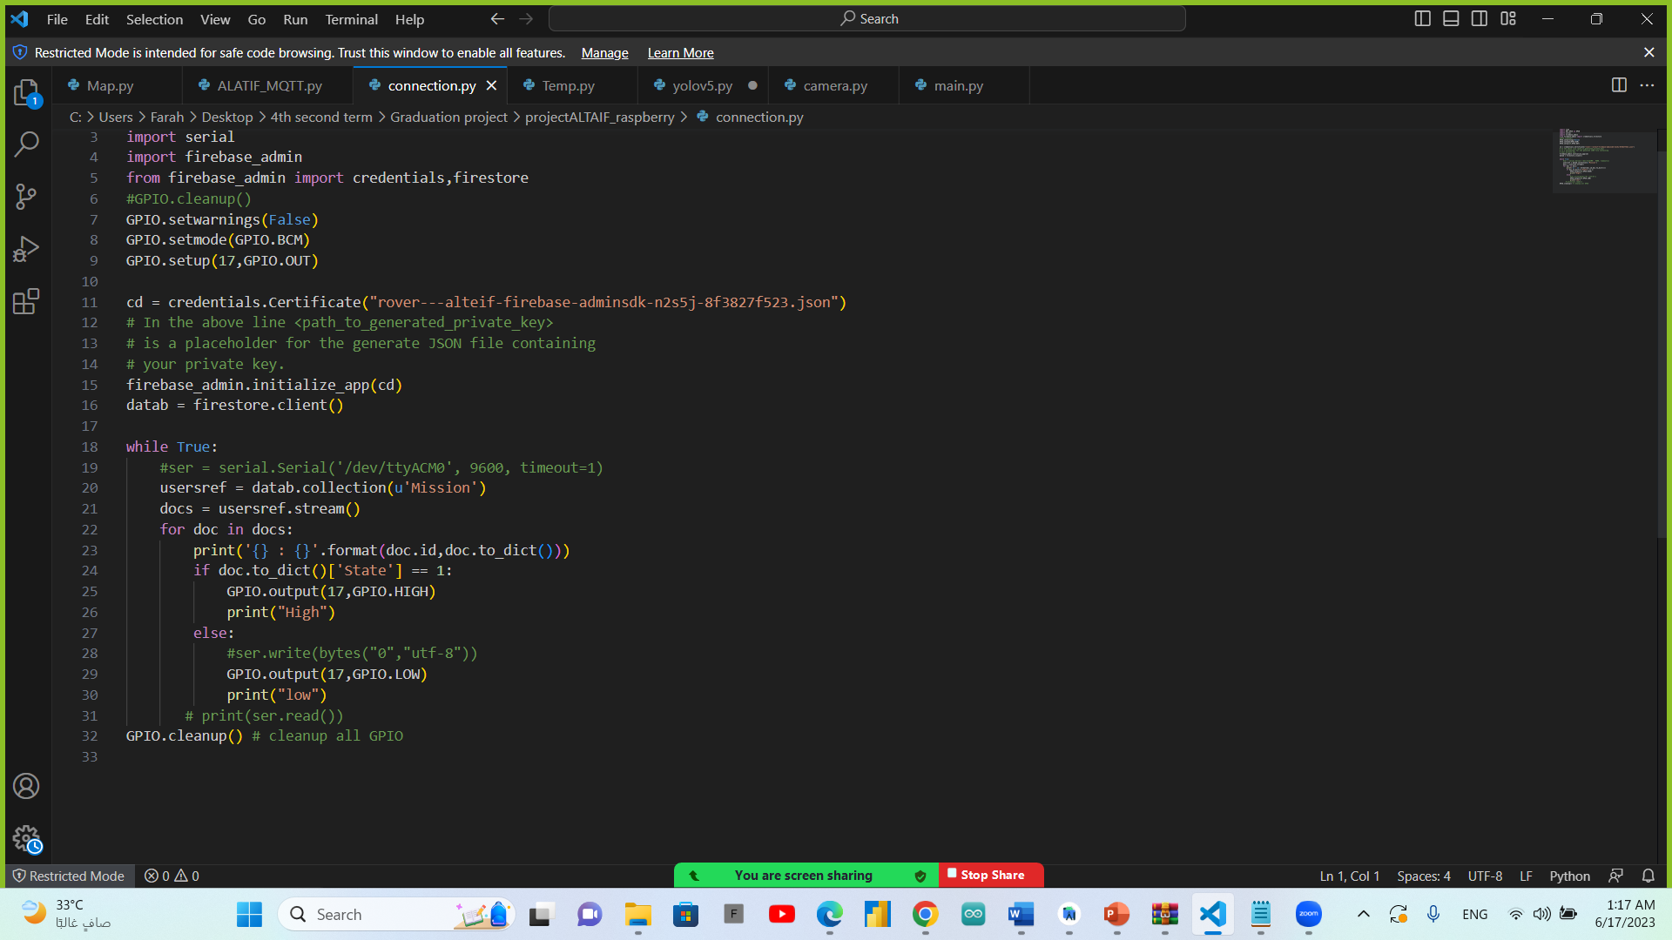

In the code below the raspberry pi sends the DH11 sensor reads from Arduino to firebase in order to be shown in the flutter app.



### Implementation of Arduino code

* **Self-driving mechanism**

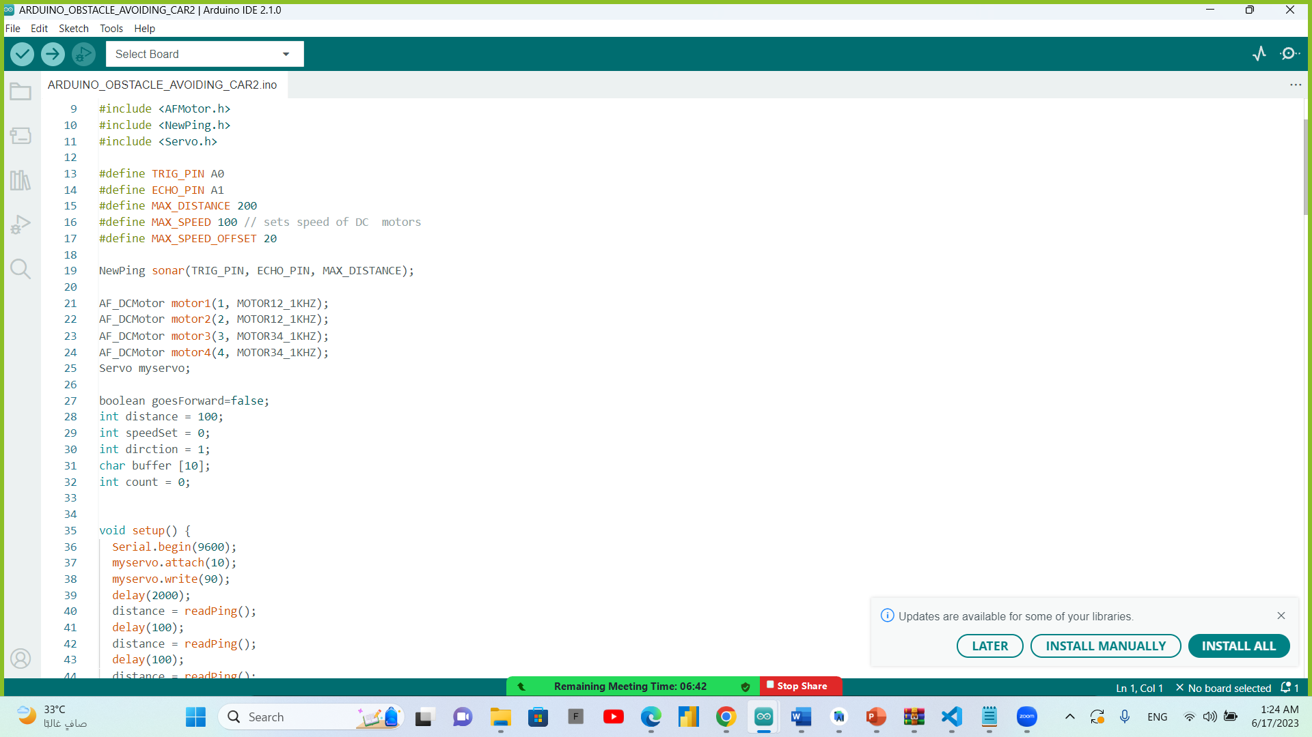

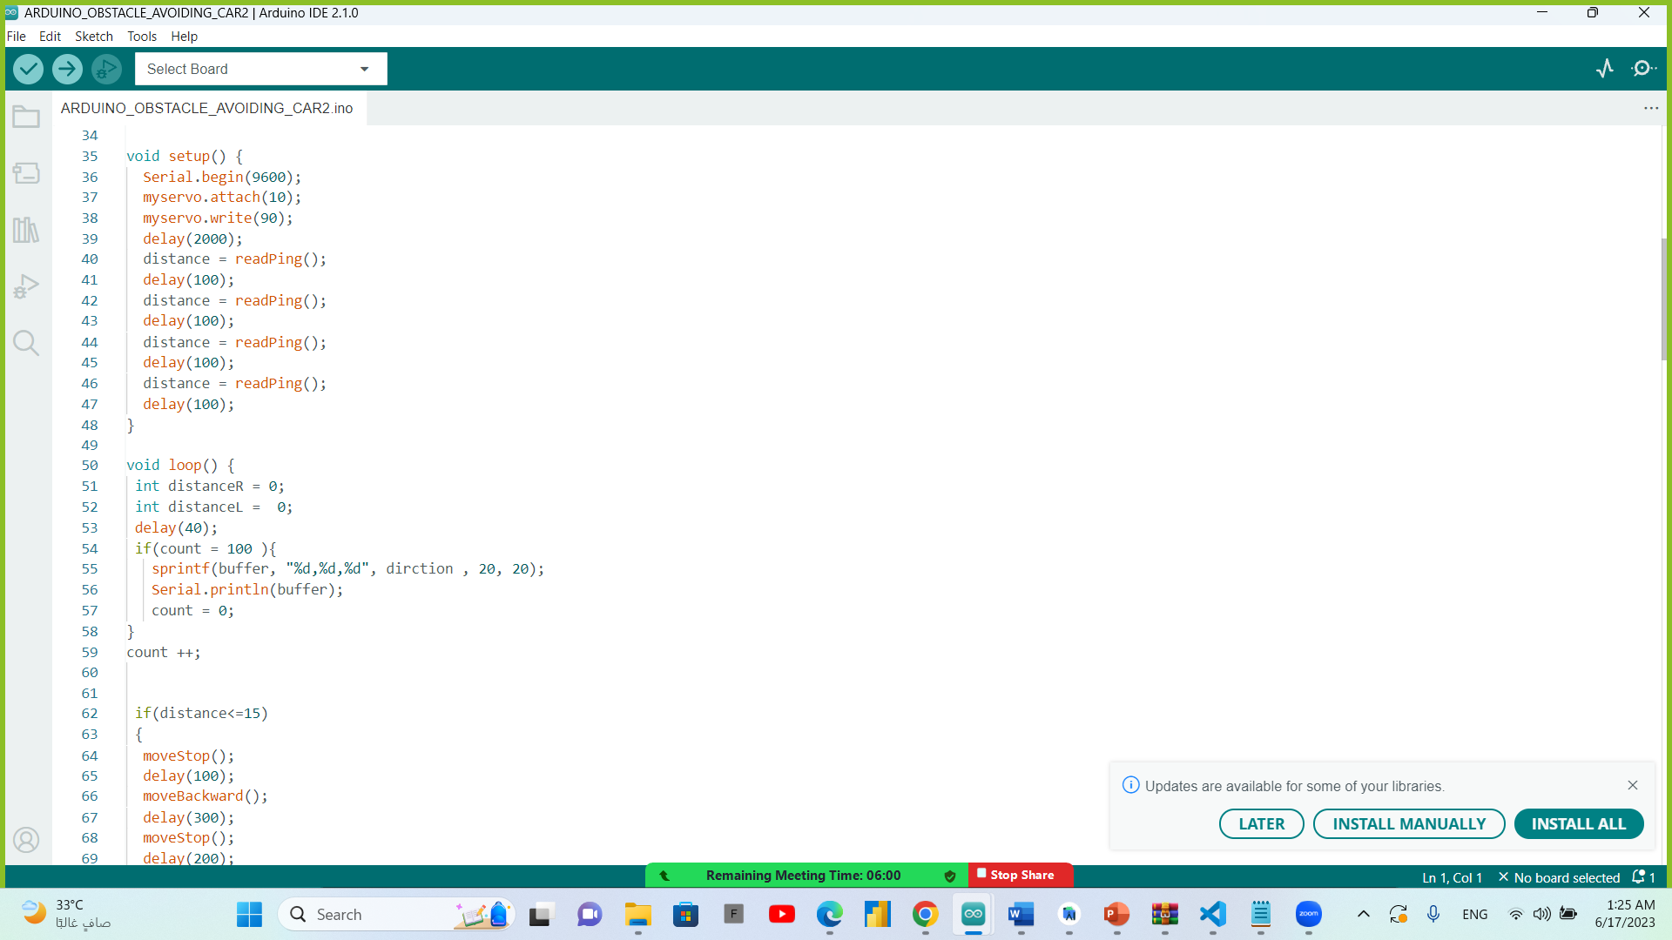

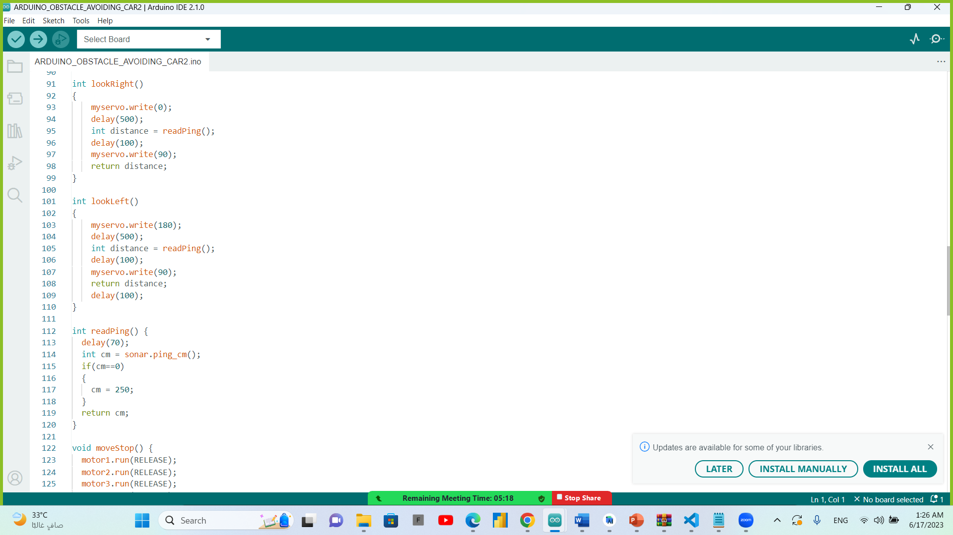

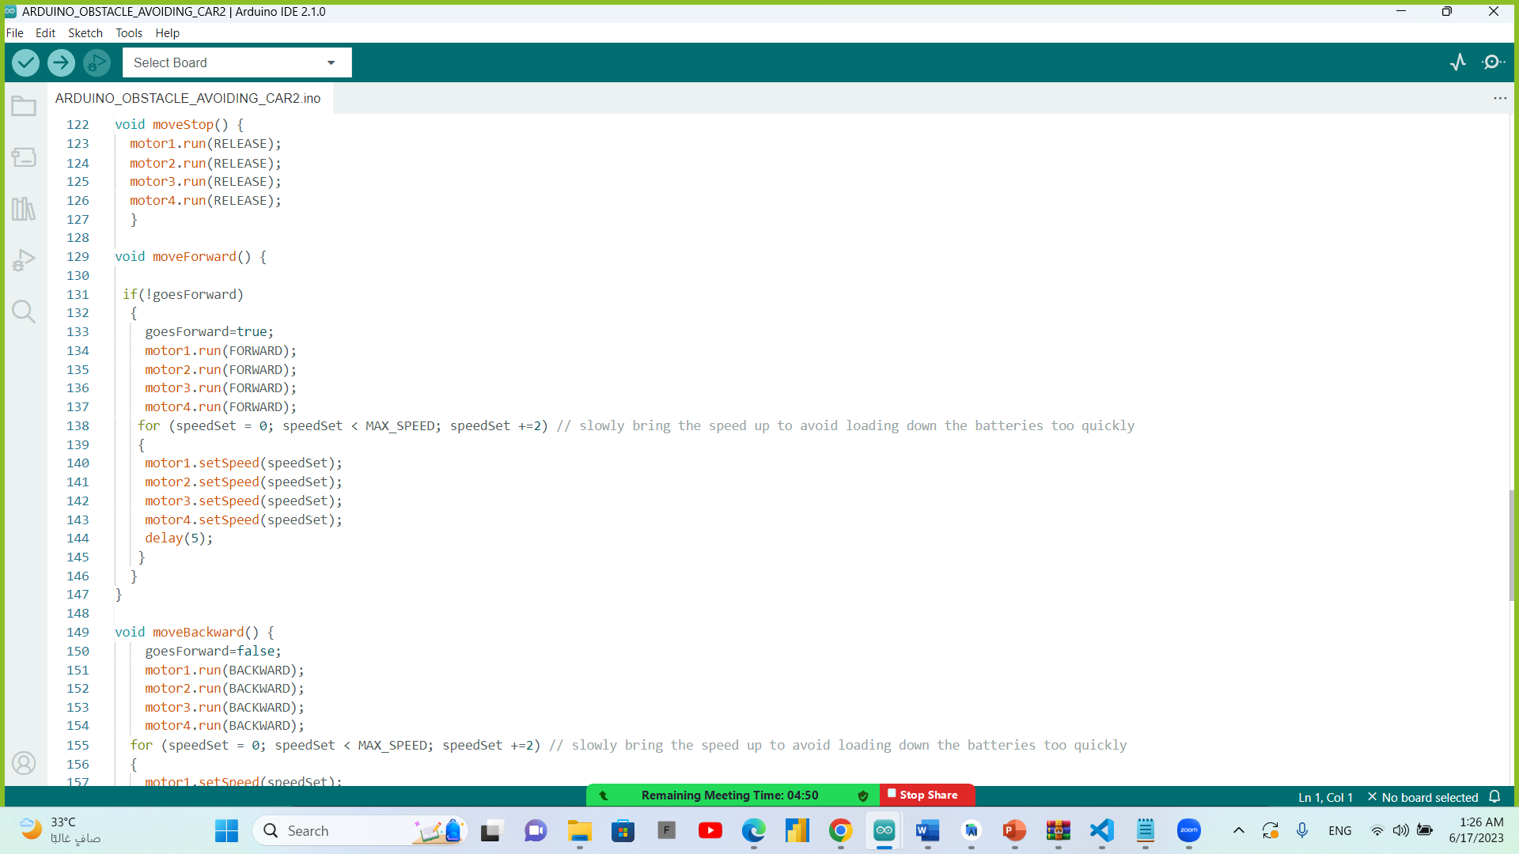

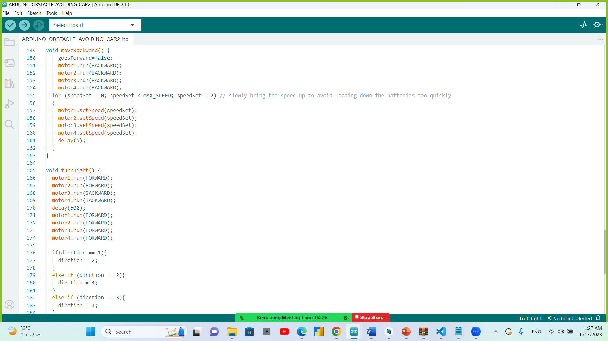

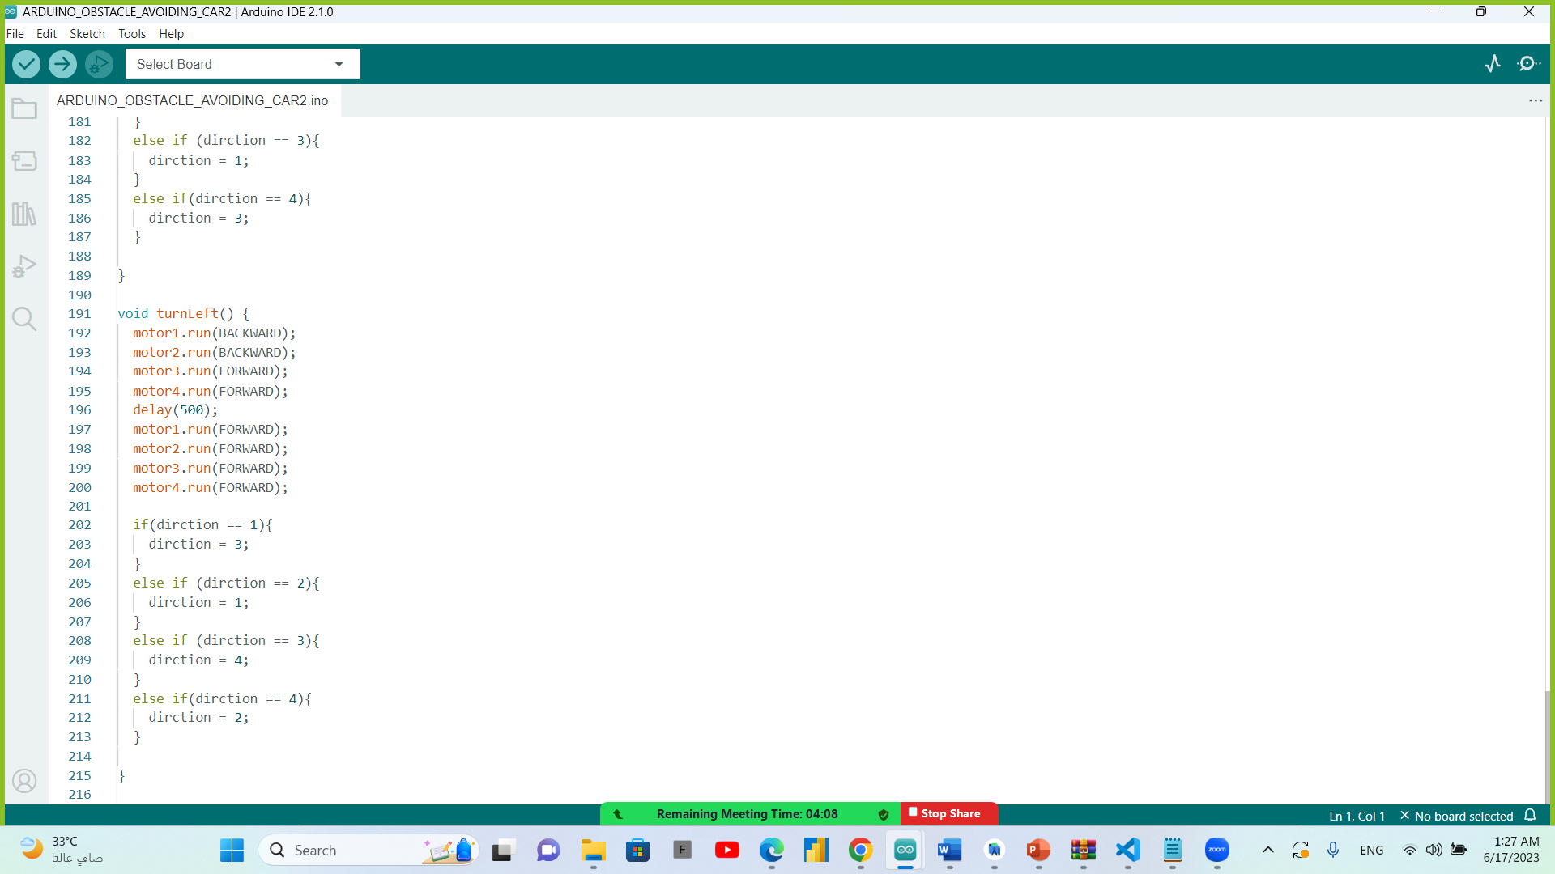

* **Connected sensors**

In the code below we connect the DH11 sensor to Arduino to get the measures of temperature and humidity.

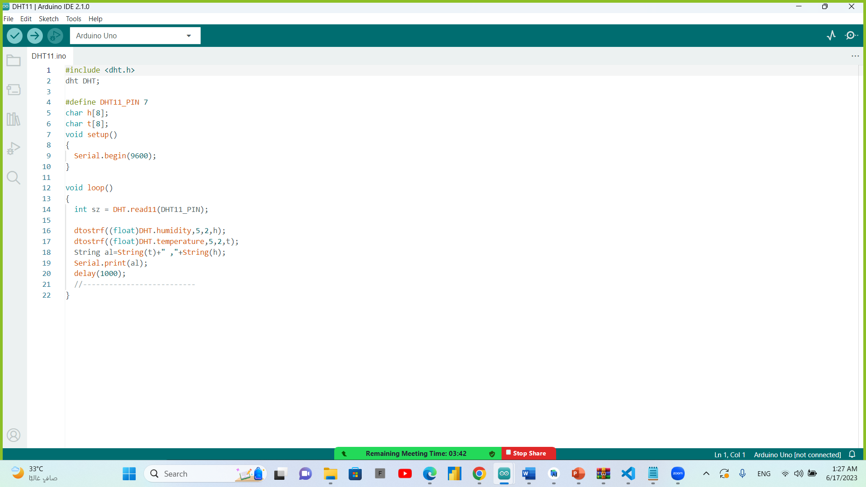

## Testing

Testing the object detection output have accuracy: 80%, Testing rover movement was in the right conditions and directions, and Sensors reads was accurate.

In testing duration, the rover movement was difficult as we control its movement algorithm by adding three ultra-sonic sensors and control speed by increasing the power of batteries and teach the rover how to avoid obstacles and how to send maps on our application by connecting it to firebase to get the history of its movement and to receive reading from sensors.

In object detection model testing we test it until we get accuracy equal to 80%.

We test the application a lot to make connection between the application, firebase, Arduino, and raspberry pi, to control the state of moving and stopping and in sending sensor’s reading to the application, and in showing the live video with its URL.

## Evaluation

**Evaluation using wireless Camera:**

By using (Android / IOS) application: DroidCam to make stream video from the camera on local network

**Evaluation using wire Camera:**

By using python-OpenCV we can capture the video from the connected camera.

Using python-OpenCV capture the video then applying Yolov5 pre trained model to apply object detection on image then render image to make stream live object detection video.

In the mean while the Arduino is sending power to the dc motors and get the reads of ultrasonic sensor to change its direction if there is obstacle or wall in 20cm from the rover, and it sends the reads of heat and humidity reads every 1 min. to the raspberry pi.

## Summary

The project work with two main component the Arduino and raspberry pi to make the movement, exploration, and object detection in the place around.

# Chapter four: Discussion and conclusion

## Main findings

1. Self-driving mechanism by Arduino code and ultrasonic sensor.
2. Humidity and temperature measurements
3. Detection of some objects.
4. Can see and detect at night or dark areas.
5. Receiving a report by end of the mission.
6. Receiving a map for the paths that the rover moved on.

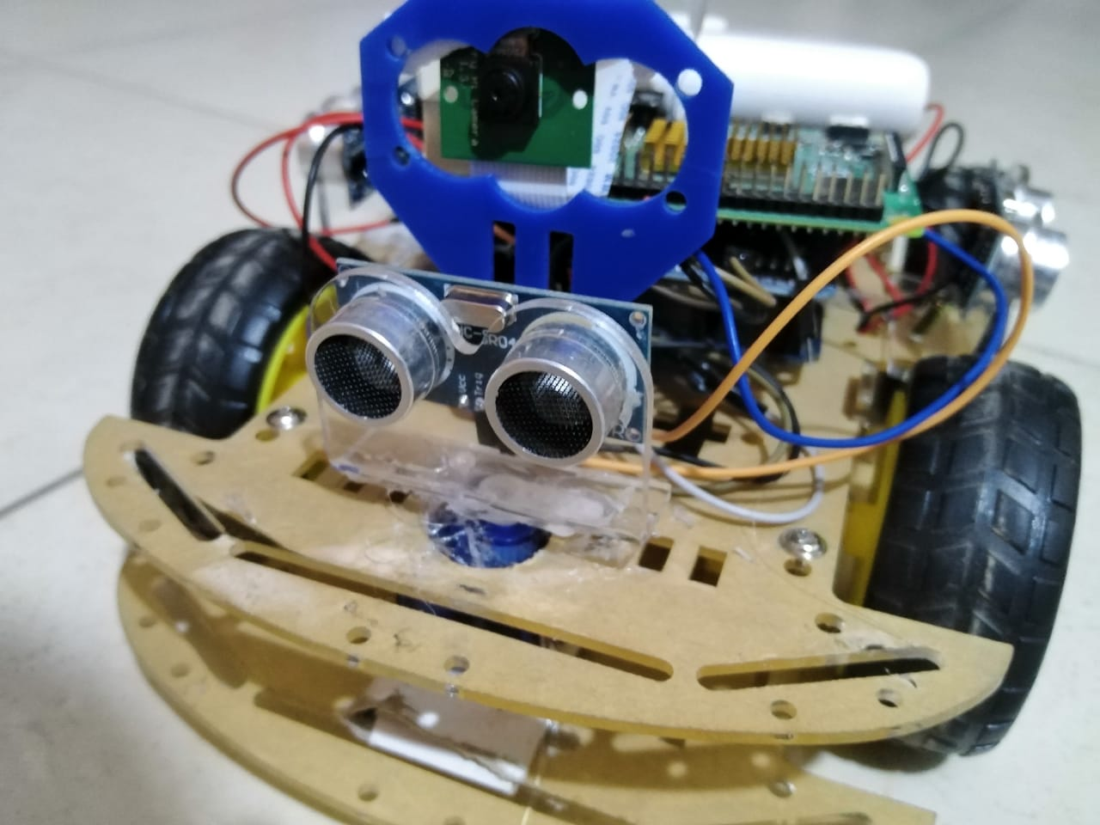

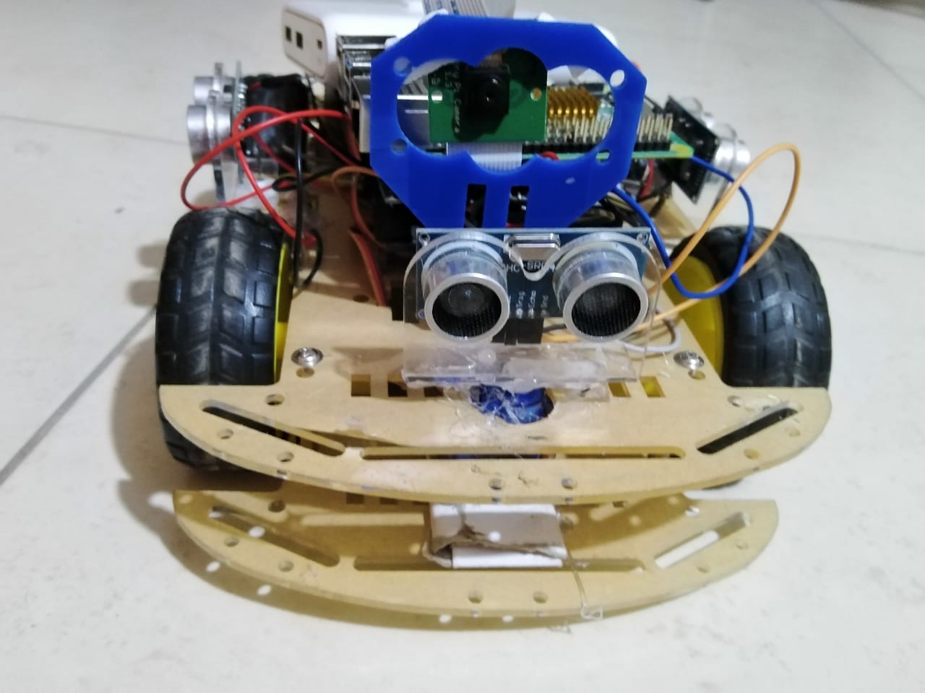

## Why is this project important?

This project aims to facilitate the daily research missions by managing the exploring completely using IOT and computer vision, only the user starts and end the mission from the application, he can receive all information automatically through application with an easy UI. The system is safer for a scientist than exploring by themselves in danger environment may be has a very high, very low temperature or harmful objects. Or rover is small in size so it can go in narrow places where a person cannot go in and explore what are there and send us a complete picture and paths of those places even at night it has LEDs will be turned on at night like ancient cemeteries or any other places hard to reach by human like space.

## Limitations

1. Don’t trained on reinforcement learning model for self-driving mechanism.
2. Can’t return back to the initial position from which it starts its movement.
3. The map is generated according to a specific area which is limited area

## Future recommendations

1. Train the rover by a reinforcement learning model to make a sequence of right decisions by itself.
2. Make the rover return back by itself to the initial position from which it starts its movement.
3. Generating a map by using lidar sensor to produce a full area that the rover will visit.
4. Make the rover able to discover space.

# Summary

Our Rover will be sent to unknown place and move in it to discover and explore this place by seeing and detect objects around itself using camera and Artificial intelligence techniques. The Rover can record temperature and humidity measurements by DHT11 sensor and records them into a dataset. At the end of each mission the rover can generate a map of the explored place

# References

1. <https://www.worldwildlife.org/threats/effects-of-climate-change#:~:text=Impacts.%20Humans%20and%20wild%20animals%20face%20new%20challenges,and%20wreak%20havoc%20on%20people%E2%80%99s%20livelihoods%20and%20communities>
2. https://www.indeed.com/career-advice/career-development/what-is-system-analysis-and-design#:~:text=Benefits%20of%20system%20analysis%20and%20design&text=Enabling%20comprehension%20of%20complicated%20structures,the%20workload%20of%20IT%20employees
3. <https://economictimes.indiatimes.com/definition/systems-design>
4. https://www.indeed.com/career-advice/career-development/what-is-uml#:~:text=UML%20is%20a%20visual%20language,outcomes%20or%20errors%20in%20programs.
5. <https://slideplayer.com/slide/8452821/>
6. <https://www.timelog.com/en/blog/project-scope>
7. <https://pjreddie.com/publications/>
8. <https://en.wikipedia.org/wiki/PyTorch>
9. <https://www.makerspaces.com/arduino-uno-tutorial-beginners/>
10. <https://www.raspberrypi.com/products/raspberry-pi-4-model-b/specifications/>
11. <https://en.wikipedia.org/wiki/Arduino_Uno>
12. <https://www.instructables.com/How-to-Interface-DHT-11-Temperature-and-Humidity-S/>
13. <https://lastminuteengineers.com/mpu6050-accel-gyro-arduino-tutorial/>
14. <https://www.datacamp.com/tutorial/tutorial-power-bi-for-beginners>